Student Discipline Monitoring System

Shogo Roxy Serra – Project Manager/Developer

Elijah Angelo Alcarde – Project Analyst/Developer

Asia Pacific College

Submitted to

Edmundo Casiño

In partial fulfillment of the requirements for the

SOFTWARE DEVELOPMENT

Class of 3rd term School Year 2015-2016

April 21, 2016

Student Discipline Monitoring System

# Project Objective

To provide a system that protects the scholarship of students which promotes ease of communication between a student and the Disciplinary Officer, and an adaptive system where the Disciplinary Officer can manage offenses according to the changes in the student handbook.

# Abstract

Student Discipline Monitoring System is a web-based application where students, security guards, Disciplinary Officer, and Student Affairs Director manage violation tickets, sanctions, appeals, and reports according to their roles. The system makes use of Radio Frequency Identification (RFID) to file a violation in the entry access points of the school.

# Introduction

Dress code violation is the most violated minor offense in the student handbook, and the Disciplinary Officer handles at least fifty cases per day. Students have to inquire directly to the Disciplinary Officer’s office to keep track of the violations that they have committed. Moreover, there are times that the Disciplinary Officer’s consultation schedule does not match with the time where the student goes to his office. The violation is permanently recorded if the student failed to make an appeal to the D.O. Since three minor violations is equivalent to a major violation, the scholarship of the students will be at risk whenever they fail to appeal their violations.

Because some of the students know that most of the violations and sanctions written in the student handbook is not implemented properly, they become conceited and still commit actions that considered as a violation, e.g., public display of affection, self-bussing, using someone else’s ID card.

The security guards file minor offenses, which is submitted to the Disciplinary Officer at the end of the day. If they witness a student committing a major violation, they create a report to the D.O.

The Student Affairs Director views the student violations. They do not file the violation tickets but they are involved in enforcing sanctions to a student which committed a major violation. Thus, summary of the generated reports are significant to them.

The Disciplinary Officer has the center-figure role in the system. He handles all the filed violation, and reports from the security guards. The D.O. has the discretion to enforce sanctions to students according to the severity of their violation. He creates a list of suspended students, and the security guards carry out the implementation.

# System Analysis

The filing and reporting of violations of the security guards is done manually on paper. Printing expenses will increase in an alarming rate considering the future growth of Asia Pacific College. In addition, the school may need to hire additional manpower if the current system continuous, again an added expense for the institution.

Since the filing and reporting of violations is done manually, the issuing of violation tickets takes time; and the students have to wait for the ticket to be done before entering the school, which becomes a concern especially for students who are a running late for class.

The lack of ease of communication between students and D.O., inefficient process of filing violation tickets, and making an appeal statement is a major issue for students with scholarship. Because in order to create an appeal, students have to meet with the Disciplinary Officer; and his consultation schedule is not free all the time so students have to set an appointment, which also takes time. It is necessary for the students to know the consultation hours of the D.O, but it is vital that students know when and where the D.O. is available during the consultation hours.

During the appeal of students to the D.O., there are times that there are inconsistencies as to whom created the violation ticket. Because the violation ticket is done manually on paper, data validation of the forms is mostly not monitored when the violation tickets is submitted to the D.O. Thus, more problems arises because of lack of evidence; such as a case of a student making an appeal on a dress code violation, saying that he/she really did not commit the violation. Hence, the report should have proof of violation so there will be non-repudiation.

The submission of violation reports summary of the Disciplinary Officer to the Student Affairs Director is done by encoding the violation tickets to Excel, and later uploaded in Flavio. Any changes after submitting the summary will be encoded manually and uploaded again. For that reason, the summary which is seen by the director is not real-time.

# Recommendation

A web-based violation system which will have seamless means of communication between students and the Disciplinary Officer. Student Discipline Monitoring System has three main modules:

* Dress code violation – this module will be set up on the entry access points of the school. The student who will be issued a violation either scan his ID or type ID number, and enter password to proceed to the violation form. The security guard fills out the form and takes a picture of the student; however, the student has the opportunity to state the reason of violation in the form. The student can confirm the violation ticket, and see notifications from the Disciplinary Officer by scanning/entering his ID number again.
* Student page module – students can access this page using APC’s local network. They can see their violations, and notifications from the D.O. in the dashboard. Students can create and update their appeals to a violation ticket.
* Administrator page module – this is where the Disciplinary Officer manage the violation lists, sanctions, and reports. The D.O. has the overall control of all violations – he can issue or excuse a violation ticket. The D.O. could also create notifications to schedule a meeting, or to remind students of their violations.
  + Director page –one of the sub-modules of the Admin page. The user can only view violation reports.

The web application is made using PHP, and admin LTE for the dashboard templates. Web hosting will be deployed in apache server, and MySQL will be used for the database.

Student Discipline Monitoring System will be particularly useful to the Disciplinary Officer because almost all of the reports are done electronically. In addition, there will be seamless reporting and filing of violations. If there will be any future revisions in the student hand book, the Disciplinary Officer could easily change the violation list and its details.

The system is also beneficial to students. They will be aware of the violations they have committed. Thus, it will promote discipline to the student body. Those who have committed a violation, but for a valid reason will be able to easily appeal to the Disciplinary Officer through the Student Page.

# System Diagrams

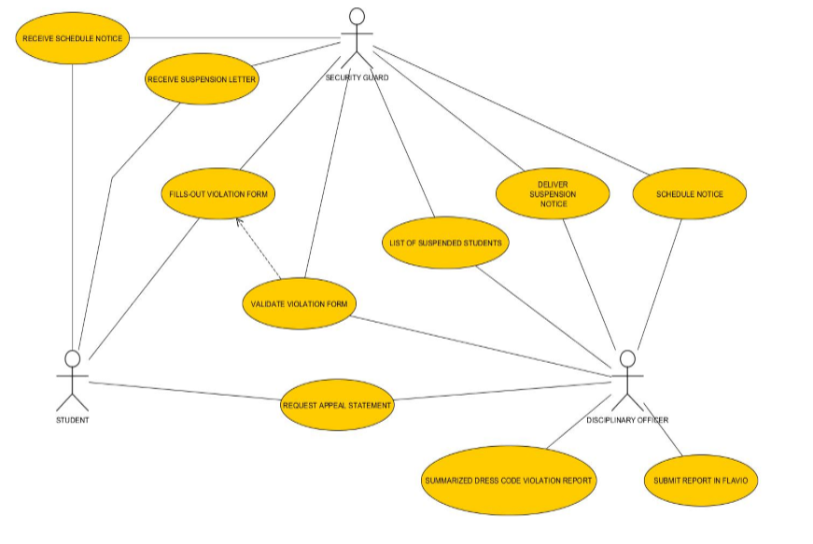**Business Use Case**

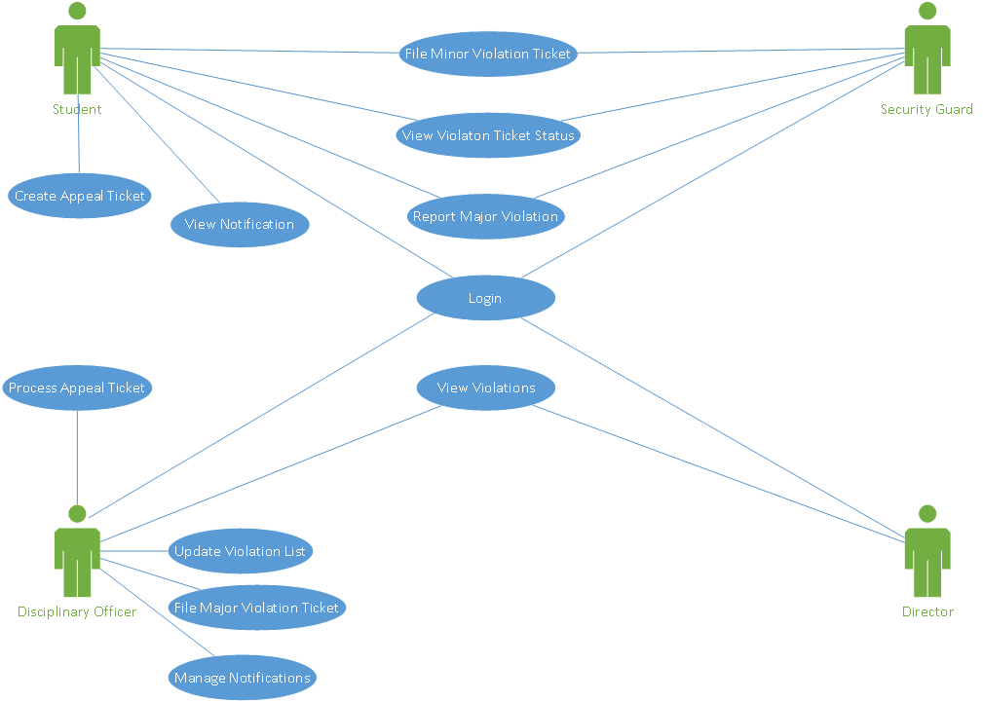**System Use Case**

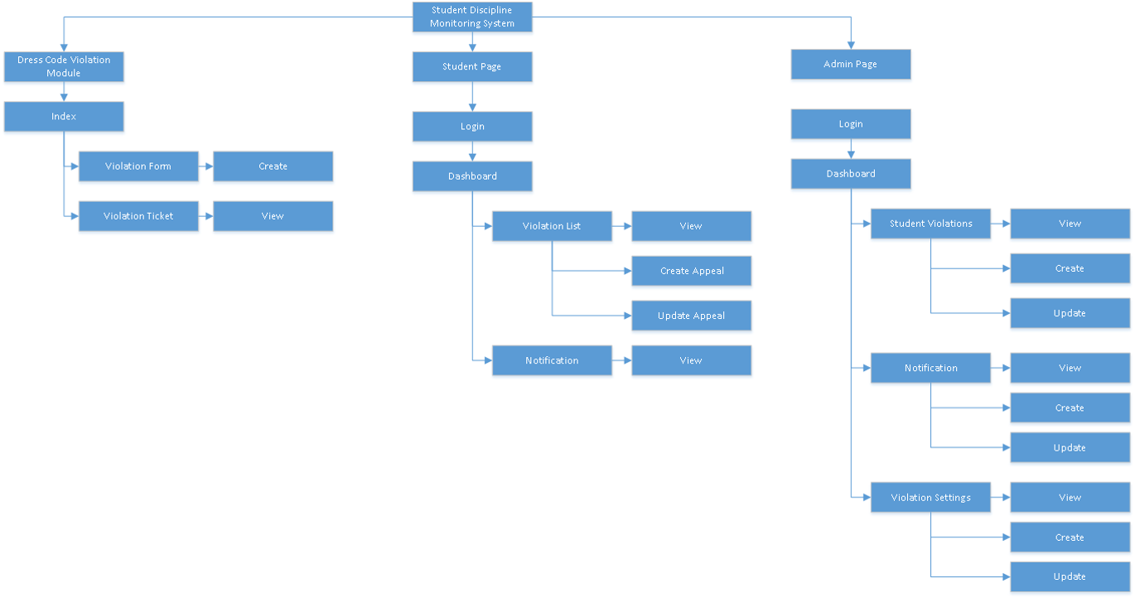**Sitemap**

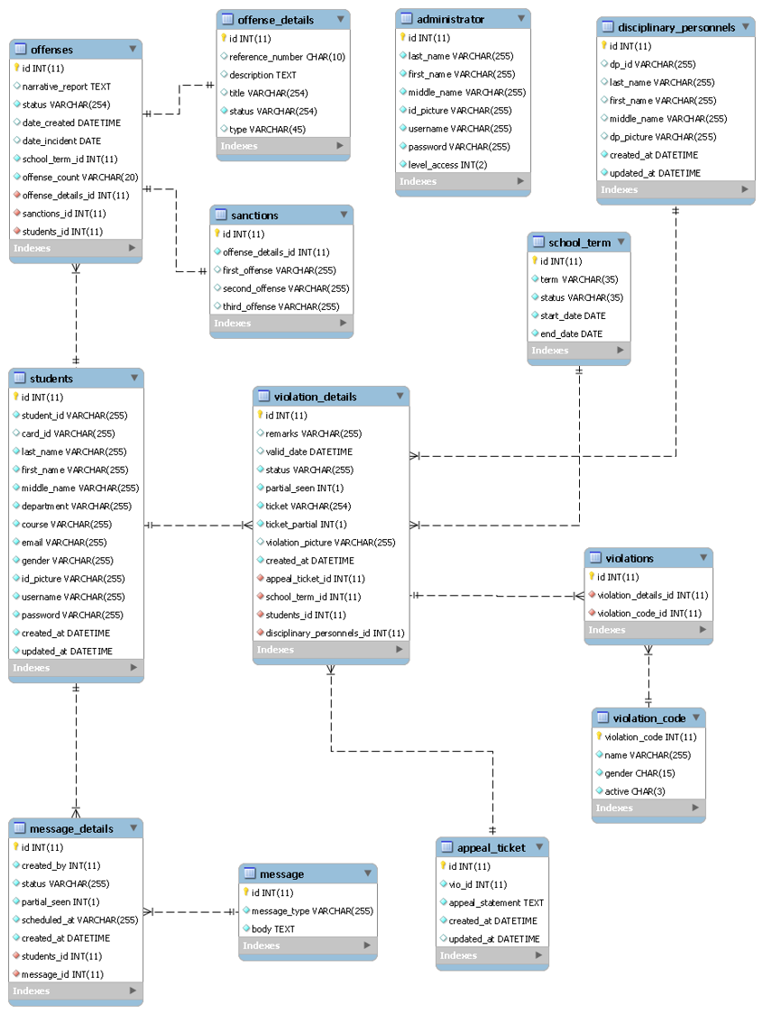**Entity Relationship Diagram**

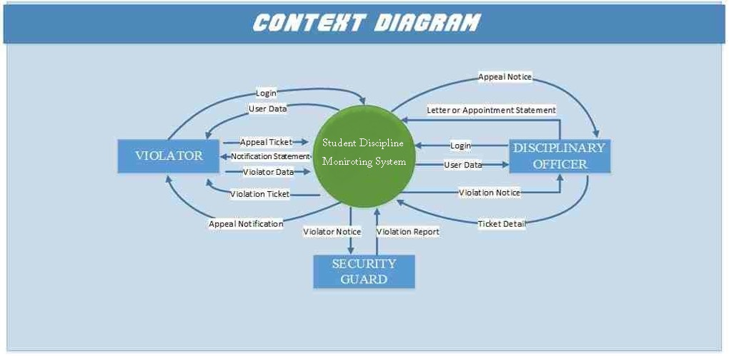**Context Diagram**

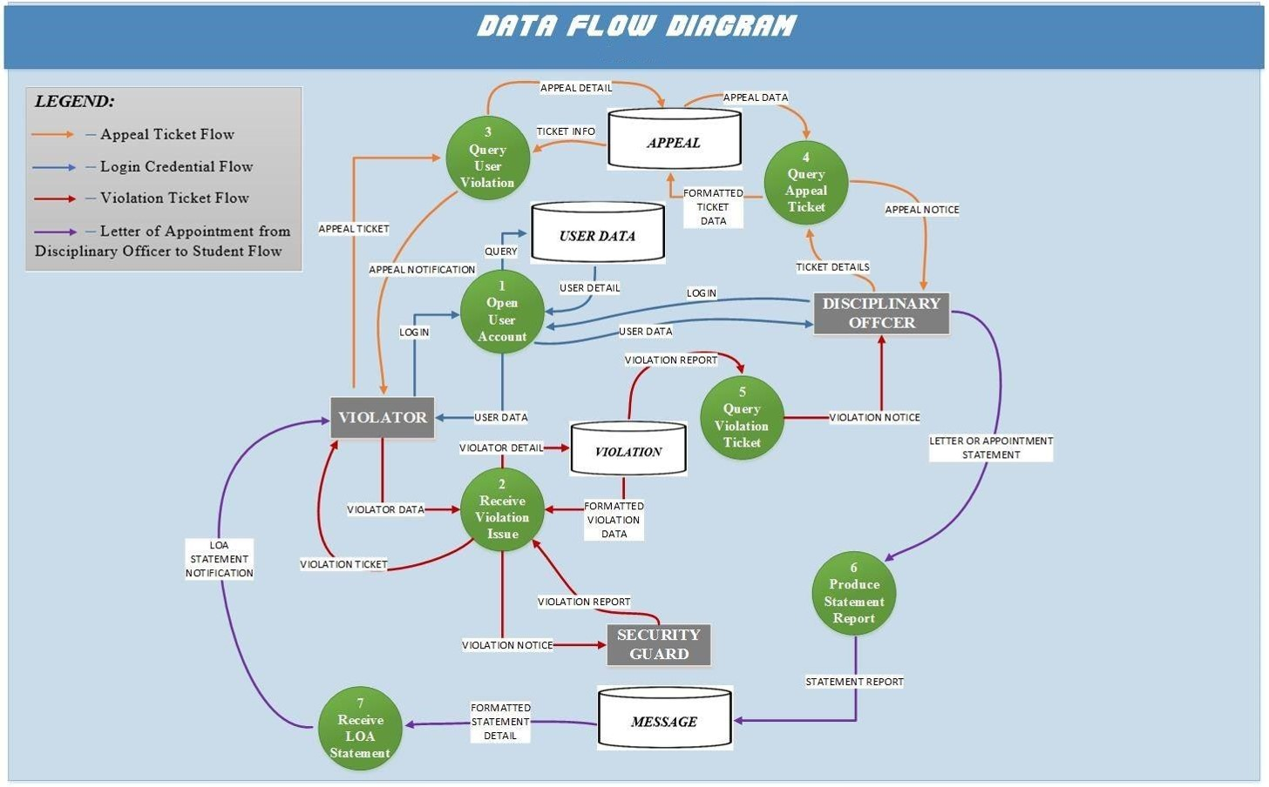**Data Flow Diagram**

# Screenshots

Modules:

* Dress code violation
* Student page
* Admin page
* Director page

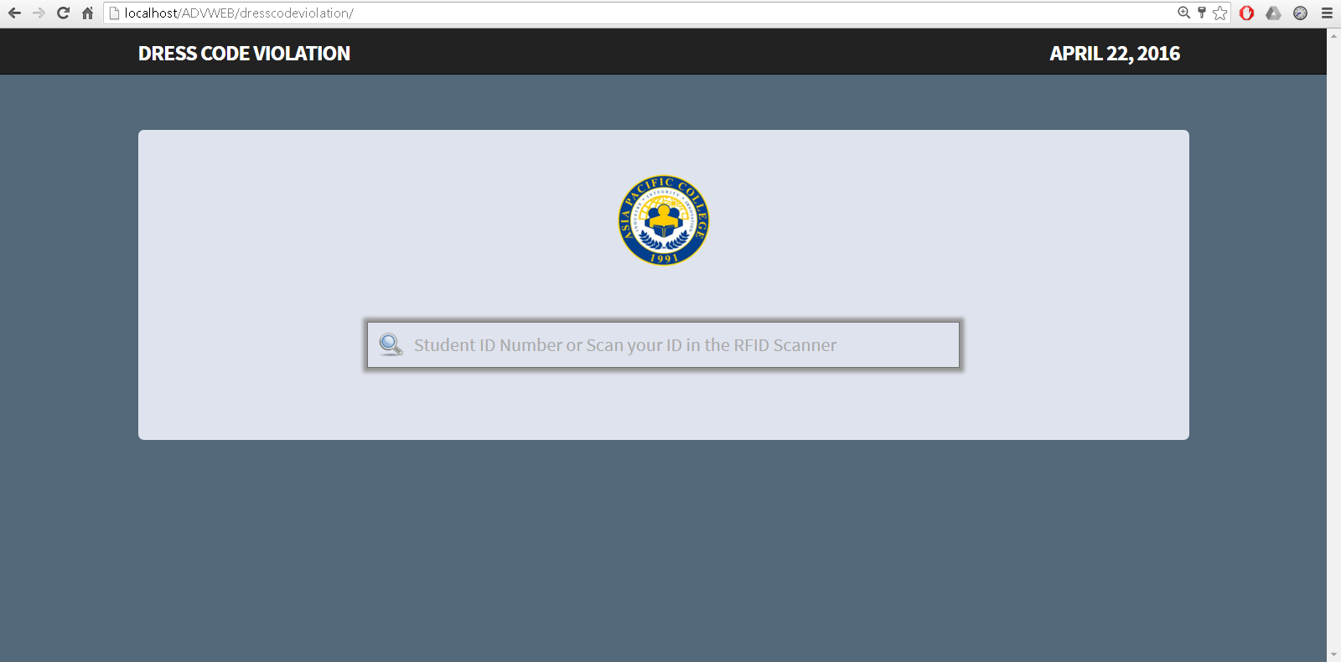

**Dress code module entry access point index**

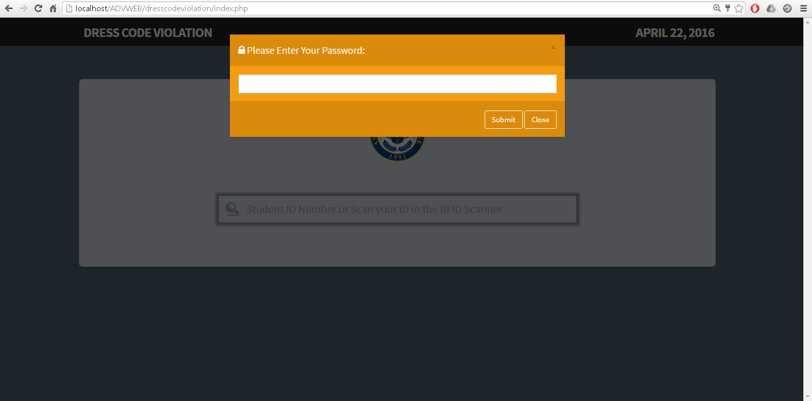

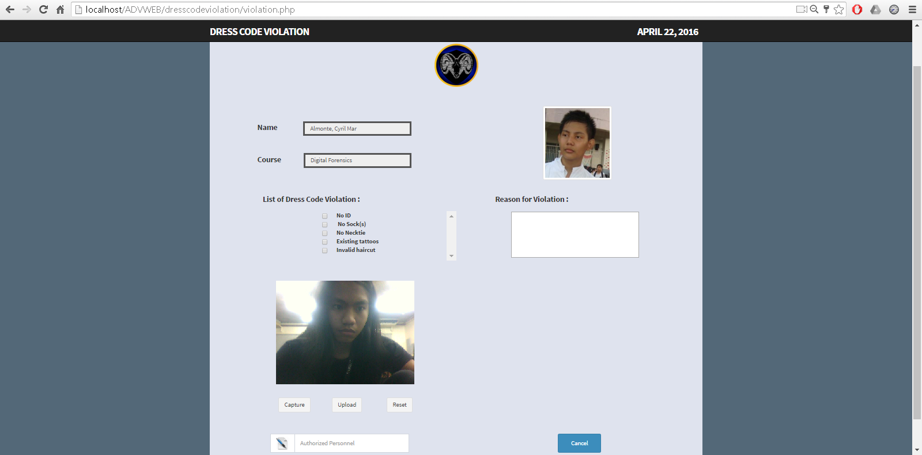**Dress code module password inquiry for student**

**Dress code module violation form**

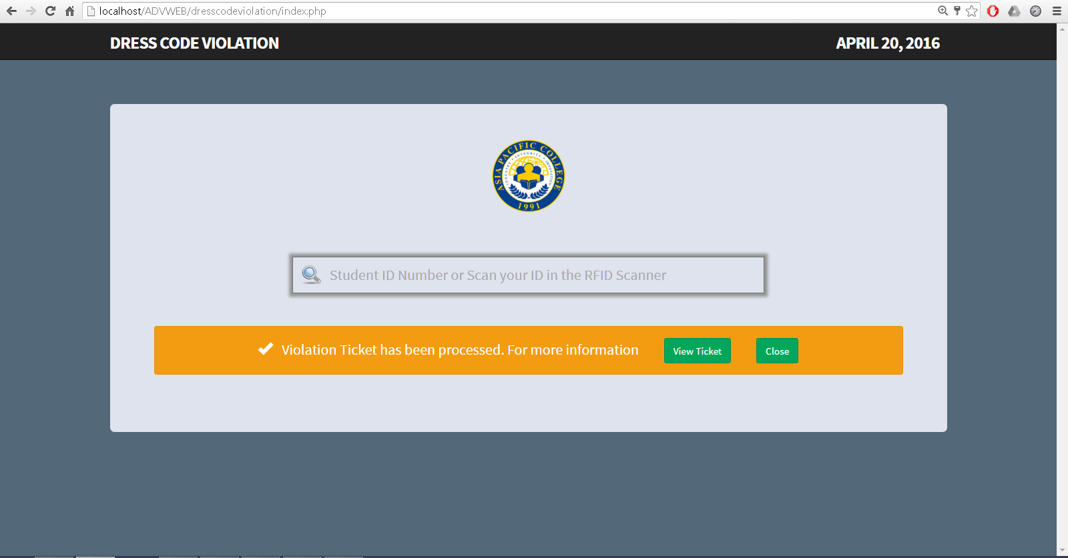

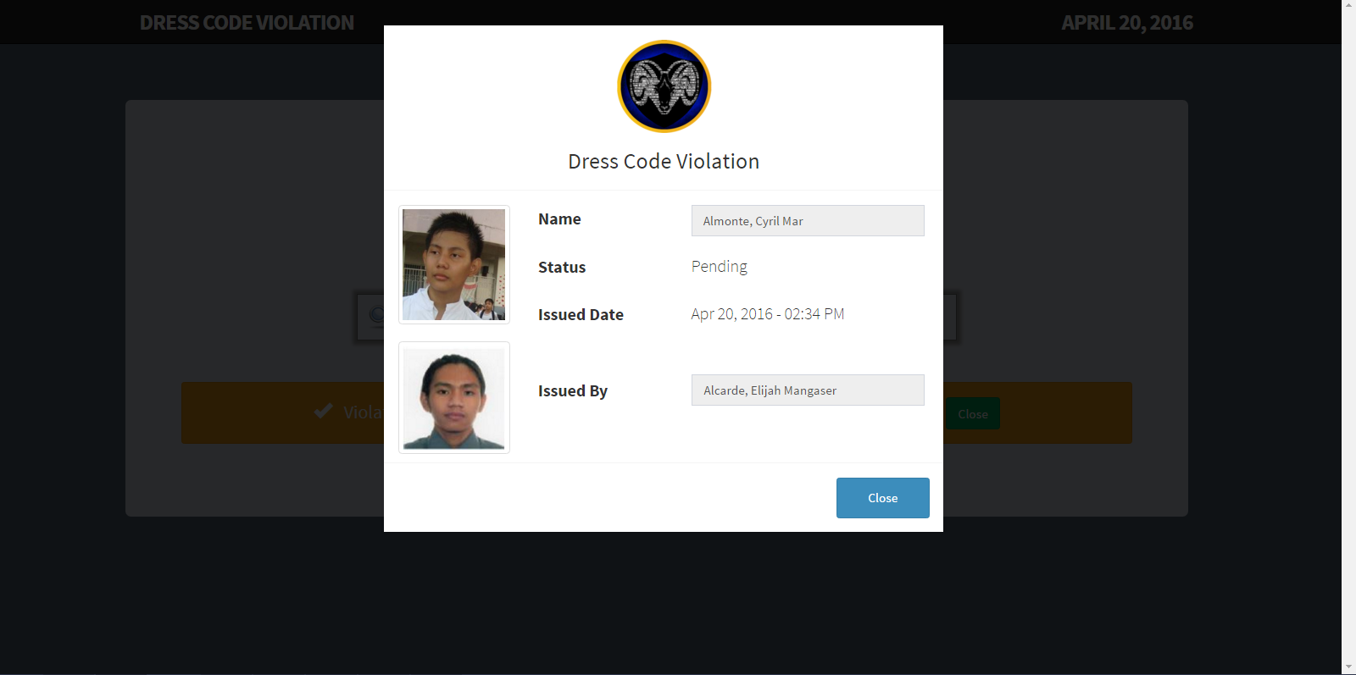**Dress code violation form confirmation**

**Dress code violation ticket**

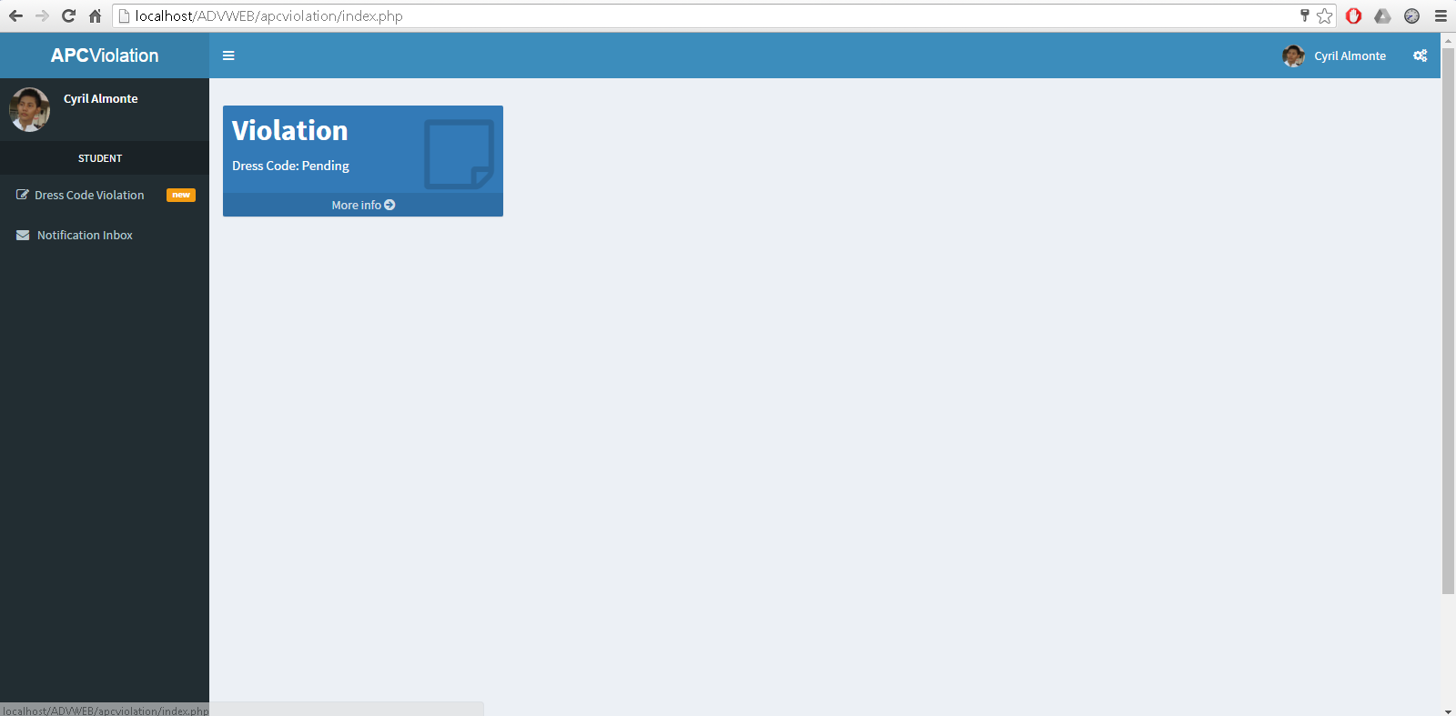

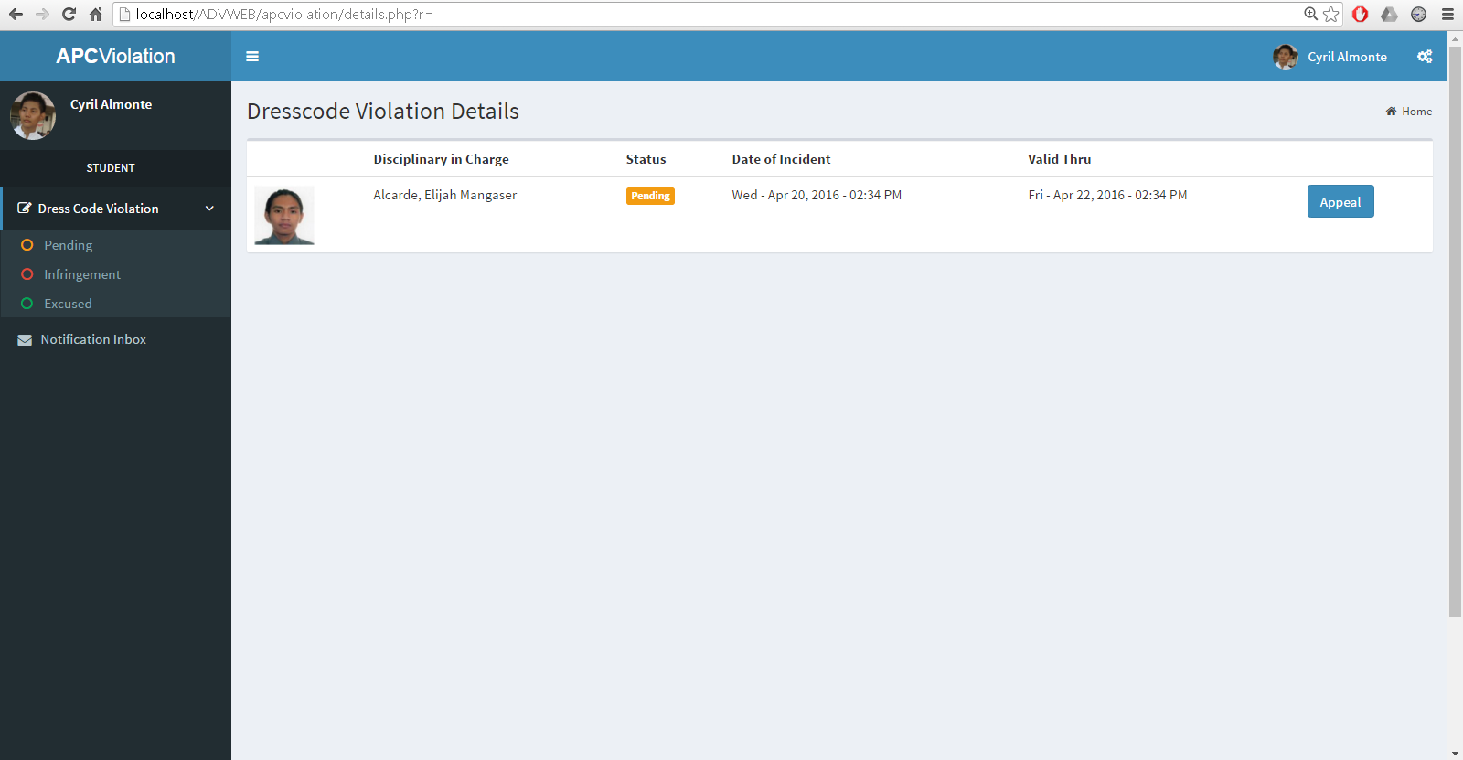**Student page dashboard**

**Student page violation ticket sections: Pending, Infringement, Excused**

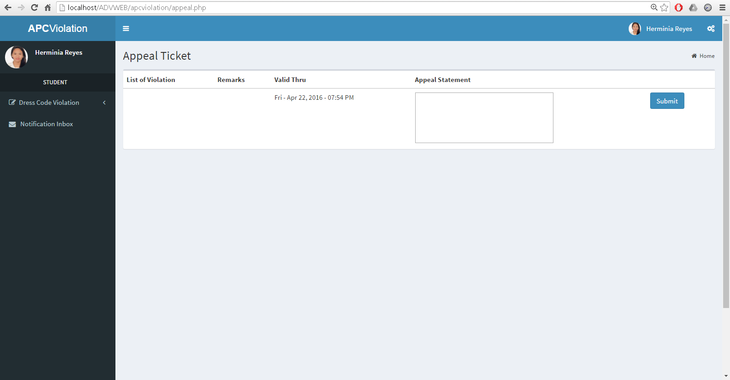

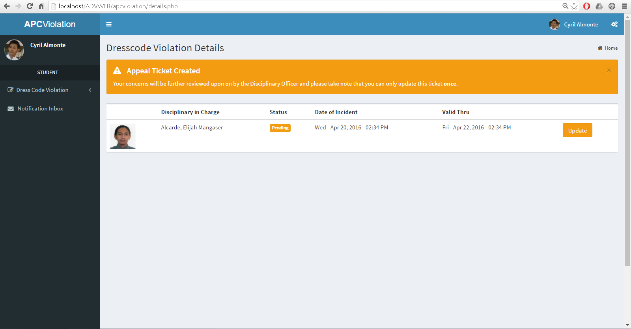**Student page appeal ticket creation**

**Student page appeal ticket confirmation**

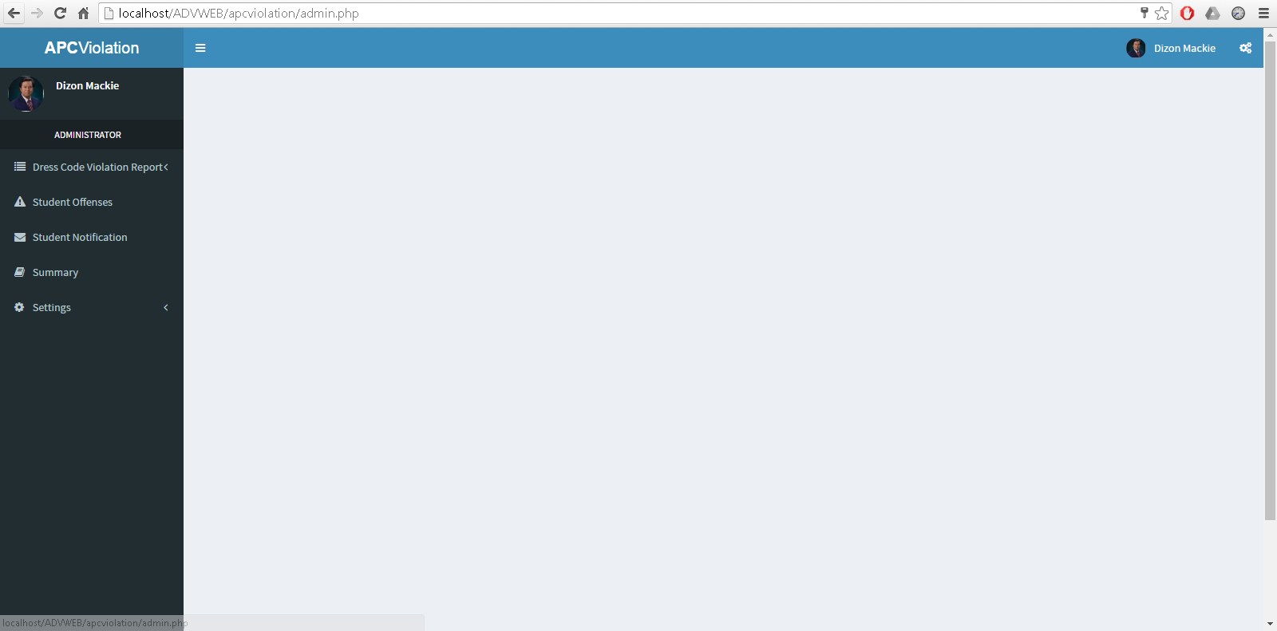

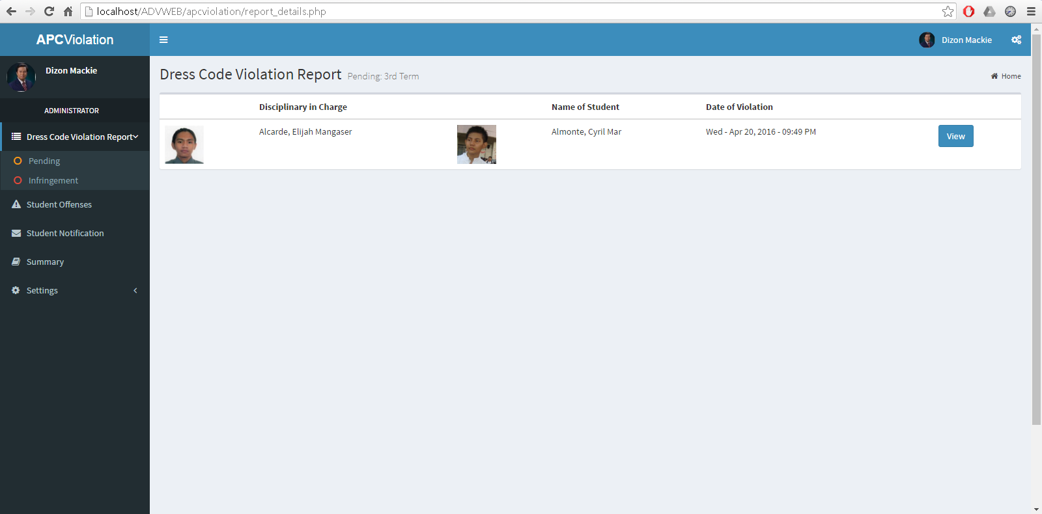**Admin page dashboard**

**Admin page dress code violation report sections: Pending, Infringement**

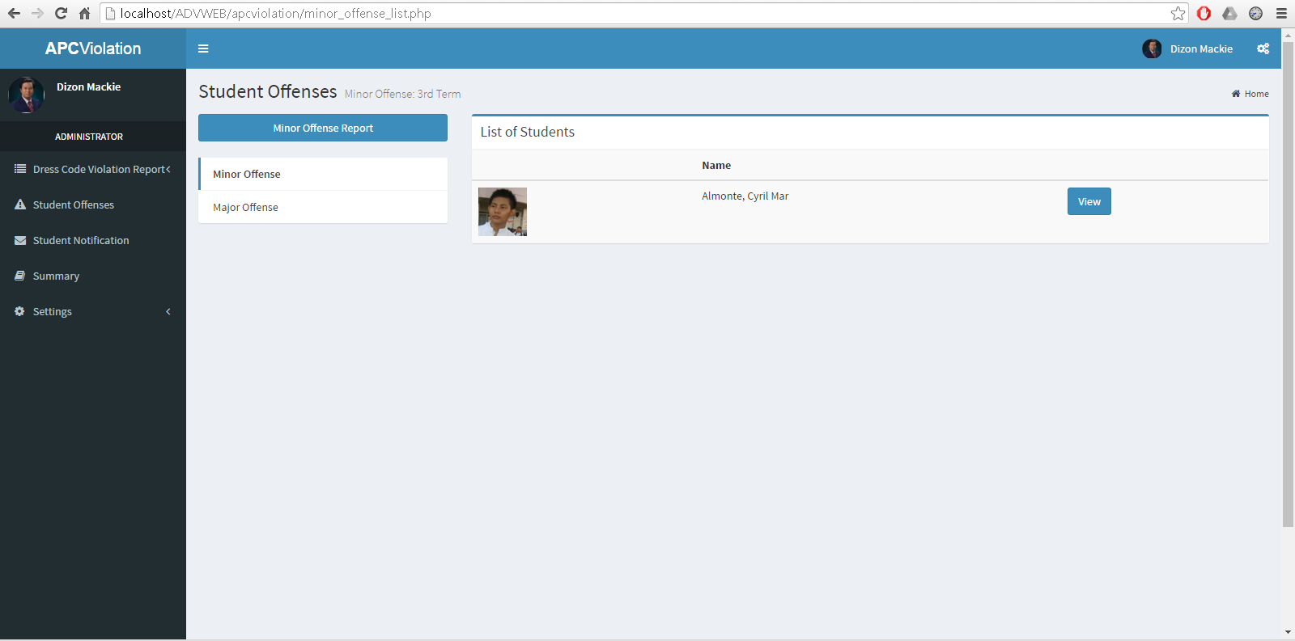

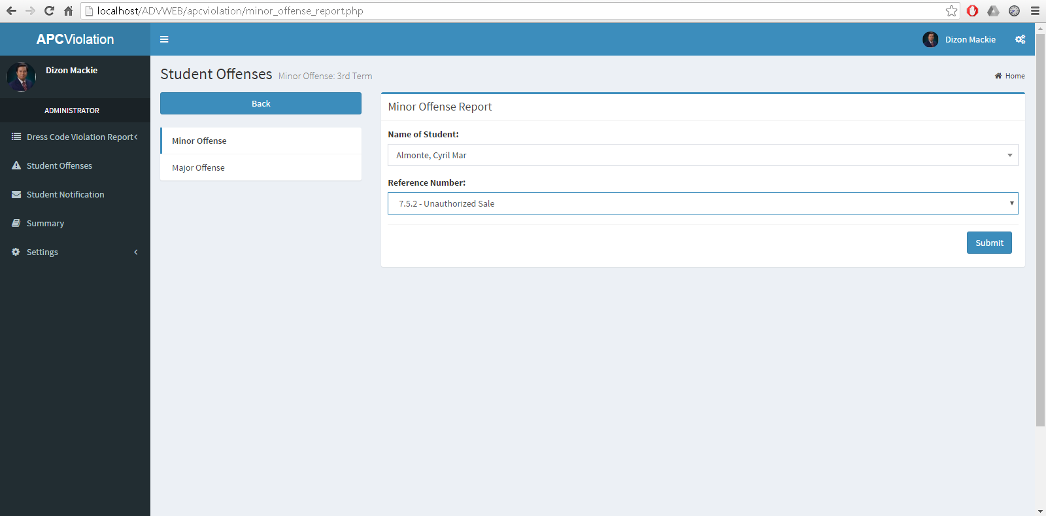**Admin page student minor/major offenses tab**

**Admin page offense report creation**

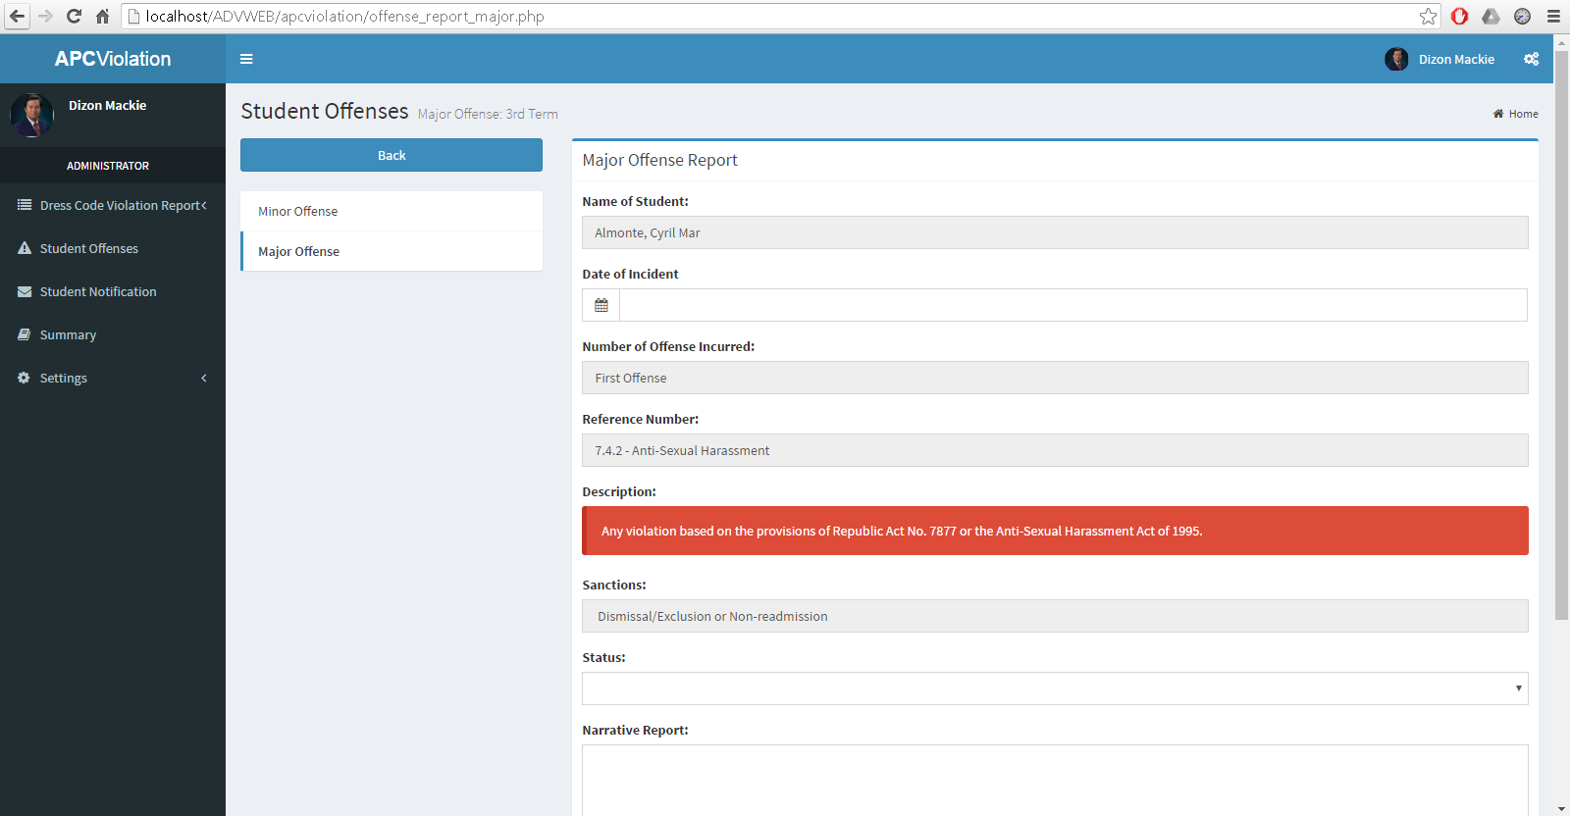

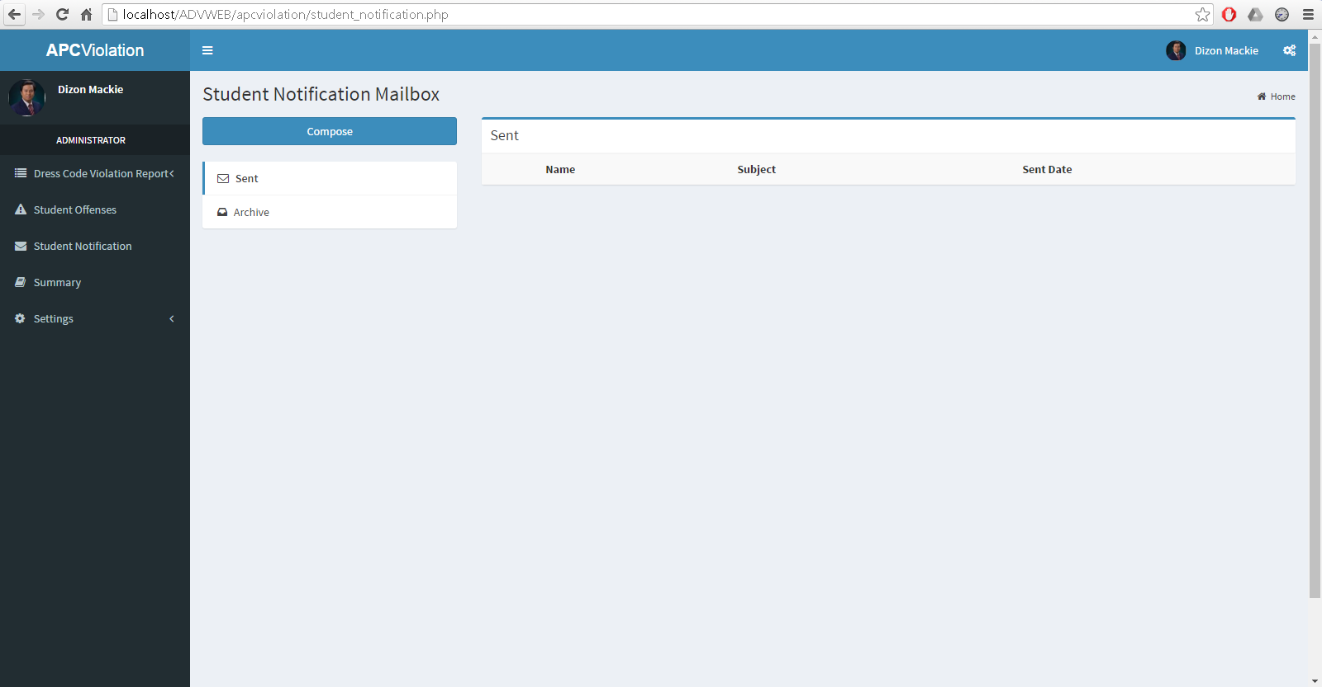**Admin page offense report form**

**Admin page notification tab**

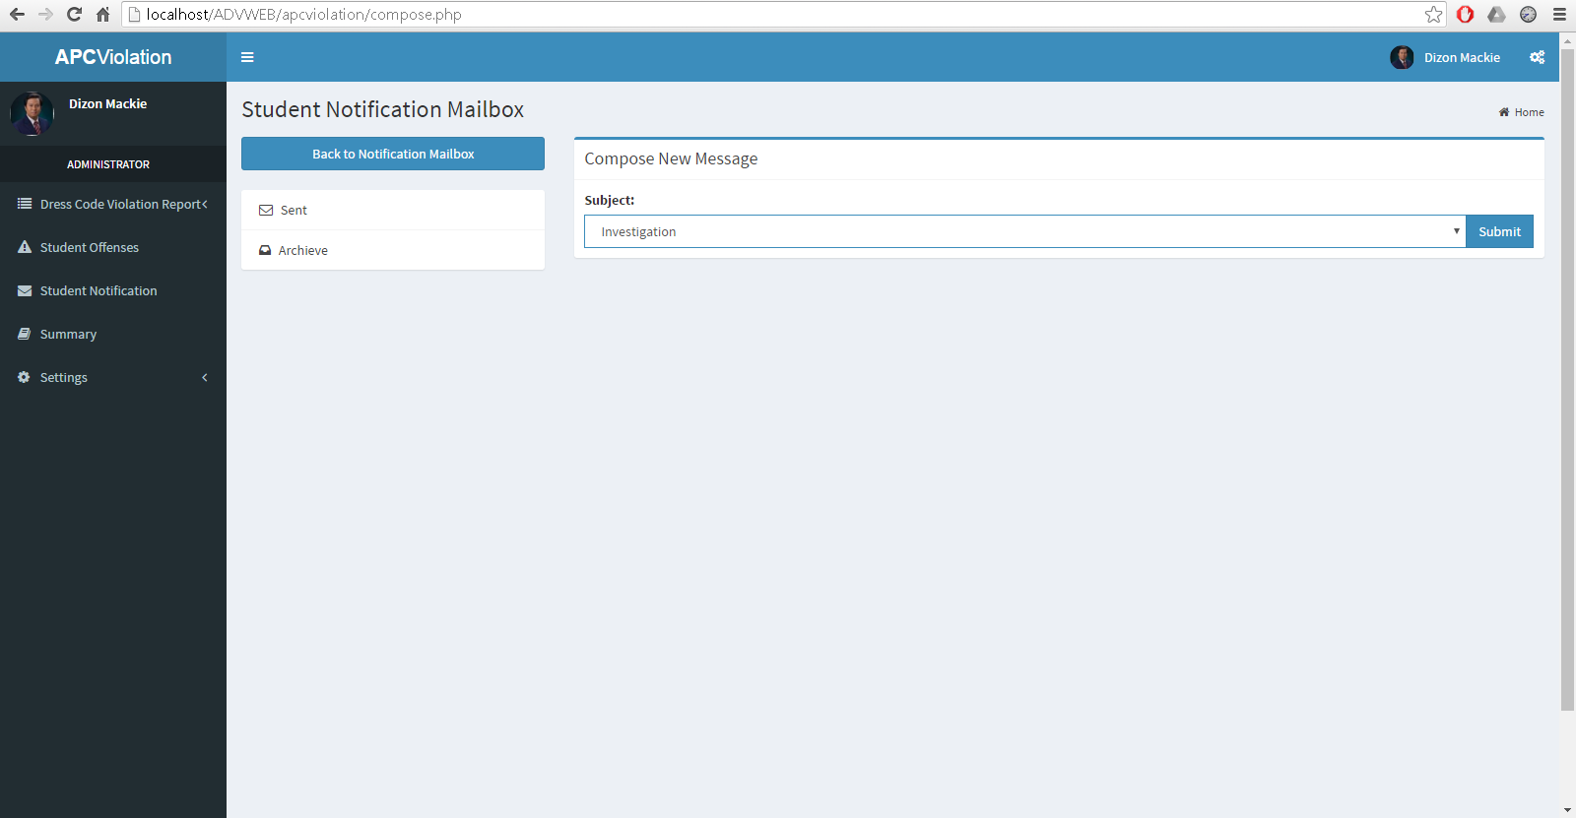

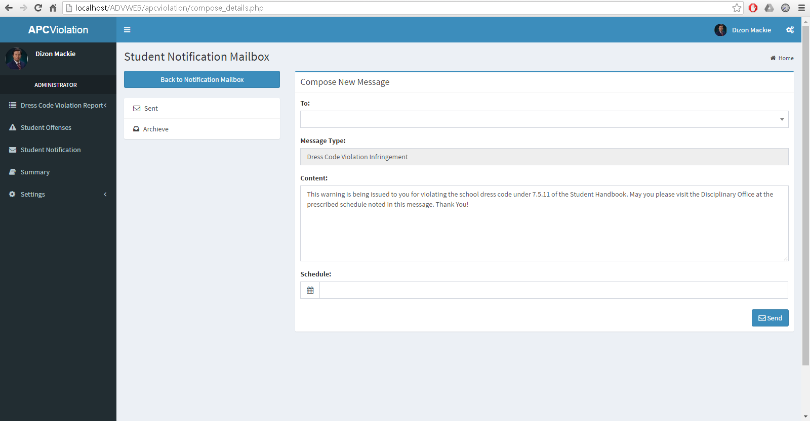**Admin page notification composition**

**Admin page notification form**

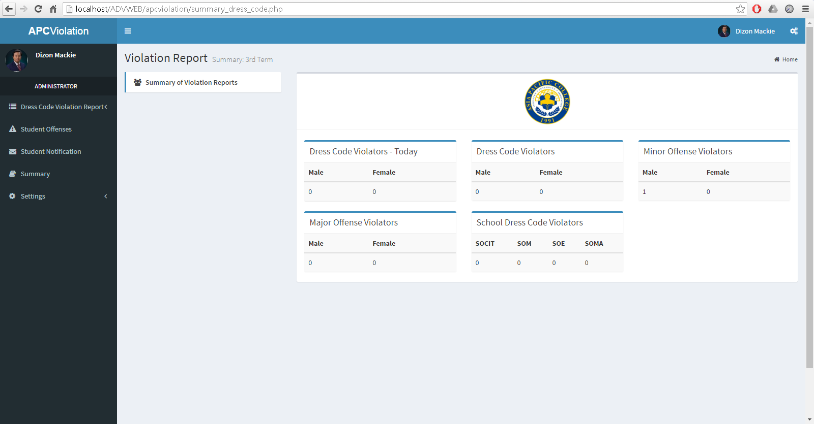

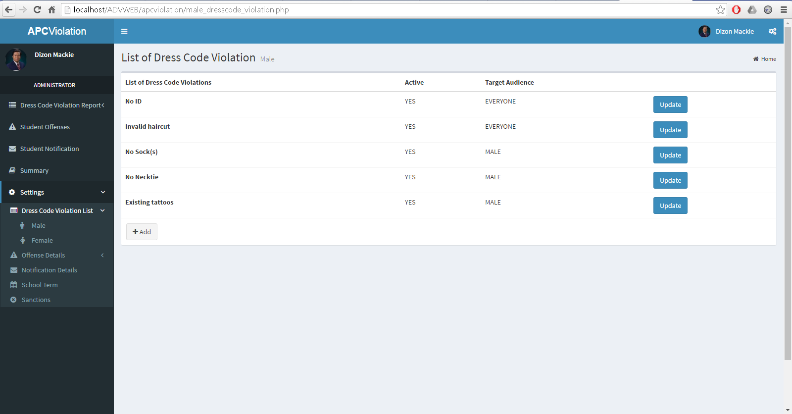**Admin page summary tab**

**Admin page dress code violation settings**

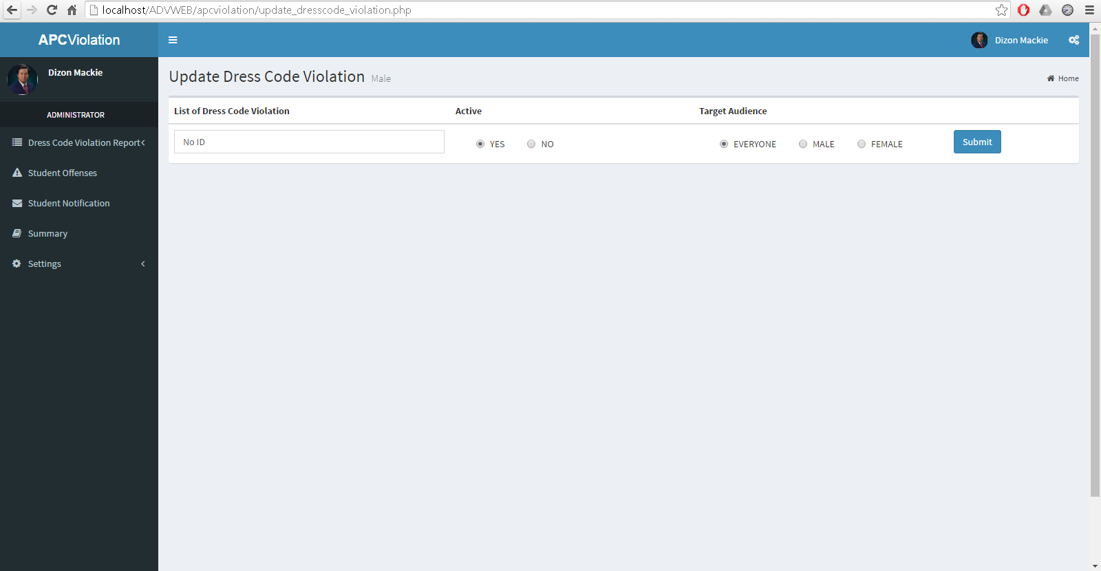

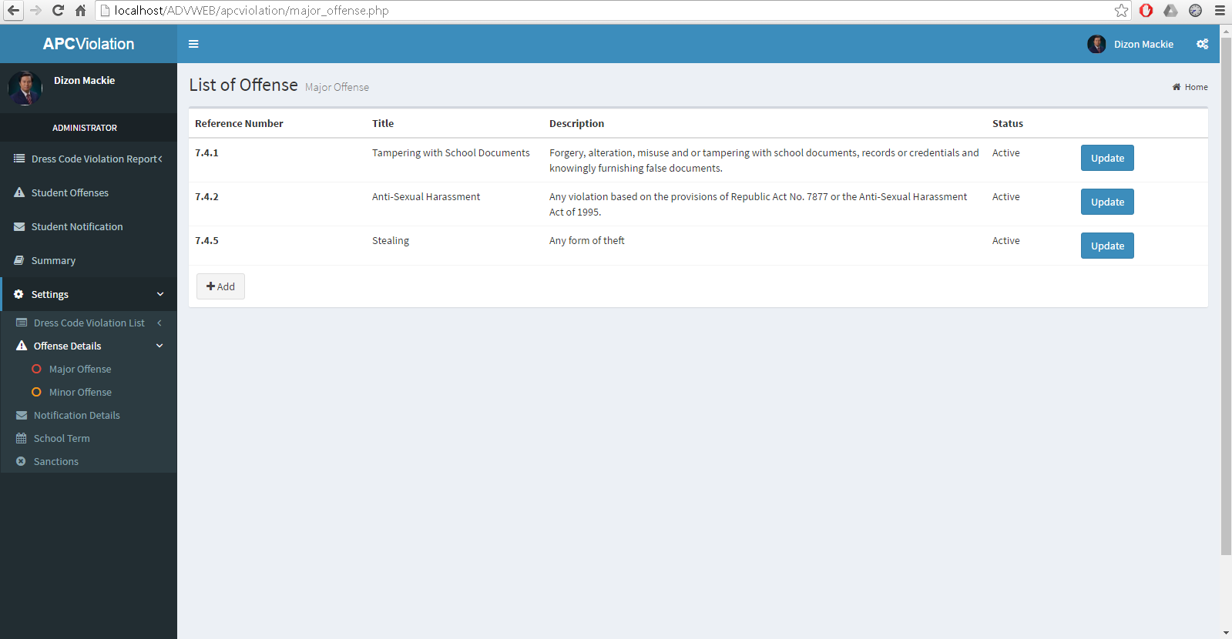**Admin page dress code violation update**

**Admin page offense details settings**

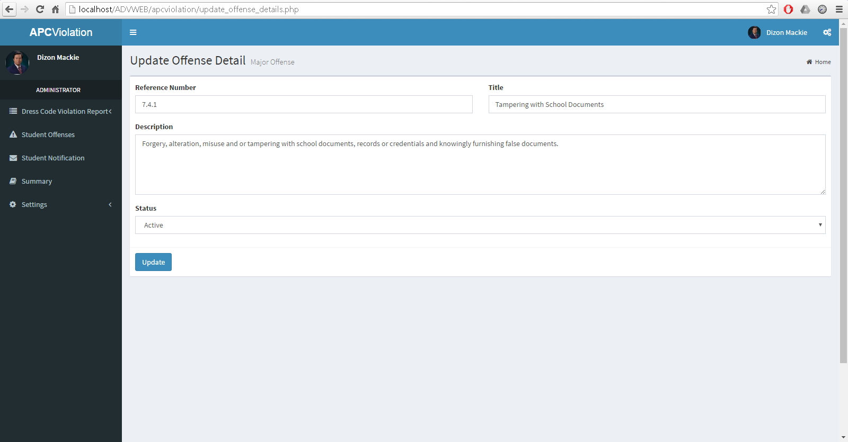

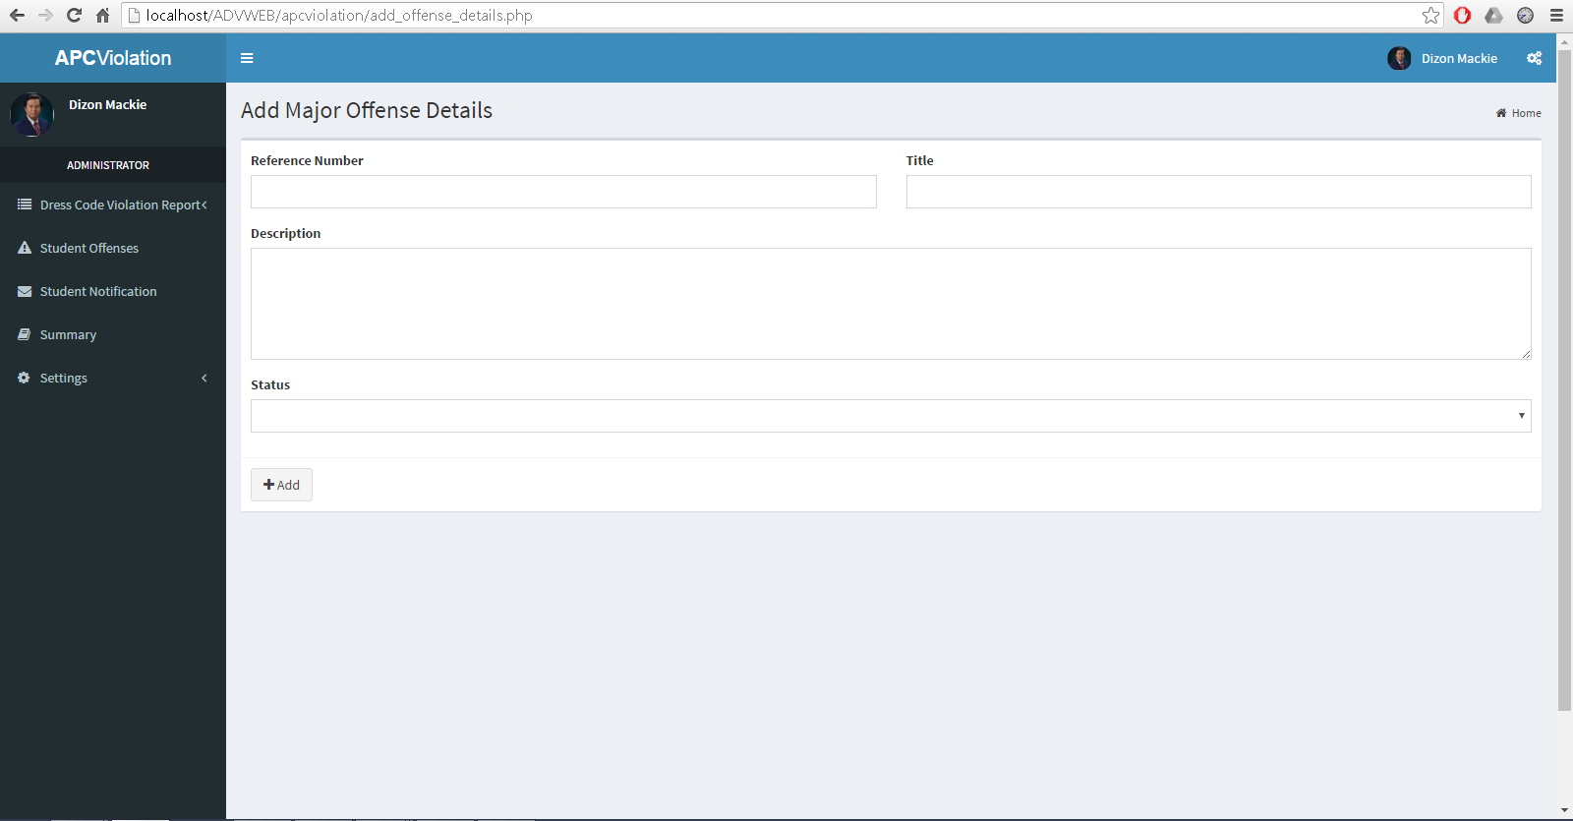**Admin page settings offense details update**

**Admin page offense details creation form**

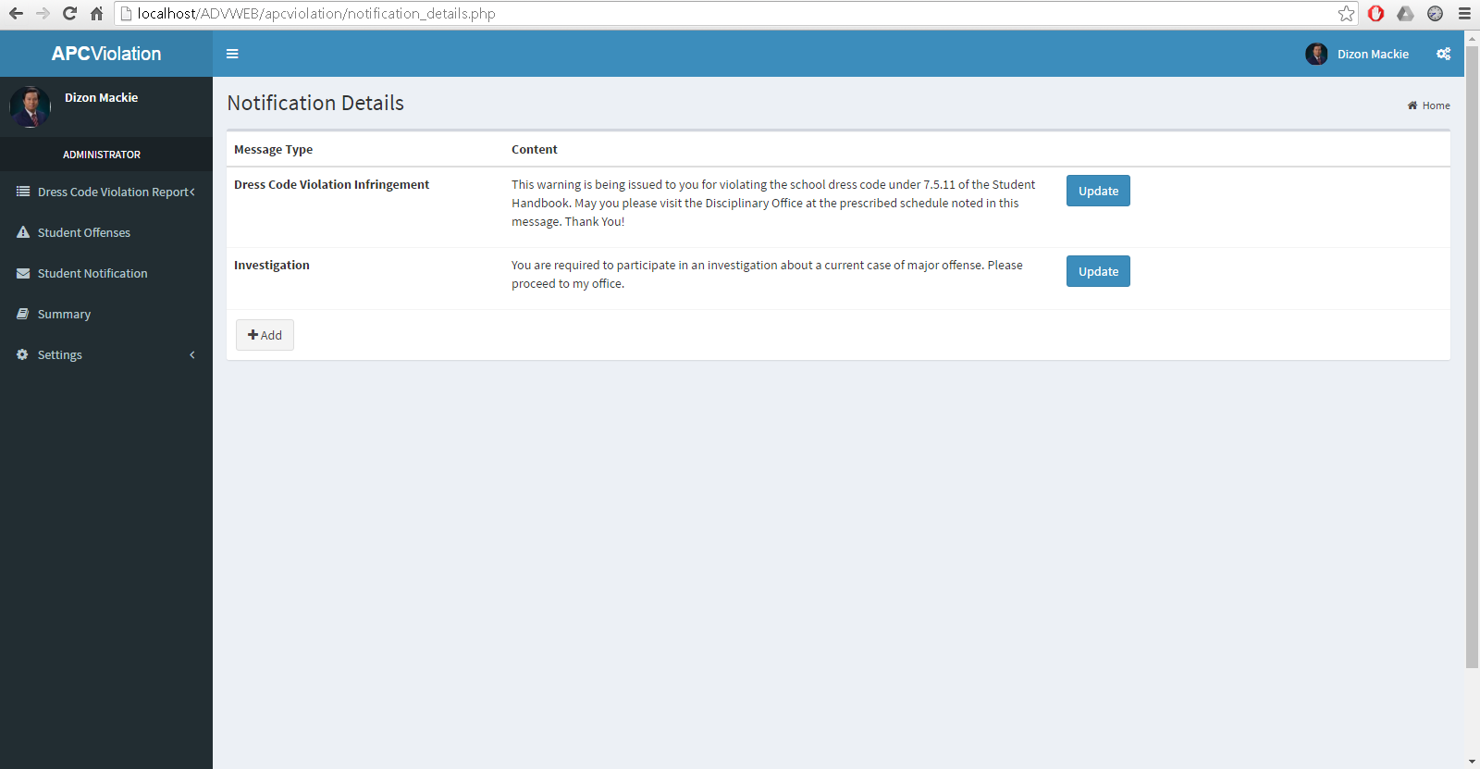

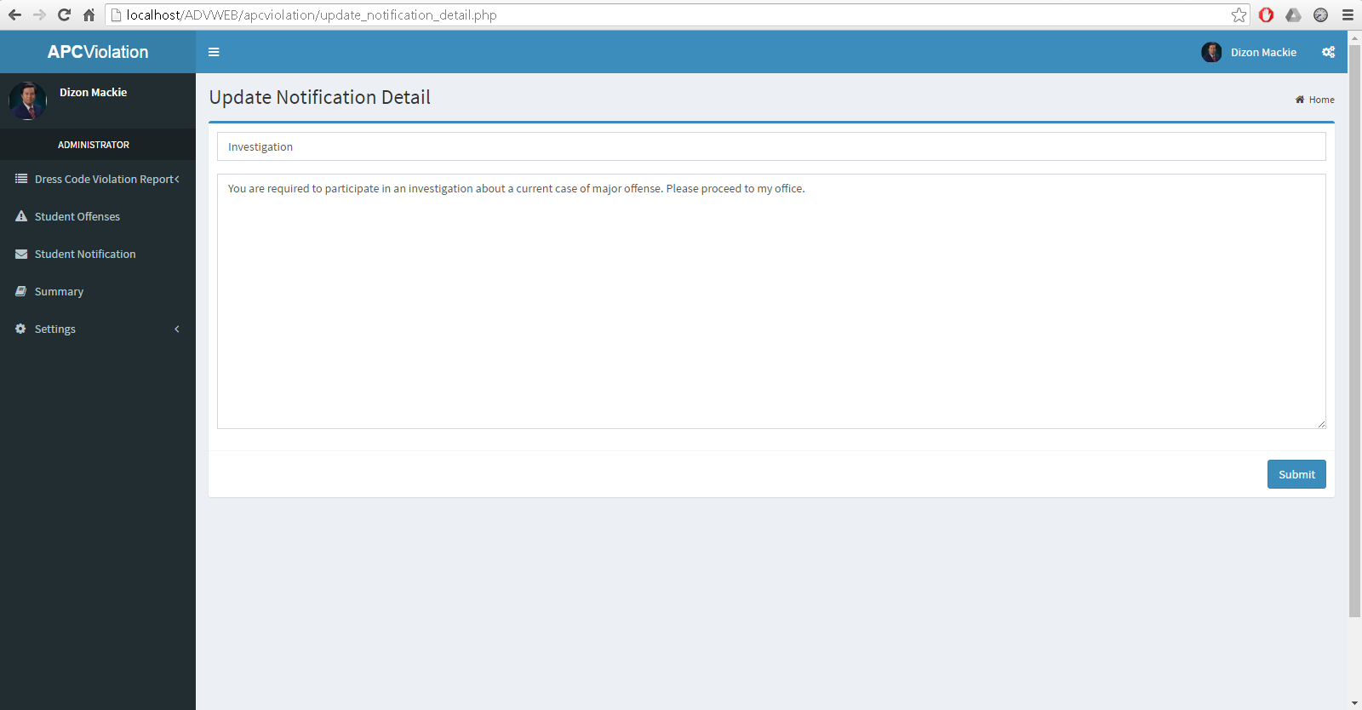**Admin page notification details settings**

**Admin page update notification details**

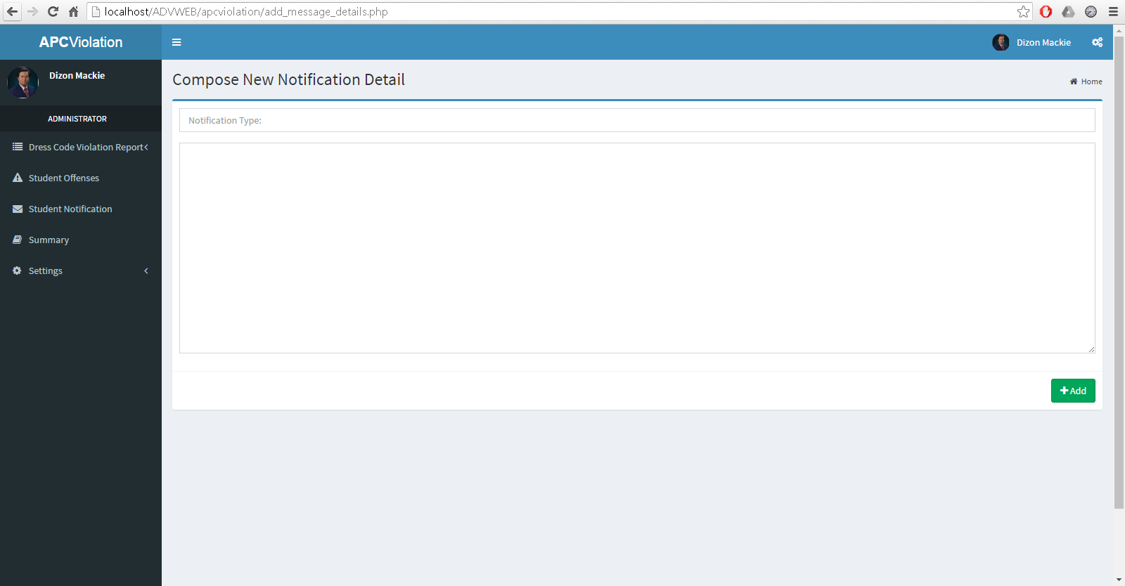

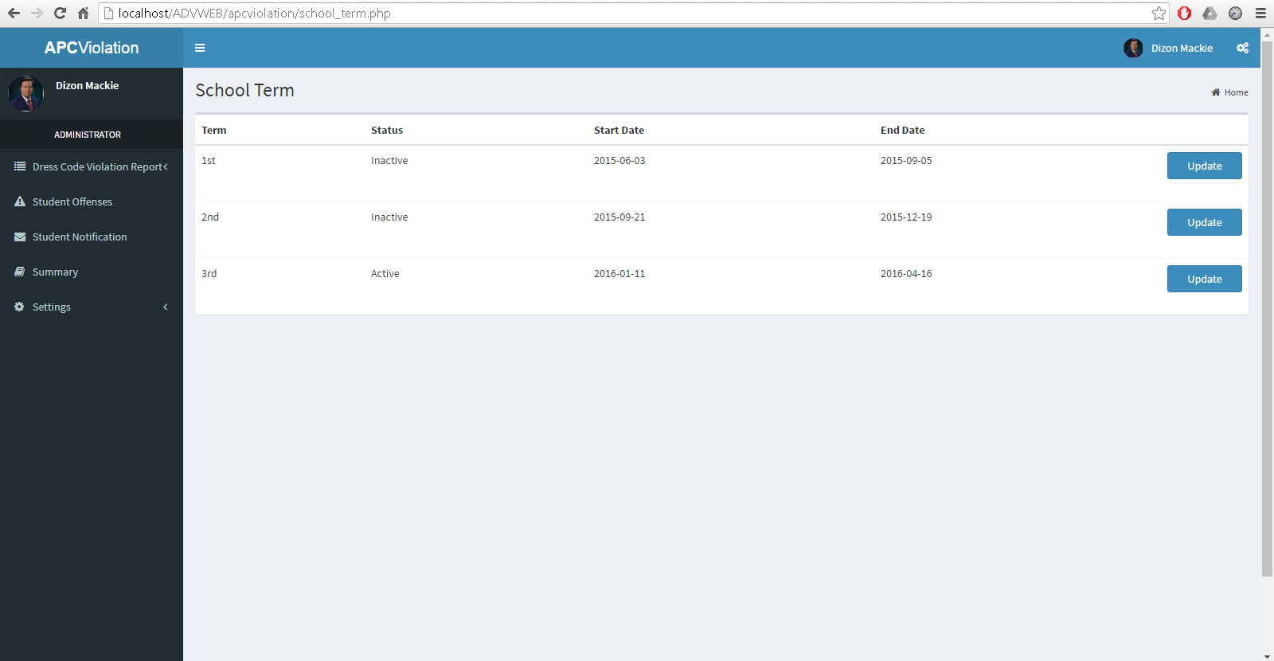**Admin page composition of new notification details**

**Admin page school term settings**

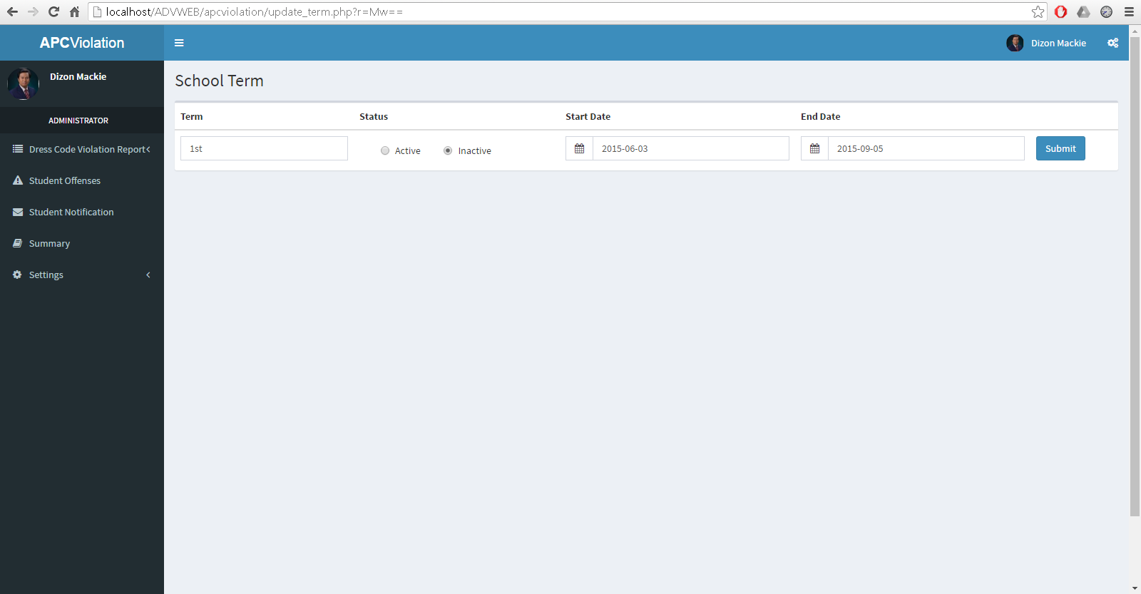

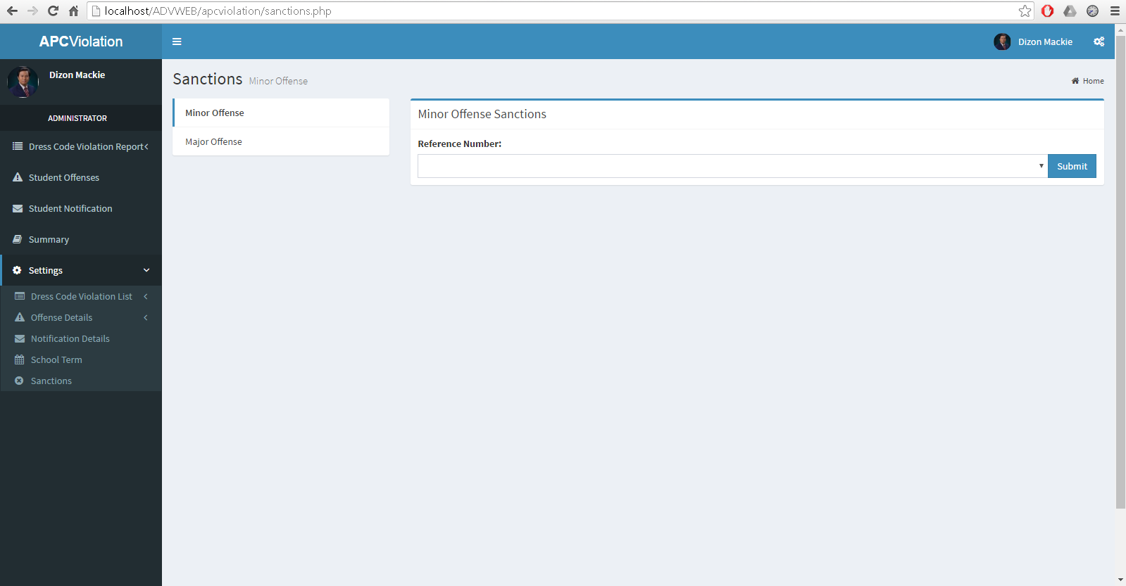**Admin page school term update**

**Admin page sanctions settings**

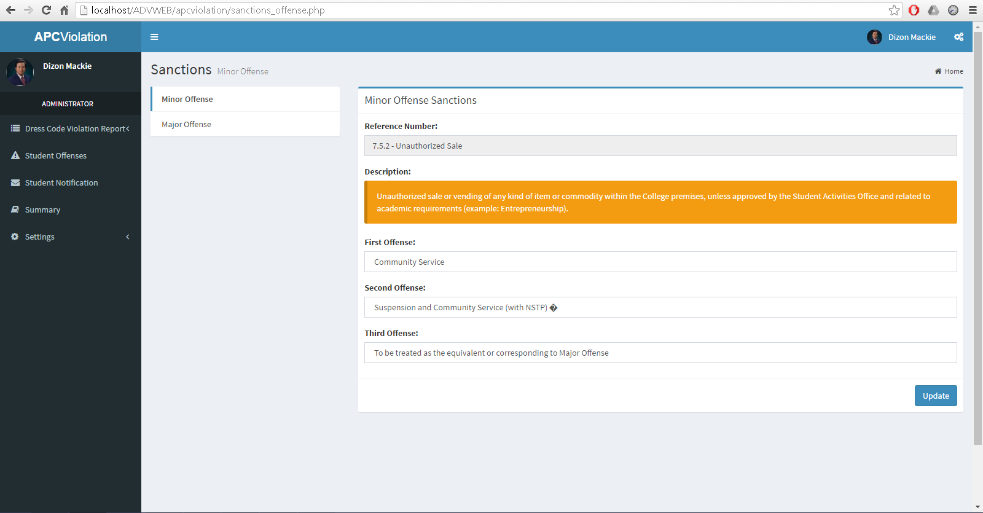

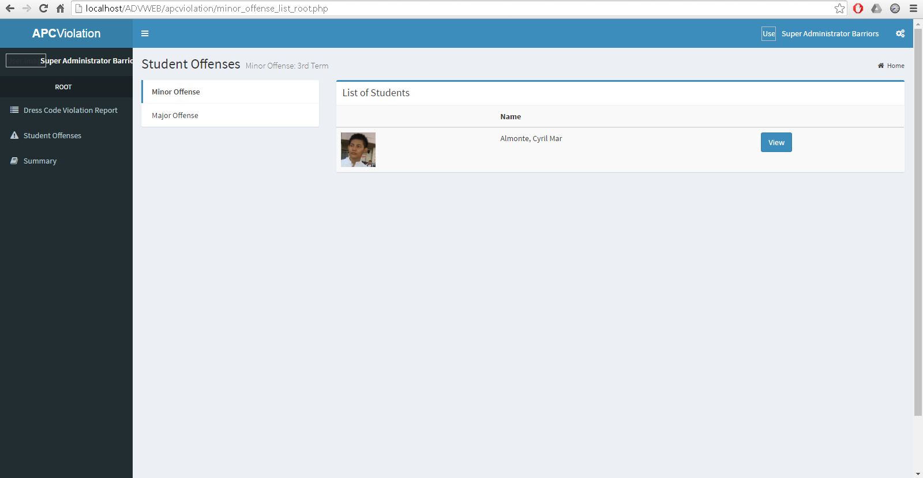**Admin page sanctions form settings**

**Director page violation reports**

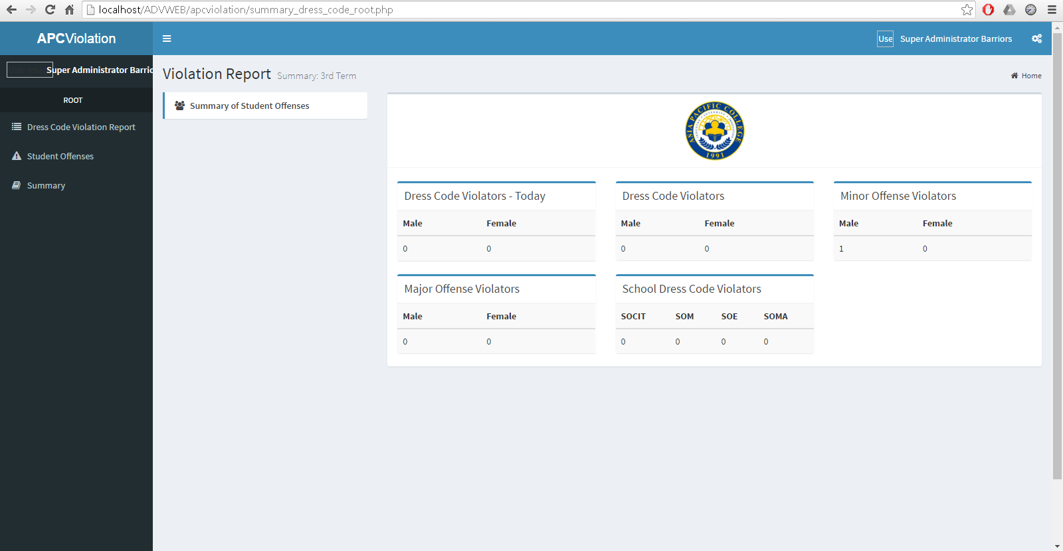

**Director page violations summary**

# Source code listing of each module

## Violation Module

**add_dresscode_violation.php**

<!-- This Page is/are for Administrator -->

<?php

require 'app/controller/init.php';

protect_page_profile_admin();

require 'app/controller/administrator/login-credential.php';

require 'app/view/administrator/overall-header.php';

?>

<!-- === Insert Administrator Content === -->

<?php

if (isset($_POST['btn_add_male'])) {

?>

<section class="content-header">

<h1>

Add Dress Code Violation Detail

<small>Male</small>

</h1>

</section>

<section class="content">

<div class="row">

<div class="col-xs-12">

<div class="box">

<!--

<div class="box-header">

<h3 class="box-title">Insert Title Here</h3>

<div class="box-tools">

<div class="input-group" style="width: 150px;">

<input type="text" name="table_search" class="form-control input-sm pull-right" placeholder="Search">

<div class="input-group-btn">

<button class="btn btn-sm btn-default"><i class="fa fa-search"></i></button>

</div>

</div>

</div>

</div>

-->

<div class="box-body table-responsive no-padding">

<table class="table table-hover">

<tr>

<th>List of Dress Code Violation</th>

<th>Active</th>

<th>Target Audience</th>

<th></th>

</tr>

<form action="male_dresscode_violation.php" method="POST">

<tbody>

<tr>

<td><input type="text" class="form-control" name="optname" autocomplete="off" /></td>

<td>

<div class="radio">

<label style="margin-left: 30px;"><input type="radio" name="optactive" value="YES">YES</label>

<label style="margin-left: 30px;"><input type="radio" name="optactive" value="NO" >NO</label>

</div>

</td>

<td>

<div class="radio">

<label style="margin-left: 30px;"><input type="radio" name="optgender" value="EVERYONE">EVERYONE</label>

<label style="margin-left: 30px;"><input type="radio" name="optgender" value="MALE" >MALE</label>

</div>

</td>

<td><button type="submit" name="add_violation_code_male" class="btn btn-primary">Submit</button></td>

</tr>

</tbody>

</form>

</table>

</div>

</div>

</div>

</div>

</section>

<?php

} elseif (isset($_POST['btn_add_female'])) {

?>

<section class="content-header">

<h1>

Add Dress Code Violation Detail

<small>Female</small>

</h1>

</section>

<section class="content">

<div class="row">

<div class="col-xs-12">

<div class="box">

<!--

<div class="box-header">

<h3 class="box-title">Insert Title Here</h3>

<div class="box-tools">

<div class="input-group" style="width: 150px;">

<input type="text" name="table_search" class="form-control input-sm pull-right" placeholder="Search">

<div class="input-group-btn">

<button class="btn btn-sm btn-default"><i class="fa fa-search"></i></button>

</div>

</div>

</div>

</div>

-->

<div class="box-body table-responsive no-padding">

<table class="table table-hover">

<tr>

<th>List of Dress Code Violation</th>

<th>Active</th>

<th>Target Audience</th>

<th></th>

</tr>

<form action="female_dresscode_violation.php" method="POST">

<tbody>

<tr>

<td><input type="text" class="form-control" name="optname" autocomplete="off" /></td>

<td>

<div class="radio">

<label style="margin-left: 30px;"><input type="radio" name="optactive" value="YES">YES</label>

<label style="margin-left: 30px;"><input type="radio" name="optactive" value="NO" >NO</label>

</div>

</td>

<td>

<div class="radio">

<label style="margin-left: 30px;"><input type="radio" name="optgender" value="EVERYONE">EVERYONE</label>

<label style="margin-left: 30px;"><input type="radio" name="optgender" value="FEMALE" >FEMALE</label>

</div>

</td>

<td><button type="submit" name="add_violation_code_male" class="btn btn-primary">Submit</button></td>

</tr>

</tbody>

</form>

</table>

</div>

</div>

</div>

</div>

</section>

<?php

}

?>

<!-- === [= NOTHING FOLLOWS =] === -->

<?php

require 'app/view/administrator/overall-footer.php';

?>

**add_message_details.php**

<!-- This Page is/are for Administrator -->

<?php

require 'app/controller/init.php';

protect_page_profile_admin();

require 'app/controller/administrator/login-credential.php';

require 'app/view/administrator/overall-header.php';

?>

<!-- === Insert Administrator Content === -->

<section class="content-header">

<h1>

Compose New Notification Detail

</h1>

<ol class="breadcrumb">

<li><a href="admin.php"><i class="fa fa-home"></i>Home</a></li>

</ol>

</section>

<section class="content">

<form action="notification_details.php" method="POST">

<div class="box box-primary">

<div class="box-body">

<div class="form-group">

<input class="form-control" name="notification_input" placeholder="Notification Type:" autocomplete="off">

</div>

<div class="form-group">

<textarea id="compose-textarea" name="notification_content" class="form-control" autocomplete="off" style="height: 300px"></textarea>

</div>

</div><!-- /.box-body -->

<div class="box-footer">

<div class="pull-right">

<button type="submit" name="btn_add" class="btn btn-success"><i class="fa fa-plus"></i> Add</button>

</div>

</div><!-- /.box-footer -->

</div><!-- /. box -->

</form>

</section>

<!-- === [= NOTHING FOLLOWS =] === -->

<?php

require 'app/view/administrator/overall-footer.php';

?>

**add_offense_details.php**

<!-- This Page is/are for Administrator -->

<?php

require 'app/controller/init.php';

protect_page_profile_admin();

require 'app/controller/administrator/login-credential.php';

require 'app/view/administrator/overall-header.php';

?>

<!-- === Insert Administrator Content === -->

<?php

if (isset($_POST['btn_add_minor'])) {

?>

<section class="content-header">

<h1>

Add Minor Offense Details

</h1>

<ol class="breadcrumb">

<li><a href="admin.php"><i class="fa fa-home"></i>Home</a></li>

</ol>

</section>

<form action="minor_offense.php" method="POST">

<section class="content">

<div class="box box-default">

<div class="box-body">

<div class="row">

<div class="col-md-6">

<div class="form-group">

<label>Reference Number</label>

<input name="ref_number" type="text" class="form-control" autocomplete="off">

</div><!-- /.form-group -->

</div>

<div class="col-md-6">

<div class="form-group">

<label>Title</label>

<input name="title" type="text" class="form-control" autocomplete="off">

</div><!-- /.form-group -->

</div>

<div class="col-md-12">

<div class="form-group">

<label>Description</label>

<textarea name="description" class="form-control" rows="5"></textarea>

</div><!-- /.form-group -->

<div class="form-group">

<label>Status</label>

<select name="status" class="form-control">

<option value=""></option>

<option value="Active">Active</option>

<option value="Inactive">Inactive</option>

</select>

</div>

</div>

</div>

</div>

<div class="box-footer clearfix">

<button type="submit" name="btn_add_minor_offense" class="btn btn-default pull-left"><i class="fa fa-plus"></i> Add</button>

</div>

</div>

</section>

</form>

<?php

}

if (isset($_POST['btn_add_major'])) {

?>

<section class="content-header">

<h1>

Add Major Offense Details

</h1>

<ol class="breadcrumb">

<li><a href="admin.php"><i class="fa fa-home"></i>Home</a></li>

</ol>

</section>

<form action="major_offense.php" method="POST">

<section class="content">

<div class="box box-default">

<div class="box-body">

<div class="row">

<div class="col-md-6">

<div class="form-group">

<label>Reference Number</label>

<input name="ref_number" type="text" class="form-control" autocomplete="off">

</div><!-- /.form-group -->

</div>

<div class="col-md-6">

<div class="form-group">

<label>Title</label>

<input name="title" type="text" class="form-control" autocomplete="off">

</div><!-- /.form-group -->

</div>

<div class="col-md-12">

<div class="form-group">

<label>Description</label>

<textarea name="description" class="form-control" rows="5"></textarea>

</div><!-- /.form-group -->

<div class="form-group">

<label>Status</label>

<select name="status" class="form-control">

<option value=""></option>

<option value="Active">Active</option>

<option value="Inactive">Inactive</option>

</select>

</div>

</div>

</div>

</div>

<div class="box-footer clearfix">

<button type="submit" name="btn_add_major_offense" class="btn btn-default pull-left"><i class="fa fa-plus"></i> Add</button>

</div>

</div>

</section>

</form>

<?php

}

?>

<!-- === [= NOTHING FOLLOWS =] === -->

<?php

require 'app/view/administrator/overall-footer.php';

?>

**add_school_term.php**

<!-- This Page is/are for Administrator -->

<?php

require 'app/controller/init.php';

protect_page_profile_admin();

require 'app/controller/administrator/login-credential.php';

require 'app/view/administrator/select2-message.php';

?>

<!-- === Insert Administrator Content === -->

<section class="content-header">

<h1>

School Term

<small></small>

</h1>

</section>

<section class="content">

<div class="row">

<div class="col-xs-12">

<div class="box">

<!--

<div class="box-header">

<h3 class="box-title">Insert Title Here</h3>

<div class="box-tools">

<div class="input-group" style="width: 150px;">

<input type="text" name="table_search" class="form-control input-sm pull-right" placeholder="Search">

<div class="input-group-btn">

<button class="btn btn-sm btn-default"><i class="fa fa-search"></i></button>

</div>

</div>

</div>

</div>

-->

<div class="box-body table-responsive no-padding">

<table class="table table-hover">

<tr>

<th>Term</th>

<th>Status</th>

<th>Start Date</th>

<th>End Date</th>

<th></th>

</tr>

<form action="school_term.php" method="POST">

<tbody>

<tr>

<td><input type="text" class="form-control" name="name_term" autocomplete="off" /></td>

<td>

<div class="radio">

<label style="margin-left: 30px;"><input type="radio" name="optactive" value="Active">Active</label>

<label style="margin-left: 30px;"><input type="radio" name="optactive" value="Inactive" >Inactive</label>

</div>

</td>

<td class="col-md-3">

<div class="input-group">

<div class="input-group-addon">

<i class="fa fa-calendar"></i>

</div>

<input type="text" class="form-control" name="start_date" data-inputmask="'alias': 'yyyy-mm-dd'" data-mask>

</div><!-- /.input group -->

</td>

<td class="col-md-3">

<div class="input-group">

<div class="input-group-addon">

<i class="fa fa-calendar"></i>

</div>

<input type="text" class="form-control" name="end_date" data-inputmask="'alias': 'yyyy-mm-dd'" data-mask>

</div><!-- /.input group -->

</td>

<td><button type="submit" name="add_term" class="btn btn-primary">Submit</button></td>

</tr>

</tbody>

</form>

</table>

</div>

</div>

</div>

</div>

</section>

<!-- === [= NOTHING FOLLOWS =] === -->

<?php

require 'app/view/administrator/select2-footer.php';

?>

**admin.php**

<!-- This Page is/are for Administrator -->

<?php

require 'app/controller/init.php';

protect_page_profile_admin();

require 'app/controller/administrator/login-credential.php';

require 'app/view/administrator/overall-header.php';

?>

<!-- === Insert Administrator Content === -->

<section class="content-header">

</section>

<section class="content">

</section>

<!-- === [= NOTHING FOLLOWS =] === -->

<?php

require 'app/view/administrator/overall-footer.php';

?>

**appeal.php**

<!-- This Page is/are for Students -->

<?php

require 'app/controller/init.php';

protect_page_profile();

require 'app/controller/student/login_credential.php';

require 'app/view/student/overall-header.php';

?>

<!-- === Insert Student Content === -->

<section class="content-header">

<h1>Appeal Ticket</h1>

<ol class="breadcrumb">

<li><a href="index.php"><i class="fa fa-home"></i>Home</a></li>

</ol>

</section>

<?php

if (isset($_POST['btn_appeal'])) {

global $conn;

$id = $_POST['btn_appeal'];

$select = "SELECT violation_details.id,

violation_details.remarks,

DATE_FORMAT(violation_details.valid_date, '%a - %b %d, %Y - %h:%i %p') AS valid_date,

violation_details.violation_picture

FROM violation_details

WHERE violation_details.id = '$id'";

$result = $conn->query($select);

while ($row = $result->fetch_object()) {

$violation_details_remarks = $row->remarks;

$violation_details_valid_date = $row->valid_date;

$violation_details_id = $row->id;

}

?>

<section class="content">

<div class="row">

<div class="col-xs-12">

<div class="box">

<!--

<div class="box-header">

<h3 class="box-title">Insert Title Here</h3>

<div class="box-tools">

<div class="input-group" style="width: 150px;">

<input type="text" name="table_search" class="form-control input-sm pull-right" placeholder="Search">

<div class="input-group-btn">

<button class="btn btn-sm btn-default"><i class="fa fa-search"></i></button>

</div>

</div>

</div>

</div>

-->

<form method="POST" action="details.php">

<div class="box-body table-responsive no-padding">

<table class="table table-hover">

<tr>

<th>List of Violation</th>

<th>Remarks</th>

<th>Valid Thru</th>

<th>Appeal Statement</th>

<th></th>

</tr>

<tbody>

<tr>

<td><?php violation_of_student($id); ?></td>

<td><?php echo $violation_details_remarks ?></td>

<td><?php echo $violation_details_valid_date ?></td>

<td><textarea name="txt_area" rows="5" cols="40" style="resize: none"></textarea></td>

<td><button name="btn_submit" type="submit" value="<?php echo $violation_details_id; ?>" class="btn btn-primary">Submit</button></td>

</tr>

</tbody>

</table>

</div>

</form>

</div><!-- /.box-body -->

<?php

}

if (isset($_POST['btn_update'])) {

global $conn;

$update_ticket = $_POST['btn_update'];

$select = "SELECT violation_details.id AS vio_id,

violation_details.remarks,

DATE_FORMAT (violation_details.valid_date, '%a - %b %d, %Y - %h:%i %p') AS valid_date,

appeal_ticket.appeal_statement,

DATE_FORMAT (appeal_ticket.created_at, '%a - %b %d, %Y - %h:%i %p') AS created_at

FROM violation_details

LEFT JOIN appeal_ticket ON appeal_ticket.vio_id = violation_details.id

WHERE appeal_ticket.vio_id = '$update_ticket'";

$result = $conn->query($select);

while ($row = $result->fetch_object()) {

$id = $row->vio_id;

?>

<div class="box">

<form method="POST" action="details.php">

<div class="box-body table-responsive no-padding">

<table class="table">

<thead>

<tr>

<th>List of Violation</th>

<th>Remarks</th>

<th>Appeal Ticket Created</th>

<th>Valid Thru</th>

<th>Appeal Statement</th>

<th></th>

</tr>

</thead>

<tbody>

<tr>

<td><?php violation_of_student($id); ?></td>

<td style="width: 200px;"><?php echo $row->remarks ?></td>

<td><?php echo $row->created_at ?></td>

<td><?php echo $row->valid_date ?></td>

<td><textarea name="txt_area" rows="5" cols="40" style="resize: none"><?php echo $row->appeal_statement; ?></textarea></td>

<td><button name="btn_update_ticket" type="submit" value="<?php echo $row->vio_id; ?>" class="btn btn-primary">Submit</button></td>

</tr>

</tbody>

</table>

</div>

</form>

</div><!-- /.box-body -->

<?php

}

}

?>

</div><!-- /.box-body -->

</div><!-- /.box -->

</div>

</div>

</section>

<!-- === [= NOTHING FOLLOWS =] === -->

<?php

require 'app/view/student/overall-footer.php';

?>

**compose.php**

<!-- This Page is/are for Administrator -->

<?php

require 'app/controller/init.php';

protect_page_profile_admin();

require 'app/controller/administrator/login-credential.php';

require 'app/view/administrator/overall-header.php';

?>

<!-- === Insert Administrator Content === -->

<section class="content-header">

<h1>

Student Notification Mailbox

</h1>

<ol class="breadcrumb">

<li><a href="admin.php"><i class="fa fa-home"></i>Home</a></li>

</ol>

</section>

<section class="content">

<div class="row">

<div class="col-md-3">

<a href="student_notification.php" class="btn btn-primary btn-block margin-bottom">Back to Notification Mailbox</a>

<div class="box box-solid">

<div class="box-body no-padding">

<ul class="nav nav-pills nav-stacked">

<li><a href="student_notification.php"><i class="fa fa-envelope-o"></i> Sent</a></li>

<li><a href="inbox.php?r=inbox_details"><i class="fa fa-inbox"></i> Archieve</a></li>

</ul>

</div><!-- /.box-body -->

</div><!-- /. box -->

</div><!-- /.col -->

<div class="col-md-9">

<div class="box box-primary">

<div class="box-header with-border">

<h3 class="box-title">Compose New Message</h3>

</div><!-- /.box-header -->

<div class="box-body">

<label>Subject:</label>

<form action="compose_details.php" method="POST">

<div class="input-group input-group">

<select name="message_type" class="form-control">

<option></option>

<?php

global $conn;

$select = "SELECT id, message_type from message";

$result = $conn->query($select);

while ($row = $result->fetch_object()) {

?>

<option value="<?php echo $row->id; ?>"><?php echo $row->message_type; ?></option>

<?php

}

?>

</select>

<span class="input-group-btn">

<button name="btn_submit" class="btn btn-primary btn-flat" type="submit">Submit</button>

</span>

</div>

</form>

</div><!-- /.box-body -->

</div><!-- /.col -->

</div><!-- /.col -->

</div><!-- /.row -->

</section><!-- /.content -->

<!-- === [= NOTHING FOLLOWS =] === -->

<?php

require 'app/view/administrator/overall-footer.php';

?>

<?php

if (isset($_POST['send'])) {

$id = $_POST['message_id'];

$date = $_POST['btn_date'];

}

?>

**compose_details.php**

<!-- This Page is/are for Administrator -->

<?php

require 'app/controller/init.php';

protect_page_profile_admin();

require 'app/controller/administrator/login-credential.php';

if (isset($_POST['btn_submit'])) {

$id = $_POST['message_type'];

$select = "SELECT message_type, body from message where id = '$id'";

$result = $conn->query($select);

while ($row = $result->fetch_object()) {

$type = $row->message_type;

$body = $row->body;

}

}

require 'app/view/administrator/select2-message.php';

?>

<!-- Content Header (Page header) -->

<section class="content-header">

<h1>

Student Notification Mailbox

</h1>

<ol class="breadcrumb">

<li><a href="admin.php"><i class="fa fa-home"></i>Home</a></li>

</ol>

</section>

<!-- Main content -->

<section class="content">

<div class="row">

<div class="col-md-3">

<a href="student_notification.php" class="btn btn-primary btn-block margin-bottom">Back to Notification Mailbox</a>

<div class="box box-solid">

<div class="box-body no-padding">

<ul class="nav nav-pills nav-stacked">

<li><a href="student_notification.php"><i class="fa fa-envelope-o"></i> Sent</a></li>

<li><a href="inbox.php?r=inbox_details"><i class="fa fa-inbox"></i> Archieve</a></li>

</ul>

</div><!-- /.box-body -->

</div><!-- /. box -->

</div><!-- /.col -->

<div class="col-md-9">

<div class="box box-primary">

<div class="box-header with-border">

<h3 class="box-title">Compose New Message</h3>

</div><!-- /.box-header -->

<form action="student_notification.php" method="POST">

<div class="box-body">

<div class="form-group">

<label>To:</label>

<select name="message_id" class="form-control select2" style="width: 100%;">

<option></option>

<?php

global $conn;

$select = "SELECT id, last_name, first_name, middle_name from students";

$result = $conn->query($select);

while ($row = $result->fetch_object()) {

?>

<option value="<?php echo $row->id; ?>"><?php echo $row->last_name . ", " . $row->first_name . " " . $row->middle_name; ?></option>

<?php

}

?>

</select>

</div>

<div class="form-group">

<label>Message Type:</label>

<input class="form-control" disabled value="<?php echo $type; ?>">

</div>

<div class="form-group">

<label>Content:</label>

<textarea id="compose-textarea" class="form-control" style="height: 150px"><?php echo $body; ?></textarea>

</div>

<label>Schedule:</label>

<div class="input-group">

<div class="input-group-addon">

<i class="fa fa-calendar"></i>

</div>

<input name="btn_date" type="text" class="form-control pull-right" id="reservationtime">

</div><!-- /.input group -->

</div><!-- /.box-body -->

<div class="box-footer">

<div class="pull-right">

<button name="send" value="<?php echo $id; ?>" type="submit" class="btn btn-primary"><i class="fa fa-envelope-o"></i> Send</button>

</div>

</div><!-- /.box-footer -->

</form>

</div><!-- /. box -->

</div><!-- /.col -->

</div><!-- /.col -->

</section><!-- /.content -->

<?php

require 'app/view/administrator/select2-footer.php';

?>

**details.php**

<!-- This Page is/are for Students -->

<?php

require 'app/controller/init.php';

protect_page_profile();

require 'app/controller/student/login_credential.php';

require 'app/view/student/overall-header.php';

if (isset($_GET['r'])) {

$seen = 1;

seen_clicked_violation_pending($seen, $student_id);

}

?>

<!-- === Insert Student Content === -->

<section class="content-header">

<h1>Dresscode Violation Details</h1>

<ol class="breadcrumb">

<li><a href="index.php"><i class="fa fa-home"></i>Home</a></li>

</ol>

</section>

<!-- === Dresscode Violation Detail Content === -->

<section class="content">

<?php

if (isset($_POST['btn_submit'])) {

$comment = $_POST['txt_area'];

$vio_id = $_POST['btn_submit'];

appeal_ticket($vio_id, $comment);

?>

<div class="alert alert-warning alert-dismissable">

<button type="button" class="close" data-dismiss="alert" aria-hidden="true">&times;</button>

<h4><i class="icon fa fa-warning"></i> Appeal Ticket Created</h4>

<p>Your concerns will be further reviewed upon on by the Disciplinary Officer and please take note that you can only update this ticket <strong>once</strong>.</p>

</div>

<?php

} else if (isset($_POST['btn_update_ticket'])) {

$vio_id_update = $_POST['btn_update_ticket'];

$update_comment = $_POST['txt_area'];

update_appeal_ticket($vio_id_update, $update_comment);

?>

<div class="alert alert-success alert-dismissable">

<button type="button" class="close" data-dismiss="alert" aria-hidden="true">&times;</button>

<h4><i class="icon fa fa-check"></i> Appeal Ticket Updated</h4>

<p>Please wait for any further notification imposed by the Disciplinary Officer.</p>

</div>

<?php

}

?>

<div class="row">

<div class="col-xs-12">

<div class="box">

<!--

<div class="box-header">

<h3 class="box-title">Insert Title Here</h3>

<div class="box-tools">

<div class="input-group" style="width: 150px;">

<input type="text" name="table_search" class="form-control input-sm pull-right" placeholder="Search">

<div class="input-group-btn">

<button class="btn btn-sm btn-default"><i class="fa fa-search"></i></button>

</div>

</div>

</div>

</div>

-->

<form method="POST" action="appeal.php">

<div class="box-body table-responsive no-padding">

<?php

if (initialize_token() === TRUE) {

global $conn;

$student_id = $_SESSION['student_id'];

?>

<table class="table table-hover">

<tr>

<th></th>

<th>Disciplinary in Charge</th>

<th>Status</th>

<th>Date of Incident</th>

<th>Valid Thru</th>

<th></th>

</tr>

<?php

if (student_has_violation($student_id)) {

$select = "SELECT disciplinary_personnels.dp_id,

DATE_FORMAT(violation_details.valid_date, '%a - %b %d, %Y - %h:%i %p') AS valid_date,

violation_details.status,

violation_details.id,

DATE_FORMAT(violation_details.created_at, '%a - %b %d, %Y - %h:%i %p') AS created_at,

disciplinary_personnels.last_name,

disciplinary_personnels.first_name,

disciplinary_personnels.middle_name,

disciplinary_personnels.dp_picture

FROM disciplinary_personnels

LEFT JOIN violation_details

ON disciplinary_personnels.dp_id = violation_details.dp_id

WHERE violation_details.student_id = '$student_id' AND status = 'Pending'";

$result = $conn->query($select);

while ($row = $result->fetch_object()) {

$id = $row->id;

$status = $row->status;

?>

<tbody>

<tr>

<td><img src="<?php echo $row->dp_picture; ?>" width="60" height="60"></td>

<td><?php echo $row->last_name . ", " . $row->first_name . " " . $row->middle_name; ?></td>

<?php

if ($status == 'Violated') {

?>

<td><span class="label label-danger"><?php echo $status; ?></span></td>

<?php

} else if ($status == 'Excused') {

?>

<td><span class="label label-success"><?php echo $status; ?></span></td>

<?php

} else {

?>

<td><span class="label label-warning"><?php echo $status; ?></span></td>

<?php

}

?>

<td><?php echo $row->created_at; ?></td>

<td><?php echo $row->valid_date; ?></td>

<?php

$count = number_appeal_ticket($id);

$update_count = determine_update_ticket($id);

if ($count == 0 && $status == 'Pending') {

include 'app/view/widgets/buttons/button_appeal_ticket.php';

} else if ($count && $update_count) {

include 'app/view/widgets/buttons/danger_appeal_ticket.php';

} else if ($count == 1 && $status == 'Pending') {

include 'app/view/widgets/buttons/update_appeal_ticket.php';

} else if ($status == 'Excused' || $status == 'Violated') {

include 'app/view/widgets/buttons/danger_appeal_ticket.php';

}

?>

</tr>

</tbody>

<?php

}

}

}

?>

</table>

</form>

</div><!-- /.box-body -->

</div><!-- /.box -->

</div>

</div>

</section>

<!-- === Dresscode Violation Detail Content === -->

<!-- === [= NOTHING FOLLOWS =] === -->

<?php

require 'app/view/student/overall-footer.php'

?>

**dresscode_report.php**

<!-- This Page is/are for Administrator -->

<?php

require 'app/controller/init.php';

protect_page_profile_admin();

require 'app/controller/administrator/login-credential.php';

if (isset($_GET['r'])) {

global $conn;

$violation_id = base64_decode($_GET['r']);

status($violation_id);

require 'app/view/administrator/overall-header.php';

?>

<!-- === Insert Administrator Content === -->

<section class="content-header">

<h1>

Dress Code Violation Report

<small>Infringement of Dress Code</small>

</h1>

<ol class="breadcrumb">

<li><a href="admin.php"><i class="fa fa-home"></i>Home</a></li>

</ol>

</section>

<section class="content">

<?php

$select = "SELECT violation_details.id,

violation_details.remarks,

violation_details.status,

violation_details.violation_picture,

students.student_id,

students.last_name,

students.first_name,

students.middle_name,

students.id_picture,

appeal_ticket.appeal_statement

FROM violation_details

INNER JOIN students

ON students.student_id = violation_details.student_id

LEFT JOIN appeal_ticket

ON violation_details.id = appeal_ticket.vio_id

WHERE violation_details.id = $violation_id";

$result = $conn->query($select);

if ($result) {

while ($row = $result->fetch_object()) {

$id = $row->id;

$violation_picture = $row->violation_picture;

?>

<section class="content">

<div class="row">

<div class="box-body table-responsive no-padding">

<div class="box box-danger">

<div class="box-header">

<img src="<?php echo $row->id_picture; ?>" width="90" height="90">

<h3 class="box-title" style="margin-left: 2%;"><?php echo $row->last_name . ', ' . $row->first_name . ' ' . $row->middle_name; ?></h3>

</div>

<div class="box-body">

<div class="box-body table-responsive no-padding">

<table class="table table-hover">

<tr>

<th>List of Violations</th>

<th>Remarks</th>

<th>Appeal Statement</th>

<th>Status</th>

<th></th>

</tr>

<tbody>

<tr>

<td>

<?php

error_reporting(0);

violation_of_student($id);

?>

</td>

<td style="width: 400px;"><?php echo $row->remarks ?></td>

<td style="width: 200px;"><?php echo $row->appeal_statement ?></td>

<form action="process_dresscode.php?p=<?php echo base64_encode($row->first_name); ?>" method="POST">

<td>

<div class="radio">

<label><input type="radio" name="optradio" value="Violated" checked>Issue Dress Code Violation</label>

</div>

<div class="radio">

<label><input type="radio" name="optradio" value="Excused">Excused</label>

</div>

</td>

<td><button name="btn_submit" type="submit" value="<?php echo $row->id ?>" class="btn btn-primary">Submit</button></td>

</form>

</tr>

</tbody>

</table>

</div>

<?php

if ($violation_picture == Null) {

} else {

?>

<div class="panel panel-primary">

<!-- Default panel contents -->

<div class="panel-heading">Screenshot Violation</div>

<div class="panel-body">

<center>

<img src="<?php echo $violation_picture; ?>" height="250px" width="270px">

</center>

</div>

</div>

<?php

}

?>

</div>

</div>

</div>

</div>

<?php

}

}

}

?>

<!-- === [= NOTHING FOLLOWS =] === -->

<?php

require 'app/view/administrator/overall-footer.php';

?>

**dresscode_report_root.php**

<!-- This Page is/are for Administrator -->

<?php

require 'app/controller/init.php';

protect_page_profile_root();

require 'app/controller/root/login-credential-root.php';

if (isset($_GET['r'])) {

global $conn;

$violation_id = base64_decode($_GET['r']);

status_root($violation_id);

require 'app/view/root/overall-header.php';

?>

<!-- === Insert Administrator Content === -->

<section class="content-header">

<h1>

Dress Code Violation Report

<small>Infringement of Dress Code</small>

</h1>

<ol class="breadcrumb">

<li><a href="admin.php"><i class="fa fa-home"></i>Home</a></li>

</ol>

</section>

<section class="content">

<?php

$select = "SELECT violation_details.id,

violation_details.remarks,

violation_details.status,

violation_details.violation_picture,

students.student_id,

students.last_name,

students.first_name,

students.middle_name,

students.id_picture,

appeal_ticket.appeal_statement

FROM violation_details

INNER JOIN students

ON students.student_id = violation_details.student_id

LEFT JOIN appeal_ticket

ON violation_details.id = appeal_ticket.vio_id

WHERE violation_details.id = $violation_id";

$result = $conn->query($select);

if ($result) {

while ($row = $result->fetch_object()) {

$id = $row->id;

$violation_picture = $row->violation_picture;

?>

<section class="content">

<div class="row">

<div class="box-body table-responsive no-padding">

<div class="box box-danger">

<div class="box-header">

<img src="<?php echo $row->id_picture; ?>" width="90" height="90">

<h3 class="box-title" style="margin-left: 2%;"><?php echo $row->last_name . ', ' . $row->first_name . ' ' . $row->middle_name; ?></h3>

</div>

<div class="box-body">

<div class="box-body table-responsive no-padding">

<table class="table table-hover">

<tr>

<th>List of Violations</th>

<th>Remarks</th>

<th>Appeal Statement</th>

<th>Status</th>

</tr>

<tbody>

<tr>

<td>

<?php

error_reporting(0);

violation_of_student($id);

?>

</td>

<td style="width: 400px;"><?php echo $row->remarks ?></td>

<td style="width: 200px;"><?php echo $row->appeal_statement ?></td>

<td>

<?php

if ($row->status == 'Violated') {

?>

<small class="label label-danger"> Infringement of Dress Code</small>

<?php

} else {

?>

<small class="label label-success">Excused</small>

<?php

}

?>

</td>

</tr>

</tbody>

</table>

</div>

<?php

if ($violation_picture == Null) {

} else {

?>

<div class="panel panel-primary">

<!-- Default panel contents -->

<div class="panel-heading">Screenshot Violation</div>

<div class="panel-body">

<center>

<img src="<?php echo $violation_picture; ?>" height="250px" width="270px">

</center>

</div>

</div>

<?php

}

?>

</div>

</div>

</div>

</div>

<?php

}

}

}

?>

<!-- === [= NOTHING FOLLOWS =] === -->

<?php

require 'app/view/administrator/overall-footer.php';

?>

**excused.php**

<!-- This Page is/are for Students -->

<?php

require 'app/controller/init.php';

protect_page_profile();

require 'app/controller/student/login_credential.php';

require 'app/view/student/overall-header.php';

if (isset($_GET['r'])) {

$seen = 1;

seen_clicked_violation_excused($seen, $student_id);

}

?>

<!-- === Insert Student Content === -->

<section class="content-header">

<h1>Dresscode Violation Details</h1>

<ol class="breadcrumb">

<li><a href="index.php"><i class="fa fa-home"></i>Home</a></li>

</ol>

</section>

<!-- === Dresscode Violation Detail Content === -->

<section class="content">

<?php

if (isset($_POST['btn_submit'])) {

$comment = $_POST['txt_area'];

$vio_id = $_POST['btn_submit'];

appeal_ticket($vio_id, $comment);

?>

<div class="alert alert-warning alert-dismissable">

<button type="button" class="close" data-dismiss="alert" aria-hidden="true">&times;</button>

<h4><i class="icon fa fa-warning"></i> Appeal Ticket Created</h4>

<p>Your concerns will be further reviewed upon on by the Disciplinary Officer and please take note that you can only update this ticket <strong>once</strong>.</p>

</div>

<?php

} else if (isset($_POST['btn_update_ticket'])) {

$vio_id_update = $_POST['btn_update_ticket'];

$update_comment = $_POST['txt_area'];

update_appeal_ticket($vio_id_update, $update_comment);

?>

<div class="alert alert-success alert-dismissable">

<button type="button" class="close" data-dismiss="alert" aria-hidden="true">&times;</button>

<h4><i class="icon fa fa-check"></i> Appeal Ticket Updated</h4>

<p>Please wait for any further notification imposed by the Disciplinary Officer.</p>

</div>

<?php

}

?>

<div class="row">

<div class="col-xs-12">

<div class="box">

<!--

<div class="box-header">

<h3 class="box-title">Insert Title Here</h3>

<div class="box-tools">

<div class="input-group" style="width: 150px;">

<input type="text" name="table_search" class="form-control input-sm pull-right" placeholder="Search">

<div class="input-group-btn">

<button class="btn btn-sm btn-default"><i class="fa fa-search"></i></button>

</div>

</div>

</div>

</div>

-->

<form method="POST" action="appeal.php">

<div class="box-body table-responsive no-padding">

<?php

if (initialize_token() === TRUE) {

global $conn;

$student_id = $_SESSION['student_id'];

?>

<table class="table table-hover">

<tr>

<th></th>

<th>Disciplinary in Charge</th>

<th>Status</th>

<th>Date of Incident</th>

<th>Valid Thru</th>

<th></th>

</tr>

<?php

if (student_has_violation($student_id)) {

$select = "SELECT disciplinary_personnels.dp_id,

DATE_FORMAT(violation_details.valid_date, '%a - %b %d, %Y - %h:%i %p') AS valid_date,

violation_details.status,

violation_details.id,

DATE_FORMAT(violation_details.created_at, '%a - %b %d, %Y - %h:%i %p') AS created_at,

disciplinary_personnels.last_name,

disciplinary_personnels.first_name,

disciplinary_personnels.middle_name,

disciplinary_personnels.dp_picture

FROM disciplinary_personnels

LEFT JOIN violation_details

ON disciplinary_personnels.dp_id = violation_details.dp_id

WHERE violation_details.student_id = '$student_id' and status = 'Excused'";

$result = $conn->query($select);

while ($row = $result->fetch_object()) {

$id = $row->id;

$status = $row->status;

?>

<tbody>

<tr>

<td><img src="<?php echo $row->dp_picture; ?>" width="60" height="60"></td>

<td><?php echo $row->last_name . ", " . $row->first_name . " " . $row->middle_name; ?></td>

<?php

if ($status == 'Violated') {

?>

<td><span class="label label-danger"><?php echo $status; ?></span></td>

<?php

} else if ($status == 'Excused') {

?>

<td><span class="label label-success"><?php echo $status; ?></span></td>

<?php

} else {

?>

<td><span class="label label-warning"><?php echo $status; ?></span></td>

<?php

}

?>

<td><?php echo $row->created_at; ?></td>

<td><?php echo $row->valid_date; ?></td>

<?php

$count = number_appeal_ticket($id);

$update_count = determine_update_ticket($id);

if ($count == 0 && $status == 'Pending') {

include 'app/view/widgets/buttons/button_appeal_ticket.php';

} else if ($count && $update_count) {

include 'app/view/widgets/buttons/danger_appeal_ticket.php';

} else if ($count == 1 && $status == 'Pending') {

include 'app/view/widgets/buttons/update_appeal_ticket.php';

} else if ($status == 'Excused' || $status == 'Violated') {

include 'app/view/widgets/buttons/danger_appeal_ticket.php';

}

?>

</tr>

</tbody>

<?php

}

}

}

?>

</table>

</form>

</div><!-- /.box-body -->

</div><!-- /.box -->

</div>

</div>

</section>

<!-- === Dresscode Violation Detail Content === -->

<!-- === [= NOTHING FOLLOWS =] === -->

<?php

require 'app/view/student/overall-footer.php'

?>

**female_dresscode_violation.php**

<!-- This Page is/are for Administrator -->

<?php

require 'app/controller/init.php';

protect_page_profile_admin();

require 'app/controller/administrator/login-credential.php';

require 'app/view/administrator/overall-header.php';

update_violation_list_male();

add_violation_list_male();

?>

<!-- === Insert Administrator Content === -->

<section class="content-header">

<h1>

List of Dress Code Violation

<small>Female</small>

</h1>

<ol class="breadcrumb">

<li><a href="admin.php"><i class="fa fa-home"></i>Home</a></li>

</ol>

</section>

<section class="content">

<?php

if (isset($_POST['submit_violation_list'])) {

$vio_name = $_POST['optname'];

?>

<div class="alert alert-success alert-dismissable">

<button type="button" class="close" data-dismiss="alert" aria-hidden="true">&times;</button>

<p><i class="icon fa fa-check"></i> The Dress Code Violation detail has been updated.</p>

</div>

<?php

} else if (isset($_POST['add_violation_code_male'])) {

$vio_name = $_POST['optname'];

?>

<div class="alert alert-success alert-dismissable">

<button type="button" class="close" data-dismiss="alert" aria-hidden="true">&times;</button>

<p><i class="icon fa fa-list-alt"></i> <?php echo $vio_name; ?> has been added to the Lists of Dress Code Violation.</p>

</div>

<?php

}

?>

<div class="row">

<div class="col-xs-12">

<div class="box">

<!--

<div class="box-header">

<h3 class="box-title">Insert Title Here</h3>

<div class="box-tools">

<div class="input-group" style="width: 150px;">

<input type="text" name="table_search" class="form-control input-sm pull-right" placeholder="Search">

<div class="input-group-btn">

<button class="btn btn-sm btn-default"><i class="fa fa-search"></i></button>

</div>

</div>

</div>

</div>

-->

<form action="update_dresscode_violation.php" method="POST">

<div class="box-body table-responsive no-padding">

<table class="table table-hover">

<tr>

<th>List of Dress Code Violations</th>

<th>Active</th>

<th>Target Audience</th>

<th></th>

</tr>

<tbody>

<?php

global $conn;

$select = "SELECT name, active, gender, violation_code from violation_code where gender = 'FEMALE' or gender = 'EVERYONE' order by active asc, gender asc";

$result = $conn->query($select);

while ($row = $result->fetch_object()) {

if ($row->gender === 'FEMALE' or $row->gender === 'EVERYONE') {

?><tr>

<td><label><?php echo $violation_name = $row->name; ?></label></td>

<td><p><?php echo $row->active; ?></p></td>

<td><?php echo $row->gender; ?></td>

<td><button type="submit" name="update_violation_list_female" value="<?php echo $row->violation_code ?>" class="btn btn-primary">Update</button></td>

<?php

}

?>

</tr>

<?php

}

?>

</tbody>

</table>

</div>

</form>

<form action="add_dresscode_violation.php" method="POST">

<div class="box-footer clearfix">

<button type="submit" name="btn_add_female" class="btn btn-default pull-left"><i class="fa fa-plus"></i> Add</button>

</div>

</form>

</div>

</div>

</div>

</section>

<!-- === [= NOTHING FOLLOWS =] === -->

<?php

require 'app/view/administrator/overall-footer.php';

?>

**inbox.php**

<!-- This Page is/are for Administrator -->

<?php

require 'app/controller/init.php';

protect_page_profile_admin();

require 'app/controller/administrator/login-credential.php';

require 'app/view/administrator/overall-header.php';

?>

<!-- === Insert Administrator Content === -->

<section class="content-header">

<h1>

Student Notification Mailbox

</h1>

<ol class="breadcrumb">

<li><a href="admin.php"><i class="fa fa-home"></i>Home</a></li>

</ol>

</section>

<section class="content">

<div class="row">

<div class="col-md-3">

<a href="compose.php" class="btn btn-primary btn-block margin-bottom">Compose</a>

<div class="box box-solid">

<div class="box-body no-padding">

<ul class="nav nav-pills nav-stacked">

<li><a href="student_notification.php"><i class="fa fa-envelope-o"></i> Sent</a></li>

<li class="active"><a href="inbox.php"><i class="fa fa-inbox"></i> Archive</a></li>

</ul>

</div><!-- /.box-body -->

</div><!-- /. box -->

</div><!-- /.col -->

<div class="col-md-9">

<div class="box box-primary">

<div class="box-header with-border">

<h3 class="box-title">Archive</h3>

<div class="box-tools pull-right">

</div><!-- /.box-tools -->

</div><!-- /.box-header -->

<div class="box-body no-padding">

<form action="inbox_resend.php" method="POST">

<div class="table-responsive mailbox-messages">

<table class="table table-hover table-striped">

<tr>

<th></th>

<th>Name</th>

<th>Subject</th>

<th></th>

<th></th>

</tr>

<tbody>

<?php archive_notification_of_student(); ?>

</tbody>

</table><!-- /.table -->

</div><!-- /.mail-box-messages -->

</form>

</div><!-- /.box-body -->

<div class="box-footer no-padding">

</div>

</div><!-- /. box -->

</div><!-- /.col -->

</div><!-- /.row -->

</section><!-- /.content -->

<!-- === [= NOTHING FOLLOWS =] === -->

<?php

require 'app/view/administrator/overall-footer.php';

?>

**inbox_resend.php**

<!-- This Page is/are for Administrator -->

<?php

require 'app/controller/init.php';

protect_page_profile_admin();

require 'app/controller/administrator/login-credential.php';

require 'app/view/handler/redirection/_case_closed_notification.php';

if (isset($_POST['btn_reschedule'])) {

$id = $_POST['btn_reschedule'];

$select = "SELECT message.message_type,

message.body

FROM message_details

LEFT JOIN message

ON message_details.message_id = message.id

WHERE message_details.id = $id";

$result = $conn->query($select);

while ($row = $result->fetch_object()) {

$type = $row->message_type;

$body = $row->body;

}

}

require 'app/view/administrator/select2-message.php';

?>

<!-- === Insert Administrator Content === -->

<section class="content-header">

<h1>

Student Notification Mailbox

</h1>

<ol class="breadcrumb">

<li><a href="admin.php"><i class="fa fa-home"></i>Home</a></li>

</ol>

</section>

<section class="content">

<div class="row">

<div class="col-md-3">

<a href="compose.php" class="btn btn-primary btn-block margin-bottom">Compose</a>

<div class="box box-solid">

<div class="box-body no-padding">

<ul class="nav nav-pills nav-stacked">

<li><a href="student_notification.php"><i class="fa fa-envelope-o"></i> Sent</a></li>

<li class="active"><a href="inbox.php"><i class="fa fa-inbox"></i> Archive</a></li>

</ul>

</div><!-- /.box-body -->

</div><!-- /. box -->

</div><!-- /.col -->

<div class="col-md-9">

<div class="box box-primary">

<div class="box-header with-border">

<h3 class="box-title">Reschedule Meeting</h3>

</div><!-- /.box-header -->

<form action="student_notification.php" method="POST">

<div class="box-body">

<div class="form-group">

<label>Message Type:</label>

<input class="form-control" disabled value="<?php echo $type; ?>">

</div>

<div class="form-group">

<label>Content:</label>

<textarea id="compose-textarea" class="form-control" style="height: 150px"><?php echo $body; ?></textarea>

</div>

<label>Schedule:</label>

<div class="input-group">

<div class="input-group-addon">

<i class="fa fa-calendar"></i>

</div>

<input name="reschedule_date" type="text" class="form-control pull-right" id="reservationtime">

</div><!-- /.input group -->

</div><!-- /.box-body -->

<div class="box-footer">

<div class="pull-right">

<button name="btn_reschedule" value="<?php echo $id; ?>" type="submit" class="btn btn-primary"> Reschedule</button>

</div>

</div><!-- /.box-footer -->

</form>

</div><!-- /. box -->

</div><!-- /.col -->

</div><!-- /.row -->

</section><!-- /.content -->

<!-- === [= NOTHING FOLLOWS =] === -->

<?php

require 'app/view/administrator/select2-footer.php';

?>

**major_offense.php**

<!-- This Page is/are for Administrator -->

<?php

require 'app/controller/init.php';

protect_page_profile_admin();

require 'app/controller/administrator/login-credential.php';

require 'app/view/administrator/overall-header.php';

create_major_offense();

update_major_offense();

?>

<!-- === Insert Administrator Content === -->

<section class="content-header">

<h1>

List of Offense

<small>Major Offense</small>

</h1>

<ol class="breadcrumb">

<li><a href="admin.php"><i class="fa fa-home"></i>Home</a></li>

</ol>

</section>

<section class="content">

<?php

if (isset($_POST['update_major_offense'])) {

?>

<div class="alert alert-success alert-dismissable">

<button type="button" class="close" data-dismiss="alert" aria-hidden="true">&times;</button>

<p><i class="icon fa fa-check"></i> Major Offense Detail Updated</p>

</div>

<?php

}

?>

<?php

if (isset($_POST['btn_add_major_offense'])) {

$ref_number = $_POST['ref_number'];

$title = $_POST['title'];

?>

<div class="alert alert-success alert-dismissable">

<button type="button" class="close" data-dismiss="alert" aria-hidden="true">&times;</button>

<p><i class="icon fa fa-check"></i> Major Offense Detail Added:</p>

<ul>

<li>Reference Number: <?php echo $ref_number; ?></li>

<li>Title: <?php echo $title; ?></li>

</ul>

</div>

<?php

}

?>

<div class="row">

<div class="col-xs-12">

<div class="box">

<!--

<div class="box-header">

<h3 class="box-title">Insert Title Here</h3>

<div class="box-tools">

<div class="input-group" style="width: 150px;">

<input type="text" name="table_search" class="form-control input-sm pull-right" placeholder="Search">

<div class="input-group-btn">

<button class="btn btn-sm btn-default"><i class="fa fa-search"></i></button>

</div>

</div>

</div>

</div>

-->

<form action="update_offense_details.php" method="POST">

<div class="box-body table-responsive no-padding">

<table class="table table-hover">

<tr>

<th>Reference Number</th>

<th>Title</th>

<th>Description</th>

<th>Status</th>

<th></th>

</tr>

<tbody>

<?php

global $conn;

$select = "SELECT id, reference_number, description, title, status from offense_details where type = 'Major Offense'";

$result = $conn->query($select);

while ($row = $result->fetch_object()) {

if ($row->type = "Major Offense") {

?><tr>

<td style="width: 200px;"><label><?php echo $row->reference_number; ?></label></td>

<td style="width: 200px;"><p><?php echo $row->title; ?></p></td>

<td style="width: 500px;"><?php echo $row->description; ?></td>

<td style="width: 100px;"><?php echo $row->status; ?></td>

<td style="width: 150px;"><button type="submit" name="update_majors_offense" value="<?php echo $row->id ?>" class="btn btn-primary">Update</button></td>

<?php

}

?>

</tr>

<?php

}

?>

</tbody>

</table>

</div>

</form>

<form action="add_offense_details.php" method="POST">

<div class="box-footer clearfix">

<button type="submit" name="btn_add_major" class="btn btn-default pull-left"><i class="fa fa-plus"></i> Add</button>

</div>

</form>

</div>

</div>

</div>

</section>

<!-- === [= NOTHING FOLLOWS =] === -->

<?php

require 'app/view/administrator/overall-footer.php';

?>

**major_offense_list.php**

<!-- This Page is/are for Administrator -->

<?php

require 'app/controller/init.php';

protect_page_profile_admin();

require 'app/controller/administrator/login-credential.php';

// require 'app/view/handler/gateway/_offense_major.php';

if (isset($_POST['btn_major'])) {

$student_id = $_POST['btn_major'];

$incident_date = $_POST['incident_date'];

$report = $_POST['description'];

$status = $_POST['status'];

if (empty($incident_date) && empty($report) && empty($status)) {

header('Location: offense_report_major.php?r=' . base64_encode('incomplete_date_incident_and_report'));

} elseif (empty($incident_date)) {

header('Location: offense_report_major.php?r=' . base64_encode('incomplete_date_incident'));

} elseif (empty($report)) {

header('Location: offense_report_major.php?r=' . base64_encode('incomplete_report'));

} elseif (empty($status)) {

header('Location: offense_report_major.php?r=' . base64_encode('incomplete_status'));

} else {

$offense_details_id = $_SESSION['offense_details_id'];

$sanctions_minor_id = $_SESSION['sanctions_minor_id'];

$term = school_term_id();

$count = minor_offense_exists($student_id, $offense_details_id);

if ($count == '' && $status == 'Case Record') {

$offense_count = "-";

} elseif ($count == 'First Offense' && $status == 'Case Record') {

$offense_count = "-";

} elseif ($count == 'Second Offense' && $status == 'Case Record') {

$offense_count = "-";

}

if ($count == '' && $status == 'Issue') {

$offense_count = "First Offense";

} elseif ($count == 'First Offense' && $status == 'Issue') {

$offense_count = "Second Offense";

} elseif ($count == "Second Offense" && $status == 'Issue') {

$offense_count = "Third Offense";

}

create_major_offense_report($student_id, $incident_date, $report, $offense_details_id, $sanctions_minor_id, $term, $offense_count, $status);

}

}

require 'app/view/administrator/overall-header.php';

?>

<!-- === Insert Administrator Content === -->

<section class="content-header">

<h1>

Student Offenses

<small>Major Offense: <?php echo school_term() . " Term"; ?></small>

</h1>

<ol class="breadcrumb">

<li><a href="admin.php"><i class="fa fa-home"></i>Home</a></li>

</ol>

</section>

<section class="content">

<?php

// require 'app/view/handler/redirection/_major_notification.php';

if (isset($_GET['r'])) {

$decode = base64_decode($_GET['r']);

if ($decode == 'create_offense_success') {

?>

<div class="alert alert-success alert-dismissable">

<button type="button" class="close" data-dismiss="alert" aria-hidden="true">&times;</button>

<p><i class="icon fa fa-check"></i> Major Offense Report has been recorded.</p>

</div>

<?php

unset($_SESSION['student_name']);

}

}

if (isset($_GET['m'])) {

$decode = base64_decode($_GET['m']);

unset($_SESSION['student_name']);

if ($decode == 'maximum_capacity') {

?>

<div class="alert alert-danger alert-dismissable">

<button type="button" class="close" data-dismiss="alert" aria-hidden="true">&times;</button>

<p><i class="icon fa fa-warning"></i> The Student has already accumulated Three Major Offenses.</p>

</div>

<?php

}

}

?>

<div class="row">

<div class="col-md-3">

<a href="major_offense_report.php" class="btn btn-primary btn-block margin-bottom">Major Offense Report</a>

<div class="box box-solid">

<div class="box-body no-padding">

<ul class="nav nav-pills nav-stacked">

<li><a href="minor_offense_list.php"> Minor Offense</a></li>

<li class="active"><a href="major_offense_list.php"> Major Offense</a></li>

</ul>

</div><!-- /.box-body -->

</div><!-- /. box -->

</div><!-- /.col -->

<div class="col-md-9">

<div class="box box-primary">

<div class="box-header with-border">

<h3 class="box-title">List of Students</h3>

<div class="box-tools pull-right">

</div><!-- /.box-tools -->

</div><!-- /.box-header -->

<div class="box-body no-padding">

<div class="table-responsive mailbox-messages">

<table class="table table-hover table-striped">

<tr>

<th></th>

<th>Name</th>

<th></th>

</tr>

<tbody>

<?php student_has_major_offense(); ?>

</tbody>

</table><!-- /.table -->

</div><!-- /.mail-box-messages -->

</div><!-- /.box-body -->

<div class="box-footer no-padding">

</div>

</div><!-- /. box -->

</div><!-- /.col -->

</div><!-- /.row -->

</section><!-- /.content -->

<!-- === [= NOTHING FOLLOWS =] === -->

<?php

require 'app/view/administrator/overall-footer.php';

?>

**major_offense_list_root.php**

<!-- This Page is/are for Administrator -->

<?php

require 'app/controller/init.php';

protect_page_profile_root();

require 'app/controller/root/login-credential-root.php';

require 'app/view/root/overall-header.php';

?>

<!-- === Insert Administrator Content === -->

<section class="content-header">

<h1>

Student Offenses

<small>Major Offense: <?php echo school_term() . " Term"; ?></small>

</h1>

<ol class="breadcrumb">

<li><a href="admin.php"><i class="fa fa-home"></i>Home</a></li>

</ol>

</section>

<section class="content">

<div class="row">

<div class="col-md-3">

<div class="box box-solid">

<div class="box-body no-padding">

<ul class="nav nav-pills nav-stacked">

<li><a href="minor_offense_list_root.php"> Minor Offense</a></li>

<li class="active"><a href="major_offense_list_root.php"> Major Offense</a></li>

</ul>

</div><!-- /.box-body -->

</div><!-- /. box -->

</div><!-- /.col -->

<div class="col-md-9">

<div class="box box-primary">

<div class="box-header with-border">

<h3 class="box-title">List of Students</h3>

<div class="box-tools pull-right">

</div><!-- /.box-tools -->

</div><!-- /.box-header -->

<div class="box-body no-padding">

<div class="table-responsive mailbox-messages">

<table class="table table-hover table-striped">

<tr>

<th></th>

<th>Name</th>

<th></th>

</tr>

<tbody>

<?php student_has_major_offense_root(); ?>

</tbody>

</table><!-- /.table -->

</div><!-- /.mail-box-messages -->

</div><!-- /.box-body -->

<div class="box-footer no-padding">

</div>

</div><!-- /. box -->

</div><!-- /.col -->

</div><!-- /.row -->

</section><!-- /.content -->

<!-- === [= NOTHING FOLLOWS =] === -->

<?php

require 'app/view/administrator/overall-footer.php';

?>

**major_offense_report.php**

<!-- This Page is/are for Administrator -->

<?php

require 'app/controller/init.php';

protect_page_profile_admin();

require 'app/controller/administrator/login-credential.php';

require 'app/view/administrator/select2-message.php';

?>

<!-- === Insert Administrator Content === -->

<section class="content-header">

<h1>

Student Offenses

<small>Major Offense: <?php echo school_term() . " Term"; ?></small>

</h1>

<ol class="breadcrumb">

<li><a href="admin.php"><i class="fa fa-home"></i>Home</a></li>

</ol>

</section>

<section class="content">

<?php

require 'app/view/handler/gateway/_minor.php';

?>

<div class="row">

<div class="col-md-3">

<a href="major_offense_list.php" class="btn btn-primary btn-block margin-bottom">Back</a>

<div class="box box-solid">

<div class="box-body no-padding">

<ul class="nav nav-pills nav-stacked">

<li><a href="minor_offense_list.php"> Minor Offense</a></li>

<li class="active"><a href="major_offense_list.php"> Major Offense</a></li>

</ul>

</div><!-- /.box-body -->

</div><!-- /. box -->

</div><!-- /.col -->

<div class="col-md-9">

<div class="box box-primary">

<div class="box-header with-border">

<h3 class="box-title">Major Offense Report</h3>

</div><!-- /.box-header -->

<div class="box-body">

<form action="offense_report_major.php" method="POST">

<div class="form-group">

<label>Name of Student:</label>

<select name="student_name" class="form-control select2" style="width: 100%;">

<option></option>

<?php

global $conn;

$select = "SELECT id, last_name, first_name, middle_name from students";

$result = $conn->query($select);

while ($row = $result->fetch_object()) {

?>

<option value="<?php echo $row->id; ?>"><?php echo $row->last_name . ", " . $row->first_name . " " . $row->middle_name; ?></option>

<?php

}

?>

</select>

</div>

<div class="form-group">

<label>Reference Number: </label>

<select name="sanctions_minor" class="form-control">

<option></option>

<?php

global $conn;

$select = "SELECT id, reference_number, title FROM offense_details WHERE status = 'Active' AND type = 'Major Offense'";

$result = $conn->query($select);

while ($row = $result->fetch_object()) {

?>

<option value="<?php echo $row->id; ?>"><?php echo $row->reference_number . " - " . $row->title; ?></option>

<?php

}

?>

</select>

</div>

<div class="box-footer">

<button type="submit" name="major_submit" class="btn btn-primary pull-right">Submit</button>

</div>

</form>

</div><!-- /.box-body -->

</div><!-- /.col -->

</div><!-- /.col -->

</div><!-- /.row -->

</section><!-- /.content -->

<!-- === [= NOTHING FOLLOWS =] === -->

<?php

require 'app/view/administrator/select2-footer.php';

?>

**major_report_student.php**

<!-- This Page is/are for Administrator -->

<?php

require 'app/controller/init.php';

protect_page_profile_admin();

require 'app/controller/administrator/login-credential.php';

require 'app/view/administrator/overall-header.php';

?>

<!-- === Insert Administrator Content === -->

<section class="content-header">

<h1>

Student Offenses

<small>Major Offense: <?php echo school_term() . " Term"; ?></small>

</h1>

<ol class="breadcrumb">

<li><a href="admin.php"><i class="fa fa-home"></i>Home</a></li>

</ol>

</section>

<section class="content">

<?php

require 'app/view/handler/redirection/_minor_notification.php';

?>

<div class="row">

<div class="col-md-3">

<a href="major_offense_report.php" class="btn btn-primary btn-block margin-bottom">Major Offense Report</a>

<div class="box box-solid">

<div class="box-body no-padding">

<ul class="nav nav-pills nav-stacked">

<li><a href="minor_offense_list.php"> Minor Offense</a></li>

<li class="active"><a href="major_offense_list.php"> Major Offense</a></li>

</ul>

</div><!-- /.box-body -->

</div><!-- /. box -->

</div><!-- /.col -->

<?php

if (isset($_GET['r'])) {

global $conn;

$id = base64_decode($_GET['r']);

$select = "SELECT id_picture, last_name, first_name, middle_name From students where id = $id";

$query = $conn->query($select);

while ($row = $query->fetch_object()) {

$id_picture = $row->id_picture;

$last_name = $row->last_name;

$first_name = $row->first_name;

$middle_name = $row->middle_name;

}

}

?>

<div class="col-md-9">

<div class="box box-primary">

<div class="box-header with-border">

<img src="<?php echo $id_picture; ?>" width="90" height="90">

<h3 class="box-title" style="margin-left: 2%;"><?php echo $last_name . ", " . $first_name . " " . $middle_name; ?></h3>

<div class="box-tools pull-right">

</div><!-- /.box-tools -->

</div><!-- /.box-header -->

<div class="box-body no-padding">

<form action="student_major_report.php" method="POST">

<div class="table-responsive mailbox-messages">

<table class="table table-hover table-striped">

<tr>

<th>Major Offense Reference</th>

<th>Date of Incident</th>

<th>Number of Offense Committed</th>

<th></th>

</tr>

<tbody>

<?php relate_major_offense($id); ?>

</tbody>

</table><!-- /.table -->

</div><!-- /.mail-box-messages -->

</form>

</div><!-- /.box-body -->

<div class="box-footer no-padding">

</div>

</div><!-- /. box -->

</div><!-- /.col -->

</div><!-- /.row -->

</section><!-- /.content -->

<!-- === [= NOTHING FOLLOWS =] === -->

<?php

require 'app/view/administrator/overall-footer.php';

?>

**major_report_student_root.php**

<!-- This Page is/are for Administrator -->

<?php

require 'app/controller/init.php';

protect_page_profile_root();

require 'app/controller/root/login-credential-root.php';

require 'app/view/root/overall-header.php';

?>

<!-- === Insert Administrator Content === -->

<section class="content-header">

<h1>

Student Offenses

<small>Major Offense: <?php echo school_term() . " Term"; ?></small>

</h1>

<ol class="breadcrumb">

<li><a href="admin.php"><i class="fa fa-home"></i>Home</a></li>

</ol>

</section>

<section class="content">

<?php

require 'app/view/handler/redirection/_minor_notification.php';

?>

<div class="row">

<div class="col-md-3">

<div class="box box-solid">

<div class="box-body no-padding">

<ul class="nav nav-pills nav-stacked">

<li><a href="minor_offense_list_root.php"> Minor Offense</a></li>

<li class="active"><a href="major_offense_list_root.php"> Major Offense</a></li>

</ul>

</div><!-- /.box-body -->

</div><!-- /. box -->

</div><!-- /.col -->

<?php

if (isset($_GET['r'])) {

global $conn;

$id = base64_decode($_GET['r']);

$select = "SELECT id_picture, last_name, first_name, middle_name From students where id = $id";

$query = $conn->query($select);

while ($row = $query->fetch_object()) {

$id_picture = $row->id_picture;

$last_name = $row->last_name;

$first_name = $row->first_name;

$middle_name = $row->middle_name;

}

}

?>

<div class="col-md-9">

<div class="box box-primary">

<div class="box-header with-border">

<img src="<?php echo $id_picture; ?>" width="90" height="90">

<h3 class="box-title" style="margin-left: 2%;"><?php echo $last_name . ", " . $first_name . " " . $middle_name; ?></h3>

<div class="box-tools pull-right">

</div><!-- /.box-tools -->

</div><!-- /.box-header -->

<div class="box-body no-padding">

<form action="student_major_report.php" method="POST">

<div class="table-responsive mailbox-messages">

<table class="table table-hover table-striped">

<tr>

<th>Major Offense Reference</th>

<th>Date of Incident</th>

<th>Number of Offense Committed</th>

<th></th>

</tr>

<tbody>

<?php relate_major_offense_root($id); ?>

</tbody>

</table><!-- /.table -->

</div><!-- /.mail-box-messages -->

</form>

</div><!-- /.box-body -->

<div class="box-footer no-padding">

</div>

</div><!-- /. box -->

</div><!-- /.col -->

</div><!-- /.row -->

</section><!-- /.content -->

<!-- === [= NOTHING FOLLOWS =] === -->

<?php

require 'app/view/administrator/overall-footer.php';

?>

**male_dresscode_violation.php**

<!-- This Page is/are for Administrator -->

<?php

require 'app/controller/init.php';

protect_page_profile_admin();

require 'app/controller/administrator/login-credential.php';

require 'app/view/administrator/overall-header.php';

update_violation_list_male();

add_violation_list_male();

?>

<!-- === Insert Administrator Content === -->

<section class="content-header">

<h1>

List of Dress Code Violation

<small>Male</small>

</h1>

<ol class="breadcrumb">

<li><a href="admin.php"><i class="fa fa-home"></i>Home</a></li>

</ol>

</section>

<section class="content">

<?php

if (isset($_POST['submit_violation_list'])) {

$vio_name = $_POST['optname'];

?>

<div class="alert alert-success alert-dismissable">

<button type="button" class="close" data-dismiss="alert" aria-hidden="true">&times;</button>

<p><i class="icon fa fa-check"></i> The Dress Code Violation detail has been updated.</p>

</div>

<?php

} else if (isset($_POST['add_violation_code_male'])) {

$vio_name = $_POST['optname'];

?>

<div class="alert alert-success alert-dismissable">

<button type="button" class="close" data-dismiss="alert" aria-hidden="true">&times;</button>

<p><i class="icon fa fa-list-alt"></i> <?php echo $vio_name; ?> has been added to the Lists of Dress Code Violation.</p>

</div>

<?php

}

?>

<div class="row">

<div class="col-xs-12">

<div class="box">

<!--

<div class="box-header">

<h3 class="box-title">Insert Title Here</h3>

<div class="box-tools">

<div class="input-group" style="width: 150px;">

<input type="text" name="table_search" class="form-control input-sm pull-right" placeholder="Search">

<div class="input-group-btn">

<button class="btn btn-sm btn-default"><i class="fa fa-search"></i></button>

</div>

</div>

</div>

</div>

-->

<form action="update_dresscode_violation.php" method="POST">

<div class="box-body table-responsive no-padding">

<table class="table table-hover">

<tr>

<th>List of Dress Code Violations</th>

<th>Active</th>

<th>Target Audience</th>

<th></th>

</tr>

<tbody>

<?php

global $conn;

$select = "SELECT name, active, gender, violation_code from violation_code where gender = 'MALE' or gender = 'EVERYONE' order by active asc, gender asc";

$result = $conn->query($select);

while ($row = $result->fetch_object()) {

if ($row->gender === 'MALE' or $row->gender === 'EVERYONE') {

?><tr>

<td><label><?php echo $violation_name = $row->name; ?></label></td>

<td><p><?php echo $row->active; ?></p></td>

<td><?php echo $row->gender; ?></td>

<td><button type="submit" name="update_violation_list_male" value="<?php echo $row->violation_code ?>" class="btn btn-primary">Update</button></td>

<?php

}

?>

</tr>

<?php

}

?>

</tbody>

</table>

</div>

</form>

<form action="add_dresscode_violation.php" method="POST">

<div class="box-footer clearfix">

<button type="submit" name="btn_add_male" class="btn btn-default pull-left"><i class="fa fa-plus"></i> Add</button>

</div>

</form>

</div>

</div>

</div>

</section>

<!-- === [= NOTHING FOLLOWS =] === -->

<?php

require 'app/view/administrator/overall-footer.php';

?>

**minor_offense.php**

<!-- This Page is/are for Administrator -->

<?php

require 'app/controller/init.php';

protect_page_profile_admin();

require 'app/controller/administrator/login-credential.php';

require 'app/view/administrator/overall-header.php';

create_minor_offense();

update_minor_offense()

?>

<!-- === Insert Administrator Content === -->

<section class="content-header">

<h1>

List of Offense

<small>Minor Offense</small>

</h1>

<ol class="breadcrumb">

<li><a href="admin.php"><i class="fa fa-home"></i>Home</a></li>

</ol>

</section>

<section class="content">

<?php

if (isset($_POST['update_minor_offense'])) {

if (isset($_POST['update_minor_offense'])) {

global $conn;

$id = $_POST['update_minor_offense'];

$ref_number = $_POST['ref_number'];

$title = $_POST['title'];

$description = $_POST['description'];

$status = $_POST['status'];

$update = "UPDATE offense_details SET reference_number = '$ref_number', title = '$title', description = '$description', status = '$status'

WHERE id = '$id'";

$result = $conn->query($update);

}

?>

<div class="alert alert-success alert-dismissable">

<button type="button" class="close" data-dismiss="alert" aria-hidden="true">&times;</button>

<p><i class="icon fa fa-check"></i> Minor Offense Detail Updated</p>

</div>

<?php

}

?>

<?php

if (isset($_POST['btn_add_minor_offense'])) {

$ref_number = $_POST['ref_number'];

$title = $_POST['title'];

?>

<div class="alert alert-success alert-dismissable">

<button type="button" class="close" data-dismiss="alert" aria-hidden="true">&times;</button>

<p><i class="icon fa fa-check"></i> Minor Offense Detail Added:</p>

<ul>

<li>Reference Number: <?php echo $ref_number; ?></li>

<li>Title: <?php echo $title; ?></li>

</ul>

</div>

<?php

}

?>

<div class="row">

<div class="col-xs-12">

<div class="box">

<!--

<div class="box-header">

<h3 class="box-title">Insert Title Here</h3>

<div class="box-tools">

<div class="input-group" style="width: 150px;">

<input type="text" name="table_search" class="form-control input-sm pull-right" placeholder="Search">

<div class="input-group-btn">

<button class="btn btn-sm btn-default"><i class="fa fa-search"></i></button>

</div>

</div>

</div>

</div>

-->

<form action="update_offense_details.php" method="POST">

<div class="box-body table-responsive no-padding">

<table class="table table-hover">

<tr>

<th>Reference Number</th>

<th>Title</th>

<th>Description</th>

<th>Status</th>

<th></th>

</tr>

<tbody>

<?php

global $conn;

$select = "SELECT id, reference_number, description, title, status from offense_details where type = 'Minor Offense'";

$result = $conn->query($select);

while ($row = $result->fetch_object()) {

if ($row->type = "Minor Offense") {

?><tr>

<td style="width: 200px;"><label><?php echo $row->reference_number; ?></label></td>

<td style="width: 200px;"><p><?php echo $row->title; ?></p></td>

<td style="width: 500px;"><?php echo $row->description; ?></td>

<td style="width: 100px;"><?php echo $row->status; ?></td>

<td style="width: 150px;"><button type="submit" name="update_minor_offense" value="<?php echo $row->id ?>" class="btn btn-primary">Update</button></td>

<?php

}

?>

</tr>

<?php

}

?>

</tbody>

</table>

</div>

</form>

<form action="add_offense_details.php" method="POST">

<div class="box-footer clearfix">

<button type="submit" name="btn_add_minor" class="btn btn-default pull-left"><i class="fa fa-plus"></i> Add</button>

</div>

</form>

</div>

</div>

</div>

</section>

<!-- === [= NOTHING FOLLOWS =] === -->

<?php

require 'app/view/administrator/overall-footer.php';

?>

**minor_offense_list.php**

<!-- This Page is/are for Administrator -->

<?php

require 'app/controller/init.php';

protect_page_profile_admin();

require 'app/controller/administrator/login-credential.php';

// require 'app/view/handler/gateway/_offense_minor.php';

if (isset($_POST['btn_minor'])) {

$student_id = $_POST['btn_minor'];

$incident_date = $_POST['incident_date'];

$report = $_POST['description'];

$status = $_POST['status'];

if (empty($incident_date) && empty($report) && empty($status)) {

header('Location: offense_report_minor.php?r=' . base64_encode('incomplete_date_incident_and_report'));

} elseif (empty($incident_date)) {

header('Location: offense_report_minor.php?r=' . base64_encode('incomplete_date_incident'));

} elseif (empty($report)) {

header('Location: offense_report_minor.php?r=' . base64_encode('incomplete_report'));

} elseif (empty($status)) {

header('Location: offense_report_minor.php?r=' . base64_encode('incomplete_status'));

} else {

$offense_details_id = $_SESSION['offense_details_id'];

$sanctions_minor_id = $_SESSION['sanctions_minor_id'];

$term = school_term_id();

$count = minor_offense_exists($student_id, $offense_details_id);

if ($count == '' && $status == 'Case Record') {

$offense_count = "-";

} elseif ($count == 'First Offense' && $status == 'Case Record') {

$offense_count = "-";

} elseif ($count == 'Second Offense' && $status == 'Case Record') {

$offense_count = "-";

}

if ($count == '' && $status == 'Issue') {

$offense_count = "First Offense";

} elseif ($count == 'First Offense' && $status == 'Issue') {

$offense_count = "Second Offense";

} elseif ($count == "Second Offense" && $status == 'Issue') {

$offense_count = "Third Offense";

}

create_minor_offense_report($student_id, $incident_date, $report, $offense_details_id, $sanctions_minor_id, $term, $offense_count, $status);

}

}

require 'app/view/administrator/overall-header.php';

?>

<!-- === Insert Administrator Content === -->

<section class="content-header">

<h1>

Student Offenses

<small>Minor Offense: <?php echo school_term() . " Term"; ?></small>

</h1>

<ol class="breadcrumb">

<li><a href="admin.php"><i class="fa fa-home"></i>Home</a></li>

</ol>

</section>

<section class="content">

<?php

// require 'app/view/handler/redirection/_minor_notification.php';

if (isset($_GET['r'])) {

$decode = base64_decode($_GET['r']);

?>

<?php

if ($decode == 'create_offense_success') {

?>

<div class="alert alert-success alert-dismissable">

<button type="button" class="close" data-dismiss="alert" aria-hidden="true">&times;</button>

<p><i class="icon fa fa-check"></i> Minor Offense Report has been recorded.</p>

</div>

<?php

unset($_SESSION['student_name']);

}

}

if (isset($_GET['m'])) {

$decode = base64_decode($_GET['m']);

unset($_SESSION['student_name']);

if ($decode == 'maximum_capacity') {

?>

<div class="alert alert-danger alert-dismissable">

<button type="button" class="close" data-dismiss="alert" aria-hidden="true">&times;</button>

<p><i class="icon fa fa-warning"></i> The Student has already accumulated Three Minor Offenses.</p>

</div>

<?php

}

}

?>

<div class="row">

<div class="col-md-3">

<a href="minor_offense_report.php" class="btn btn-primary btn-block margin-bottom">Minor Offense Report</a>

<div class="box box-solid">

<div class="box-body no-padding">

<ul class="nav nav-pills nav-stacked">

<li class="active"><a href="minor_offense_list.php"> Minor Offense</a></li>

<li><a href="major_offense_list.php"> Major Offense</a></li>

</ul>

</div><!-- /.box-body -->

</div><!-- /. box -->

</div><!-- /.col -->

<div class="col-md-9">

<div class="box box-primary">

<div class="box-header with-border">

<h3 class="box-title">List of Students</h3>

<div class="box-tools pull-right">

</div><!-- /.box-tools -->

</div><!-- /.box-header -->

<div class="box-body no-padding">

<div class="table-responsive mailbox-messages">

<table class="table table-hover table-striped">

<tr>

<th></th>

<th>Name</th>

<th></th>

</tr>

<tbody>

<?php student_has_minor_offense(); ?>

</tbody>

</table><!-- /.table -->

</div><!-- /.mail-box-messages -->

</div><!-- /.box-body -->

<div class="box-footer no-padding">

</div>

</div><!-- /. box -->

</div><!-- /.col -->

</div><!-- /.row -->

</section><!-- /.content -->

<!-- === [= NOTHING FOLLOWS =] === -->

<?php

require 'app/view/administrator/overall-footer.php';

?>

**minor_offense_list_root.php**

<!-- This Page is/are for Administrator -->

<?php

require 'app/controller/init.php';

protect_page_profile_root();

require 'app/controller/root/login-credential-root.php';

require 'app/view/root/overall-header.php';

?>

<!-- === Insert Administrator Content === -->

<section class="content-header">

<h1>

Student Offenses

<small>Minor Offense: <?php echo school_term() . " Term"; ?></small>

</h1>

<ol class="breadcrumb">

<li><a href="admin.php"><i class="fa fa-home"></i>Home</a></li>

</ol>

</section>

<section class="content">

<div class="row">

<div class="col-md-3">

<div class="box box-solid">

<div class="box-body no-padding">

<ul class="nav nav-pills nav-stacked">

<li class="active"><a href="minor_offense_list_root.php"> Minor Offense</a></li>

<li><a href="major_offense_list_root.php"> Major Offense</a></li>

</ul>

</div><!-- /.box-body -->

</div><!-- /. box -->

</div><!-- /.col -->

<div class="col-md-9">

<div class="box box-primary">

<div class="box-header with-border">

<h3 class="box-title">List of Students</h3>

<div class="box-tools pull-right">

</div><!-- /.box-tools -->

</div><!-- /.box-header -->

<div class="box-body no-padding">

<div class="table-responsive mailbox-messages">

<table class="table table-hover table-striped">

<tr>

<th></th>

<th>Name</th>

<th></th>

</tr>

<tbody>

<?php student_has_minor_offense_root(); ?>

</tbody>

</table><!-- /.table -->

</div><!-- /.mail-box-messages -->

</div><!-- /.box-body -->

<div class="box-footer no-padding">

</div>

</div><!-- /. box -->

</div><!-- /.col -->

</div><!-- /.row -->

</section><!-- /.content -->

<!-- === [= NOTHING FOLLOWS =] === -->

<?php

require 'app/view/administrator/overall-footer.php';

?>

**minor_offense_report.php**

<!-- This Page is/are for Administrator -->

<?php

require 'app/controller/init.php';

protect_page_profile_admin();

require 'app/controller/administrator/login-credential.php';

require 'app/view/administrator/select2-message.php';

?>

<!-- === Insert Administrator Content === -->

<section class="content-header">

<h1>

Student Offenses

<small>Minor Offense: <?php echo school_term() . " Term"; ?></small>

</h1>

<ol class="breadcrumb">

<li><a href="admin.php"><i class="fa fa-home"></i>Home</a></li>

</ol>

</section>

<section class="content">

<?php

// require 'app/view/handler/gateway/_minor.php';

if (isset($_GET['r'])) {

$decode = base64_decode($_GET['r']);

if ($decode == "missing_fields") {

?>

<div class="alert alert-danger">

<i class="icon fa fa-warning"></i>

Please do not leave <strong><u>Name of Student</u></strong> and <strong><u>Reference Number</u></strong> field blank.

</div>

<?php

} elseif ($decode == "missing_name") {

?>

<div class="alert alert-danger">

<i class="icon fa fa-warning"></i>

Please do not leave <strong><u>Name of Student</u></strong> field blank.

</div>

<?php

} elseif ($decode == "missing_minor_sanctions") {

?>

<div class="alert alert-danger">

<i class="icon fa fa-warning"></i>

Please do not leave <strong><u>Reference Number</u></strong> field blank.

</div>

<?php

}

}

?>

<div class="row">

<div class="col-md-3">

<a href="minor_offense_list.php" class="btn btn-primary btn-block margin-bottom">Back</a>

<div class="box box-solid">

<div class="box-body no-padding">

<ul class="nav nav-pills nav-stacked">

<li class="active"><a href="minor_offense_list.php"> Minor Offense</a></li>

<li><a href="major_offense_list.php"> Major Offense</a></li>

</ul>

</div><!-- /.box-body -->

</div><!-- /. box -->

</div><!-- /.col -->

<div class="col-md-9">

<div class="box box-primary">

<div class="box-header with-border">

<h3 class="box-title">Minor Offense Report</h3>

</div><!-- /.box-header -->

<div class="box-body">

<form action="offense_report_minor.php" method="POST">

<div class="form-group">

<label>Name of Student:</label>

<select name="student_name" class="form-control select2" style="width: 100%;">

<option></option>

<?php

global $conn;

$select = "SELECT id, last_name, first_name, middle_name from students";

$result = $conn->query($select);

while ($row = $result->fetch_object()) {

?>

<option value="<?php echo $row->id; ?>"><?php echo $row->last_name . ", " . $row->first_name . " " . $row->middle_name; ?></option>

<?php

}

?>

</select>

</div>

<div class="form-group">

<label>Reference Number: </label>

<select name="sanctions_minor" class="form-control">

<option></option>

<?php

global $conn;

$select = "SELECT id, reference_number, title FROM offense_details WHERE status = 'Active' AND type = 'Minor Offense'";

$result = $conn->query($select);

while ($row = $result->fetch_object()) {

?>

<option value="<?php echo $row->id; ?>"><?php echo $row->reference_number . " - " . $row->title; ?></option>

<?php

}

?>

</select>

</div>

<div class="box-footer">

<button type="submit" name="minor_submit" class="btn btn-primary pull-right">Submit</button>

</div>

</form>

</div><!-- /.box-body -->

</div><!-- /.col -->

</div><!-- /.col -->

</div><!-- /.row -->

</section><!-- /.content -->

<!-- === [= NOTHING FOLLOWS =] === -->

<?php

require 'app/view/administrator/select2-footer.php';

?>

**minor_report_student.php**

<!-- This Page is/are for Administrator -->

<?php

require 'app/controller/init.php';

protect_page_profile_admin();

require 'app/controller/administrator/login-credential.php';

require 'app/view/handler/gateway/_offense_minor.php';

require 'app/view/administrator/overall-header.php';

?>

<!-- === Insert Administrator Content === -->

<section class="content-header">

<h1>

Student Offenses

<small>Minor Offense: <?php echo school_term() . " Term"; ?></small>

</h1>

<ol class="breadcrumb">

<li><a href="admin.php"><i class="fa fa-home"></i>Home</a></li>

</ol>

</section>

<section class="content">

<?php

require 'app/view/handler/redirection/_minor_notification.php';

?>

<div class="row">

<div class="col-md-3">

<a href="minor_offense_report.php" class="btn btn-primary btn-block margin-bottom">Minor Offense Report</a>

<div class="box box-solid">

<div class="box-body no-padding">

<ul class="nav nav-pills nav-stacked">

<li class="active"><a href="minor_offense_list.php"> Minor Offense</a></li>

<li><a href="major_offense_list.php"> Major Offense</a></li>

</ul>

</div><!-- /.box-body -->

</div><!-- /. box -->

</div><!-- /.col -->

<?php

if (isset($_GET['r'])) {

global $conn;

$id = base64_decode($_GET['r']);

$select = "SELECT id_picture, last_name, first_name, middle_name From students where id = $id";

$query = $conn->query($select);

while ($row = $query->fetch_object()) {

$id_picture = $row->id_picture;

$last_name = $row->last_name;

$first_name = $row->first_name;

$middle_name = $row->middle_name;

}

}

?>

<div class="col-md-9">

<div class="box box-primary">

<div class="box-header with-border">

<img src="<?php echo $id_picture; ?>" width="90" height="90">

<h3 class="box-title" style="margin-left: 2%;"><?php echo $last_name . ", " . $first_name . " " . $middle_name; ?></h3>

<div class="box-tools pull-right">

</div><!-- /.box-tools -->

</div><!-- /.box-header -->

<div class="box-body no-padding">

<div class="table-responsive mailbox-messages">

<table class="table table-hover table-striped">

<tr>

<th>Minor Offense Reference</th>

<th>Date of Incident</th>

<th>Number of Offense Committed</th>

<th></th>

</tr>

<tbody>

<?php relate_minor_offense($id); ?>

</tbody>

</table><!-- /.table -->

</div><!-- /.mail-box-messages -->

</div><!-- /.box-body -->

<div class="box-footer no-padding">

</div>

</div><!-- /. box -->

</div><!-- /.col -->

</div><!-- /.row -->

</section><!-- /.content -->

<!-- === [= NOTHING FOLLOWS =] === -->

<?php

require 'app/view/administrator/overall-footer.php';

?>

**minor_report_student_root.php**

<!-- This Page is/are for Administrator -->

<?php

require 'app/controller/init.php';

protect_page_profile_root();

require 'app/controller/root/login-credential-root.php';

require 'app/view/handler/gateway/_offense_minor.php';

require 'app/view/root/overall-header.php';

?>

<!-- === Insert Administrator Content === -->

<section class="content-header">

<h1>

Student Offenses

<small>Minor Offense: <?php echo school_term() . " Term"; ?></small>

</h1>

<ol class="breadcrumb">

<li><a href="admin.php"><i class="fa fa-home"></i>Home</a></li>

</ol>

</section>

<section class="content">

<?php

require 'app/view/handler/redirection/_minor_notification.php';

?>

<div class="row">

<div class="col-md-3">

<div class="box box-solid">

<div class="box-body no-padding">

<ul class="nav nav-pills nav-stacked">

<li class="active"><a href="minor_offense_list_root.php"> Minor Offense</a></li>

<li><a href="major_offense_list_root.php"> Major Offense</a></li>

</ul>

</div><!-- /.box-body -->

</div><!-- /. box -->

</div><!-- /.col -->

<?php

if (isset($_GET['r'])) {

global $conn;

$id = base64_decode($_GET['r']);

$select = "SELECT id_picture, last_name, first_name, middle_name From students where id = $id";

$query = $conn->query($select);

while ($row = $query->fetch_object()) {

$id_picture = $row->id_picture;

$last_name = $row->last_name;

$first_name = $row->first_name;

$middle_name = $row->middle_name;

}

}

?>

<div class="col-md-9">

<div class="box box-primary">

<div class="box-header with-border">

<img src="<?php echo $id_picture; ?>" width="90" height="90">

<h3 class="box-title" style="margin-left: 2%;"><?php echo $last_name . ", " . $first_name . " " . $middle_name; ?></h3>

<div class="box-tools pull-right">

</div><!-- /.box-tools -->

</div><!-- /.box-header -->

<div class="box-body no-padding">

<div class="table-responsive mailbox-messages">

<table class="table table-hover table-striped">

<tr>

<th>Minor Offense Reference</th>

<th>Date of Incident</th>

<th>Number of Offense Committed</th>

<th></th>

</tr>

<tbody>

<?php relate_minor_offense_root($id); ?>

</tbody>

</table><!-- /.table -->

</div><!-- /.mail-box-messages -->

</div><!-- /.box-body -->

<div class="box-footer no-padding">

</div>

</div><!-- /. box -->

</div><!-- /.col -->

</div><!-- /.row -->

</section><!-- /.content -->

<!-- === [= NOTHING FOLLOWS =] === -->

<?php

require 'app/view/administrator/overall-footer.php';

?>

**notification.php**

<!-- This Page is/are for Students -->

<?php

require 'app/controller/init.php';

protect_page_profile();

require 'app/controller/student/login_credential.php';

require 'app/view/student/overall-header.php';

?>

<!-- =========================================================== -->

<?php

if (isset($_GET['r'])) {

$r = base64_decode($_GET['r']);

$seen = 1;

seen_clicked($seen, $id);

}

?>

<section class="content-header">

<h1>

Notification Mailbox

</h1>

<ol class="breadcrumb">

<li><a href="index.php"><i class="fa fa-home"></i>Home</a></li>

</ol>

</section>

<section class="content">

<?php

if (isset($_POST['btn_send'])) {

if (empty($_POST['btn_confirm'])) {

?>

<div class="alert alert-danger alert-dismissable">

<button type="button" class="close" data-dismiss="alert" aria-hidden="true">&times;</button>

<p><i class="icon fa fa-warning"></i> The message was not delivered because the Terms and Agreements was left blank.</p>

</div>

<?php

} else {

?>

<div class="alert alert-success alert-dismissable">

<button type="button" class="close" data-dismiss="alert" aria-hidden="true">&times;</button>

<p><i class="icon fa fa-check"></i> The message was delivered.</p>

</div>

<?php

$btn_id = $_POST['btn_send'];

$confirm = $_POST['btn_confirm'];

update_student_notification($id, $confirm, $btn_id);

}

}

?>

<div class="row">

<div class="col-md-3">

<div class="box box-solid">

<div class="box-body no-padding">

<ul class="nav nav-pills nav-stacked">

<li class="active"><a href="notification.php?r=<?php echo base64_encode(encode_notification($id)); ?>"><i class="fa fa-inbox"></i> Inbox</a></li>

<li><a href="#"><i class="fa fa-database"></i> Archive</a></li>

</ul>

</div><!-- /.box-body -->

</div><!-- /. box -->

</div><!-- /.col -->

<div class="col-md-9">

<div class="box box-primary">

<div class="box-header with-border">

<h3 class="box-title">Inbox</h3>

<div class="box-tools pull-right">

</div><!-- /.box-tools -->

</div><!-- /.box-header -->

<div class="box-body no-padding">

<div class="table-responsive mailbox-messages">

<table class="table table-hover table-striped">

<tr>

<th></th>

<th>Name</th>

<th>Subject</th>

<th>Sent Date</th>

<th></th>

</tr>

<form action="notification_message.php" method="POST">

<tbody>

<?php received_notification($id); ?>

</tbody>

</form>

</table><!-- /.table -->

</div><!-- /.mail-box-messages -->

</div><!-- /.box-body -->

<div class="box-footer no-padding">

</div>

</div><!-- /. box -->

</div><!-- /.col -->

</div><!-- /.row -->

</section><!-- /.content -->

<!-- =========================================================== -->

<!-- === [= NOTHING FOLLOWS =] === -->

<?php

require 'app/view/student/overall-footer.php'

?>

**notification_details.php**

<!-- This Page is/are for Administrator -->

<?php

require 'app/controller/init.php';

protect_page_profile_admin();

require 'app/controller/administrator/login-credential.php';

require 'app/view/administrator/overall-header.php';

add_message_details()

?>

<!-- === Insert Administrator Content === -->

<section class="content-header">

<h1>

Notification Details

</h1>

<ol class="breadcrumb">

<li><a href="admin.php"><i class="fa fa-home"></i>Home</a></li>

</ol>

</section>

<section class="content">

<?php

if (isset($_POST['btn_add'])) {

$notification_input = $_POST['notification_input'];

?>

<div class="alert alert-success alert-dismissable">

<button type="button" class="close" data-dismiss="alert" aria-hidden="true">&times;</button>

<p><i class="icon fa fa-check"></i> Notification Detail Added:</p>

<ul>

<li>Notification Type: <?php echo $notification_input; ?></li>

</ul>

</div>

<?php

}

if (isset($_POST['btn_update'])) {

global $conn;

$id = $_POST['btn_update'];

$notification_input = $_POST['notification_input'];

$notification_content = $_POST['notification_content'];

$update = "UPDATE message SET message_type =" . " \"$notification_input\" " . ", body = \"$notification_content\"

WHERE id = '$id'";

$result = $conn->query($update);

?>

<div class="alert alert-success alert-dismissable">

<button type="button" class="close" data-dismiss="alert" aria-hidden="true">&times;</button>

<p><i class="icon fa fa-check"></i> Notification Detail Updated</p>

</div>

<?php

}

?>

<div class="row">

<div class="col-xs-12">

<div class="box">

<!--

<div class="box-header">

<h3 class="box-title">Insert Title Here</h3>

<div class="box-tools">

<div class="input-group" style="width: 150px;">

<input type="text" name="table_search" class="form-control input-sm pull-right" placeholder="Search">

<div class="input-group-btn">

<button class="btn btn-sm btn-default"><i class="fa fa-search"></i></button>

</div>

</div>

</div>

</div>

-->

<form action="update_notification_detail.php" method="POST">

<div class="box-body table-responsive no-padding">

<table class="table table-hover">

<tr>

<th>Message Type</th>

<th>Content</th>

<th></th>

</tr>

<tbody>

<?php

global $conn;

$select = "SELECT id, message_type, body from message";

$result = $conn->query($select);

while ($row = $result->fetch_object()) {

?><tr>

<td style="width: 300px;"><label><?php echo $row->message_type; ?></label></td>

<td style="width: 600px;"><p><?php echo $row->body; ?></p></td>

<td><button type="submit" name="update_notification_detail" value="<?php echo $row->id ?>" class="btn btn-primary">Update</button></td>

</tr>

<?php

}

?>

</tbody>

</table>

</div>

</form>

<form action="add_message_details.php" method="POST">

<div class="box-footer clearfix">

<button type="submit" name="btn_add_message_details" class="btn btn-default pull-left"><i class="fa fa-plus"></i> Add</button>

</div>

</form>

</div>

</div>

</div>

</section>

<!-- === [= NOTHING FOLLOWS =] === -->

<?php

require 'app/view/administrator/overall-footer.php';

?>

**notification_message.php**

<!-- This Page is/are for Students -->

<?php

require 'app/controller/init.php';

protect_page_profile();

require 'app/controller/student/login_credential.php';

require 'app/view/student/overall-header.php';

?>

<!-- =========================================================== -->

<?php

if (isset($_POST['view_notification'])) {

global $conn;

$notification_id = $_POST['view_notification'];

$student_id = $id;

$select = "SELECT message.message_type,

message.body,

message_details.scheduled_at,

message_details.id

FROM message_details

LEFT JOIN message

ON message.id = message_details.message_id

WHERE student_id = '$student_id' AND message_details.id = '$notification_id'";

$query = $conn->query($select);

while($row = $query->fetch_object()) {

$message_type = $row->message_type;

$body = $row->body;

$schedule = $row->scheduled_at;

$message_id_details = $row->id;

}

}

?>

<section class="content-header">

<h1>

Notification Mailbox

</h1>

<ol class="breadcrumb">

<li><a href="index.php"><i class="fa fa-home"></i>Home</a></li>

</ol>

</section>

<section class="content">

<div class="row">

<div class="col-md-3">

<div class="box box-solid">

<div class="box-body no-padding">

<ul class="nav nav-pills nav-stacked">

<li class="active"><a href="notification.php?r=<?php echo base64_encode(encode_notification($id)); ?>"><i class="fa fa-inbox"></i> Inbox</a></li>

<li><a href="inbox.php?inbox_details"><i class="fa fa-database"></i> Archive</a></li>

</ul>

</div><!-- /.box-body -->

</div><!-- /. box -->

</div><!-- /.col -->

<div class="col-md-9">

<div class="box box-primary">

<div class="box-header with-border">

<h3 class="box-title">Notification Message</h3>

</div><!-- /.box-header -->

<div class="box-body">

<div class="form-group">

<label>Message Type:</label>

<input class="form-control" disabled value="<?php echo $message_type; ?>">

</div>

<div class="form-group">

<label>Content:</label>

<textarea id="compose-textarea" disabled class="form-control" style="height: 150px"><?php echo $body; ?></textarea>

</div>

<div class="form-group">

<label>Schedule of Appointment:</label>

<div class="input-group">

<div class="input-group-addon">

<i class="fa fa-calendar"></i>

</div>

<input name="btn_date" type="text" disabled value="<?php echo $schedule; ?>" class="form-control pull-right" id="reservationtime">

</div>

</div><!-- /.input group -->

<form action="notification.php" method="POST">

<div class="form-group">

<label>Terms and Agreements:</label>

<div class="input-group">

<span class="input-group-addon">

<input type="checkbox" value="Confirm" name="btn_confirm">

</span>

<input type="text" class="form-control" disabled vk_19cfc="subscribed" value="I accept and will therefore comply with the requirements stated in this message.">

</div>

</div>

</div><!-- /.box-body -->

<div class="box-footer">

<div class="pull-right">

<button name="btn_send" value="<?php echo $message_id_details; ?>" type="submit" class="btn btn-primary"><i class="fa fa-envelope-o"></i> Send</button>

</div>

</div>

</form>

</div><!-- /.box-footer -->

</div><!-- /. box -->

</div><!-- /.col -->

</div><!-- /.col -->

</section><!-- /.content -->

<!-- =========================================================== -->

<!-- === [= NOTHING FOLLOWS =] === -->

<?php

require 'app/view/student/overall-footer.php'

?>

**offense_report_major.php**

<!-- This Page is/are for Administrator -->

<?php

require 'app/controller/init.php';

protect_page_profile_admin();

require 'app/controller/administrator/login-credential.php';

// require 'app/view/handler/redirection/_major_report.php';

if (isset($_POST['major_submit'])) {

if (empty($_POST['student_name']) && empty($_POST['sanctions_minor'])) {

header('Location: major_offense_report.php?r=' . base64_encode('missing_fields'));

} elseif (empty($_POST['student_name'])) {

header('Location: major_offense_report.php?r=' . base64_encode('missing_name'));

} elseif (empty($_POST['sanctions_minor'])) {

header('Location: major_offense_report.php?r=' . base64_encode('missing_minor_sanctions'));

} else {

$_SESSION['student_name'] = $_POST['student_name'];

$_SESSION['sanctions_minor'] = $_POST['sanctions_minor'];

$student_id = $_SESSION['student_name'];

$sanctions_id = $_SESSION['sanctions_minor'];

}

}

// require 'app/view/handler/gateway/_major_session.php';

if (isset($_SESSION['student_name'])) {

$student_id = $_SESSION['student_name'];

$sanctions_id = $_SESSION['sanctions_minor'];

$result = major_offense_exists($student_id, $sanctions_id);

}

if ($result == "Third Offense") {

header('Location: major_offense_list.php?m=' . base64_encode('maximum_capacity'));

}

require 'app/view/administrator/select2-message.php';

?>

<section class="content-header">

<h1>

Student Offenses

<small>Major Offense: <?php echo school_term() . " Term"; ?></small>

</h1>

<ol class="breadcrumb">

<li><a href="admin.php"><i class="fa fa-home"></i>Home</a></li>

</ol>

</section>

<section class="content">

<?php

// require 'app/view/handler/redirection/_major_count.php';

if ($result == null || $result == '-') {

$offense = "First Offense";

$sql_offense = "first_offense";

} elseif ($result == "First Offense") {

$offense = "Second Offense ";

$sql_offense = "second_offense";

} elseif ($result == "Second Offense") {

$offense = "Third Offense";

$sql_offense = "third_offense";

}

if (isset($_GET['r'])) {

$decode = base64_decode($_GET['r']);

if ($decode == 'incomplete_date_incident_and_report') {

?>

<div class="alert alert-danger">

<i class="icon fa fa-warning"></i>

Please do not leave <strong><u>Date of Incident</u></strong> and <strong><u>Narrative Report</u></strong> and <strong><u>Status</u></strong> field blank.

</div>

<?php

} elseif ($decode == 'incomplete_date_incident') {

?>

<div class="alert alert-danger">

<i class="icon fa fa-warning"></i>

Please do not leave the <strong><u>Date of Incident</u></strong> field blank.

</div>

<?php

} elseif ($decode == 'incomplete_report') {

?>

<div class="alert alert-danger">

<i class="icon fa fa-warning"></i>

Please do not leave the <strong><u>Narrative Report</u></strong> field blank.

</div>

<?php

} elseif ($decode == 'incomplete_status') {

?>

<div class="alert alert-danger">

<i class="icon fa fa-warning"></i>

Please do not leave the <strong><u>Status</u></strong> field blank.

</div>

<?php

}

}

?>

<div class="row">

<div class="col-md-3">

<a href="major_offense_list.php" class="btn btn-primary btn-block margin-bottom">Back</a>

<div class="box box-solid">

<div class="box-body no-padding">

<ul class="nav nav-pills nav-stacked">

<li><a href="minor_offense_list.php"> Minor Offense</a></li>

<li class="active"><a href="major_offense_list.php"> Major Offense</a></li>

</ul>

</div><!-- /.box-body -->

</div><!-- /. box -->

</div><!-- /.col -->

<div class="col-md-9">

<div class="box box-primary">

<div class="box-header with-border">

<h3 class="box-title">Major Offense Report</h3>

</div><!-- /.box-header -->

<div class="box-body">

<form action="major_offense_list.php" method="POST">

<div class="form-group">

<label>Name of Student:</label>

<?php

global $conn;

$select = "SELECT id, last_name, first_name, middle_name from students where id = '$student_id'";

$result = $conn->query($select);

while ($row = $result->fetch_object()) {

?>

<input class="form-control" disabled value="<?php echo $row->last_name . ", " . $row->first_name . " " . $row->middle_name; ?>">

<?php

}

?>

</div>

<div class="form-group">

<label>Date of Incident</label>

<div class="input-group">

<div class="input-group-addon">

<i class="fa fa-calendar"></i>

</div>

<input type="text" class="form-control" name="incident_date" data-inputmask="'alias': 'yyyy-mm-dd'" data-mask="">

</div>

</div>

<div class="form-group">

<label>Number of Offense Incurred: </label>

<input class="form-control" disabled value="<?php echo $offense; ?>">

</div>

<div class="form-group">

<label>Reference Number: </label>

<?php

global $conn;

$select = "SELECT id, reference_number, description, title FROM offense_details WHERE (status = 'Active' AND type = 'Major Offense') AND id = '$sanctions_id'";

$result = $conn->query($select);

while ($row = $result->fetch_object()) {

$description = $row->description;

$_SESSION['offense_details_id'] = $row->id;

?>

<input class="form-control" disabled value="<?php echo $row->reference_number . " - " . $row->title; ?>">

<?php

}

?>

</div>

<div class="form-group">

<label>Description:</label>

<div class="callout callout-danger">

<p><?php echo $description; ?></p>

</div>

</div>

<div class="form-group">

<?php

$select_join = "SELECT sanctions." . "$sql_offense" . ",

sanctions.id

FROM sanctions

LEFT JOIN offense_details

ON sanctions.offense_details_id = offense_details.reference_number

WHERE sanctions.offense_details_id = $sanctions_id";

$result_join = $conn->query($select_join);

while ($row = $result_join->fetch_object()) {

$first_offense = $row->$sql_offense;

$_SESSION['sanctions_minor_id'] = $row->id;

}

?>

<label>Sanctions:</label>

<input name="first_offense" class="form-control" disabled value="<?php echo $first_offense; ?>" autocomplete="off">

</div>

<div class="form-group">

<label>Status:</label>

<select name="status" class="form-control">

<option value=""></option>

<option value="Case Record">Major Offense Case Record</option>

<option value="Issue">Issue Major Offense</option>

</select>

</div>

<div class="form-group">

<label>Narrative Report:</label>

<textarea name="description" class="form-control" rows="10"></textarea>

</div>

<div class="box-footer">

<button type="submit" name="btn_major" value="<?php echo $student_id ?>" class="btn btn-primary pull-right">Submit</button>

</div>

</form>

</div><!-- /.box-body -->

</div><!-- /.col -->

</div><!-- /.col -->

</div><!-- /.row -->

</section><!-- /.content -->

<!-- === [= NOTHING FOLLOWS =] === -->

<?php

require 'app/view/administrator/select2-footer.php';

?>

**offense_report_minor.php**

<!-- This Page is/are for Administrator -->

<?php

require 'app/controller/init.php';

protect_page_profile_admin();

require 'app/controller/administrator/login-credential.php';

// require 'app/view/handler/redirection/_minor_report.php';

if (isset($_POST['minor_submit'])) {

if (empty($_POST['student_name']) && empty($_POST['sanctions_minor'])) {

header('Location: minor_offense_report.php?r=' . base64_encode('missing_fields'));

} elseif (empty($_POST['student_name'])) {

header('Location: minor_offense_report.php?r=' . base64_encode('missing_name'));

} elseif (empty($_POST['sanctions_minor'])) {

header('Location: minor_offense_report.php?r=' . base64_encode('missing_minor_sanctions'));

} else {

$_SESSION['student_name'] = $_POST['student_name'];

$_SESSION['sanctions_minor'] = $_POST['sanctions_minor'];

$student_id = $_SESSION['student_name'];

$sanctions_id = $_SESSION['sanctions_minor'];

}

}

// require 'app/view/handler/gateway/_minor_session.php';

if (isset($_SESSION['student_name'])) {

$student_id = $_SESSION['student_name'];

$sanctions_id = $_SESSION['sanctions_minor'];

$result = minor_offense_exists($student_id, $sanctions_id);

}

if ($result == "Third Offense") {

header('Location: minor_offense_list.php?m=' . base64_encode('maximum_capacity'));

}

require 'app/view/administrator/select2-message.php';

?>

<!-- === Insert Administrator Content === -->

<section class="content-header">

<h1>

Student Offenses

<small>Minor Offense: <?php echo school_term() . " Term"; ?></small>

</h1>

<ol class="breadcrumb">

<li><a href="admin.php"><i class="fa fa-home"></i>Home</a></li>

</ol>

</section>

<section class="content">

<?php

// require 'app/view/handler/redirection/_major_count.php';

if ($result == null || $result == '-') {

$offense = "First Offense";

$sql_offense = "first_offense";

} elseif ($result == "First Offense") {

$offense = "Second Offense ";

$sql_offense = "second_offense";

} elseif ($result == "Second Offense") {

$offense = "Third Offense";

$sql_offense = "third_offense";

}

if (isset($_GET['r'])) {

$decode = base64_decode($_GET['r']);

if ($decode == 'incomplete_date_incident_and_report') {

?>

<div class="alert alert-danger">

<i class="icon fa fa-warning"></i>

Please do not leave <strong><u>Date of Incident</u></strong> and <strong><u>Narrative Report</u></strong> and <strong><u>Status</u></strong> field blank.

</div>

<?php

} elseif ($decode == 'incomplete_date_incident') {

?>

<div class="alert alert-danger">

<i class="icon fa fa-warning"></i>

Please do not leave the <strong><u>Date of Incident</u></strong> field blank.

</div>

<?php

} elseif ($decode == 'incomplete_report') {

?>

<div class="alert alert-danger">

<i class="icon fa fa-warning"></i>

Please do not leave the <strong><u>Narrative Report</u></strong> field blank.

</div>

<?php

} elseif ($decode == 'incomplete_status') {

?>

<div class="alert alert-danger">

<i class="icon fa fa-warning"></i>

Please do not leave the <strong><u>Status</u></strong> field blank.

</div>

<?php

}

}

?>

<div class="row">

<div class="col-md-3">

<a href="minor_offense_list.php" class="btn btn-primary btn-block margin-bottom">Back</a>

<div class="box box-solid">

<div class="box-body no-padding">

<ul class="nav nav-pills nav-stacked">

<li class="active"><a href="minor_offense_list.php"> Minor Offense</a></li>

<li><a href="major_offense_list.php"> Major Offense</a></li>

</ul>

</div><!-- /.box-body -->

</div><!-- /. box -->

</div><!-- /.col -->

<div class="col-md-9">

<div class="box box-primary">

<div class="box-header with-border">

<h3 class="box-title">Minor Offense Report</h3>

</div><!-- /.box-header -->

<div class="box-body">

<form action="minor_offense_list.php" method="POST">

<div class="form-group">

<label>Name of Student:</label>

<?php

global $conn;

$select = "SELECT id, last_name, first_name, middle_name from students where id = '$student_id'";

$result = $conn->query($select);

while ($row = $result->fetch_object()) {

$student_id = $row->id;

?>

<input class="form-control" name="student_name" disabled value="<?php echo $row->last_name . ", " . $row->first_name . " " . $row->middle_name; ?>">

<?php

}

?>

</div>

<div class="form-group">

<label>Date of Incident</label>

<div class="input-group">

<div class="input-group-addon">

<i class="fa fa-calendar"></i>

</div>

<input type="text" class="form-control" name="incident_date" data-inputmask="'alias': 'yyyy-mm-dd'" data-mask="">

</div>

</div>

<div class="form-group">

<label>Number of Offense Incurred: </label>

<input class="form-control" disabled value="<?php echo $offense; ?>">

</div>

<div class="form-group">

<label>Reference Number: </label>

<?php

global $conn;

$select = "SELECT id, reference_number, description, title FROM offense_details WHERE (status = 'Active' AND type = 'Minor Offense') AND id = '$sanctions_id'";

$result = $conn->query($select);

while ($row = $result->fetch_object()) {

$description = $row->description;

$_SESSION['offense_details_id'] = $row->id;

?>

<input class="form-control" disabled value="<?php echo $row->reference_number . " - " . $row->title; ?>">

<?php

}

?>

</div>

<div class="form-group">

<label>Description:</label>

<div class="callout callout-warning">

<p><?php echo $description; ?></p>

</div>

</div>

<div class="form-group">

<?php

$select_join = "SELECT sanctions." . "$sql_offense" . ",

sanctions.id

FROM sanctions

LEFT JOIN offense_details

ON sanctions.offense_details_id = offense_details.reference_number

WHERE sanctions.offense_details_id = $sanctions_id";

$result_join = $conn->query($select_join);

while ($row = $result_join->fetch_object()) {

$first_offense = $row->$sql_offense;

$_SESSION['sanctions_minor_id'] = $row->id;

}

?>

<label>Sanctions:</label>

<input name="offense" class="form-control" disabled value="<?php echo $first_offense; ?>" autocomplete="off">

</div>

<div class="form-group">

<label>Status:</label>

<select name="status" class="form-control">

<option value=""></option>

<option value="Case Record">Minor Offense Case Record</option>

<option value="Issue">Issue Minor Offense</option>

</select>

</div>

<div class="form-group">

<label>Narrative Report:</label>

<textarea name="description" class="form-control" rows="10"></textarea>

</div>

<div class="box-footer">

<button type="submit" name="btn_minor" value="<?php echo $student_id ?>" class="btn btn-primary pull-right">Submit</button>

</div>

</form>

</div><!-- /.box-body -->

</div><!-- /.col -->

</div><!-- /.col -->

</div><!-- /.row -->

</section><!-- /.content -->

<!-- === [= NOTHING FOLLOWS =] === -->

<?php

require 'app/view/administrator/select2-footer.php';

?>

**process_dresscode.php**

<?php

require 'app/controller/init.php';

protect_page_profile_admin();

if (isset($_POST['btn_submit'])) {

$status = $_POST['optradio'];

$violation_id = $_POST['btn_submit'];

admin_violation_details($violation_id, $status);

}

?>

**report_details.php**

<!-- This Page is/are for Administrator -->

<?php

require 'app/controller/init.php';

protect_page_profile_admin();

require 'app/controller/administrator/login-credential.php';

require 'app/view/administrator/overall-header.php';

?>

<!-- === Insert Administrator Content === -->

<section class="content-header">

<h1>

Dress Code Violation Report

<small>Pending: <?php echo school_term() . " Term"; ?></small>

</h1>

<ol class="breadcrumb">

<li><a href="admin.php"><i class="fa fa-home"></i>Home</a></li>

</ol>

</section>

<section class="content">

<?php

if (isset($_POST['btn_submit'])) {

$violation_details_id = $_POST['btn_submit'];

$radio_button = $_POST['optradio'];

admin_violation_details($violation_details_id, $radio_button);

?>

<div class="alert alert-success alert-dismissable">

<button type="button" class="close" data-dismiss="alert" aria-hidden="true">&times;</button>

<p><i class="icon fa fa-check"></i> Changes were made to the Dress Code Violation Ticket.</p>

</div>

<?php

}

?>

<div class="row">

<div class="col-xs-12">

<div class="box">

<!--

<div class="box-header">

<h3 class="box-title">Insert Title Here</h3>

<div class="box-tools">

<div class="input-group" style="width: 150px;">

<input type="text" name="table_search" class="form-control input-sm pull-right" placeholder="Search">

<div class="input-group-btn">

<button class="btn btn-sm btn-default"><i class="fa fa-search"></i></button>

</div>

</div>

</div>

</div>

-->

<?php

if (initialize_token_admin() === TRUE) {

global $conn;

$admin_id = $_SESSION['admin_id'];

}

?>

<form action="report_details_dresscode.php" method="POST">

<div class="box-body table-responsive no-padding">

<table class="table table-hover">

<tr>

<th></th>

<th>Disciplinary in Charge</th>

<th></th>

<th>Name of Student</th>

<th>Date of Violation</th>

<th></th>

</tr>

<?php

if (violation_reports()) {

$id = school_term_id();

$select = "SELECT disciplinary_personnels.dp_id,

disciplinary_personnels.dp_picture,

disciplinary_personnels.last_name AS dp_last_name,

disciplinary_personnels.first_name AS dp_first_name,

disciplinary_personnels.middle_name AS dp_middle_name,

DATE_FORMAT(violation_details.created_at, '%a - %b %d, %Y - %h:%i %p') AS created_at,

violation_details.status,

violation_details.id,

violation_details.school_term_id,

students.student_id,

students.id_picture,

students.last_name,

students.first_name,

students.middle_name

FROM violation_details

INNER JOIN disciplinary_personnels

ON disciplinary_personnels.dp_id = violation_details.dp_id

INNER JOIN students

ON students.student_id = violation_details.student_id

LEFT JOIN school_term

ON violation_details.school_term_id = school_term.id

WHERE violation_details.status = 'Pending' AND

violation_details.school_term_id = '$id'";

$result = $conn->query($select);

?>

<tbody>

<tr>

<?php

$result = $conn->query($select);

while ($row = $result->fetch_object()) {

?>

<td><img src="<?php echo $row->dp_picture; ?>" width="60" height="60"></td>

<td><?php echo $row->dp_last_name . ", " . $row->dp_first_name . " " . $row->dp_middle_name; ?></td>

<td><img src="<?php echo $row->id_picture; ?>" width="60" height="60"></td>

<td><?php echo $row->last_name . ", " . $row->first_name . " " . $row->middle_name; ?></td>

<td><?php echo $row->created_at; ?></td>

<td><button name="btn_view" type="submit" value="<?php echo $row->id ?>" class="btn btn-primary">View</button></td>

</tr>

<?php

}

}

?>

</tbody>

</table>

</div>

</form>

</div>

</div>

</div>

</section>

<!-- === [= NOTHING FOLLOWS =] === -->

<?php

require 'app/view/administrator/overall-footer.php';

?>

**report_details_dresscode.php**

<!-- This Page is/are for Administrator -->

<?php

require 'app/controller/init.php';

protect_page_profile_admin();

require 'app/controller/administrator/login-credential.php';

require 'app/view/administrator/overall-header.php';

?>

<!-- === Insert Administrator Content === -->

<section class="content-header">

<h1>

Dress Code Violation Report

<small>Pending</small>

</h1>

<ol class="breadcrumb">

<li><a href="admin.php"><i class="fa fa-home"></i>Home</a></li>

</ol>

</section>

<section class="content">

<?php

if (isset($_POST['btn_view'])) {

global $conn;

$vio_id = $_POST['btn_view'];

$select = "SELECT violation_details.id,

violation_details.remarks,

violation_details.status,

violation_details.violation_picture,

students.student_id,

students.last_name,

students.first_name,

students.middle_name,

appeal_ticket.appeal_statement

FROM violation_details

INNER JOIN students

ON students.student_id = violation_details.student_id

LEFT JOIN appeal_ticket

ON violation_details.id = appeal_ticket.vio_id

WHERE violation_details.id = '$vio_id'";

$result = $conn->query($select);

while ($row = $result->fetch_object()) {

$id = $row->id;

$violation_picture = $row->violation_picture;

?>

<section class="content">

<div class="row">

<div class="box-body table-responsive no-padding">

<div class="box box-warning">

<div class="box-header with-border">

<h3 class="box-title"><?php echo $row->student_id . ' | ' . $row->last_name . ', ' . $row->first_name . ' ' . $row->middle_name ?></h3>

</div>

<div class="box-body">

<div class="box-body table-responsive no-padding">

<table class="table table-hover">

<tr>

<th>List of Violations</th>

<th>Remarks</th>

<th>Appeal Statement</th>

<th>Status</th>

<th></th>

</tr>

<tbody>

<tr>

<td>

<?php

error_reporting(0);

violation_of_student($id);

?>

</td>

<td style="width: 400px;"><?php echo $row->remarks ?></td>

<td style="width: 200px;"><?php echo $row->appeal_statement ?></td>

<form action="report_details.php" method="POST">

<td>

<div class="radio">

<?php if ($row->status) { ?>

<label><input type="radio" name="optradio" value="<?php echo $row->status ?>" checked>Pending</label>

<?php

}

?>

</div>

<div class="radio">

<label><input type="radio" name="optradio" value="Violated">Issue Dress Code Violation</label>

</div>

<div class="radio">

<label><input type="radio" name="optradio" value="Excused">Excused</label>

</div>

</td>

<td><button name="btn_submit" type="submit" value="<?php echo $row->id ?>" class="btn btn-primary">Submit</button></td>

</form>

</tr>

</tbody>

</table>

</div>

<?php

if ($violation_picture == Null) {

} else {

?>

<div class="panel panel-primary">

<!-- Default panel contents -->

<div class="panel-heading">Screenshot Violation</div>

<div class="panel-body">

<center>

<img src="<?php echo $violation_picture; ?>" height="250px" width="270px">

</center>

</div>

</div>

<?php

}

?>

</div>

</div>

</div>

</div>

<?php

}

}

?>

<!-- === [= NOTHING FOLLOWS =] === -->

<?php

require 'app/view/administrator/overall-footer.php';

?>

**report_details_minor_offense.php**

<!-- This Page is/are for Administrator -->

<?php

require 'app/controller/init.php';

protect_page_profile_admin();

require 'app/controller/administrator/login-credential.php';

require 'app/view/administrator/overall-header.php';

?>

<!-- === Insert Administrator Content === -->

<section class="content-header">

<h1>

Dress Code Violation Report

<small>Pending: <?php echo school_term() . " Term"; ?></small>

</h1>

<ol class="breadcrumb">

<li><a href="admin.php"><i class="fa fa-home"></i>Home</a></li>

</ol>

</section>

<section class="content">

<div class="row">

<div class="col-xs-12">

<div class="box">

<?php

if (initialize_token_admin() === TRUE) {

global $conn;

$admin_id = $_SESSION['admin_id'];

}

?>

<form action="report_details_dresscode.php" method="POST">

<div class="box-body table-responsive no-padding">

<table class="table table-hover">

<tr>

<th></th>

<th>Disciplinary in Charge</th>

<th></th>

<th>Name of Student</th>

<th>Date of Violation</th>

<th></th>

</tr>

<?php

if (violation_reports()) {

$id = school_term_id();

$select = "SELECT disciplinary_personnels.dp_id,

disciplinary_personnels.dp_picture,

disciplinary_personnels.last_name AS dp_last_name,

disciplinary_personnels.first_name AS dp_first_name,

disciplinary_personnels.middle_name AS dp_middle_name,

DATE_FORMAT(violation_details.created_at, '%a - %b %d, %Y - %h:%i %p') AS created_at,

violation_details.status,

violation_details.id,

violation_details.school_term_id,

students.student_id,

students.id_picture,

students.last_name,

students.first_name,

students.middle_name

FROM violation_details

INNER JOIN disciplinary_personnels

ON disciplinary_personnels.dp_id = violation_details.dp_id

INNER JOIN students

ON students.student_id = violation_details.student_id

LEFT JOIN school_term

ON violation_details.school_term_id = school_term.id

WHERE violation_details.status = 'Pending' AND

violation_details.school_term_id = '$id'";

$result = $conn->query($select);

?>

<tbody>

<tr>

<?php

$result = $conn->query($select);

while ($row = $result->fetch_object()) {

?>

<td><img src="<?php echo $row->dp_picture; ?>" width="60" height="60"></td>

<td><?php echo $row->dp_last_name . ", " . $row->dp_first_name . " " . $row->dp_middle_name; ?></td>

<td><img src="<?php echo $row->id_picture; ?>" width="60" height="60"></td>

<td><?php echo $row->last_name . ", " . $row->first_name . " " . $row->middle_name; ?></td>

<td><?php echo $row->created_at; ?></td>

<td><button name="btn_view" type="submit" value="<?php echo $row->id ?>" class="btn btn-primary">View</button></td>

</tr>

<?php

}

}

?>

</tbody>

</table>

</div>

</form>

</div>

</div>

</div>

</section>

<!-- === [= NOTHING FOLLOWS =] === -->

<?php

require 'app/view/administrator/overall-footer.php';

?>

**root.php**

<!-- This Page is/are for Administrator -->

<?php

require 'app/controller/init.php';

protect_page_profile_root();

require 'app/controller/root/login-credential-root.php';

require 'app/view/root/overall-header.php';

?>

<!-- === Insert Administrator Content === -->

<section class="content-header">

</section>

<section class="content">

</section>

<!-- === [= NOTHING FOLLOWS =] === -->

<?php

require 'app/view/administrator/overall-footer.php';

?>

**sanctions.php**

<!-- This Page is/are for Administrator -->

<?php

require 'app/controller/init.php';

protect_page_profile_admin();

require 'app/controller/administrator/login-credential.php';

require 'app/view/administrator/overall-header.php';

add_sanction_minor();

update_sanction_minor();

?>

<!-- === Insert Administrator Content === -->

<section class="content-header">

<h1>

Sanctions

<small>Minor Offense</small>

</h1>

<ol class="breadcrumb">

<li><a href="admin.php"><i class="fa fa-home"></i>Home</a></li>

</ol>

</section>

<section class="content">

<?php

if (isset($_POST['add_sanctions'])) {

?>

<div class="alert alert-success alert-dismissable">

<button type="button" class="close" data-dismiss="alert" aria-hidden="true">&times;</button>

<p><i class="icon fa fa-check"></i> Sanction Details for Minor Offense has been added.</p>

</div>

<?php

}

if (isset($_POST['update_sanctions'])) {

?>

<div class="alert alert-success alert-dismissable">

<button type="button" class="close" data-dismiss="alert" aria-hidden="true">&times;</button>

<p><i class="icon fa fa-check"></i> Sanction Details for Minor Offense has been updated.</p>

</div>

<?php

}

?>

<div class="row">

<div class="col-md-3">

<div class="box box-solid">

<div class="box-body no-padding">

<ul class="nav nav-pills nav-stacked">

<li class="active"><a href="sanctions.php"> Minor Offense</a></li>

<li><a href="sanctions_major_offense.php"> Major Offense</a></li>

</ul>

</div><!-- /.box-body -->

</div><!-- /. box -->

</div><!-- /.col -->

<div class="col-md-9">

<div class="box box-primary">

<div class="box-header with-border">

<h3 class="box-title">Minor Offense Sanctions</h3>

</div><!-- /.box-header -->

<div class="box-body">

<label>Reference Number:</label>

<form action="sanctions_offense.php" method="POST">

<div class="input-group input-group">

<select name="sanctions_minor" class="form-control">

<option></option>

<?php

global $conn;

$select = "SELECT id, reference_number, title FROM offense_details WHERE status = 'Active' AND type = 'Minor Offense'";

$result = $conn->query($select);

while ($row = $result->fetch_object()) {

?>

<option value="<?php echo $row->id; ?>"><?php echo $row->reference_number . " - " . $row->title; ?></option>

<?php

}

?>

</select>

<span class="input-group-btn">

<button name="btn_submit" class="btn btn-primary btn-flat" type="submit">Submit</button>

</span>

</div>

</form>

</div><!-- /.box-body -->

</div><!-- /.col -->

</div><!-- /.col -->

</div><!-- /.row -->

</section><!-- /.content -->

<!-- === [= NOTHING FOLLOWS =] === -->

<?php

require 'app/view/administrator/overall-footer.php';

?>

**sanctions_major.php**

<!-- This Page is/are for Administrator -->

<?php

require 'app/controller/init.php';

protect_page_profile_admin();

require 'app/controller/administrator/login-credential.php';

require 'app/view/administrator/select2-message.php';

if (isset($_POST['sanctions_major'])) {

global $conn;

$id = $_POST['sanctions_major'];

$select = "SELECT reference_number, title from offense_details where (status = 'Active' AND type = 'Major Offense') AND id = '$id'";

$query = $conn->query($select);

while ($row = $query->fetch_object()) {

$ref_number = $row->reference_number;

$title = $row->title;

}

$select_join = "SELECT offense_details.description

FROM offense_details

LEFT JOIN sanctions

ON sanctions.offense_details_id = offense_details.id

WHERE offense_details.id = $id AND type = 'Major Offense'";

$query_join = $conn->query($select_join);

while ($row_join = $query_join->fetch_object()) {

$description = $row_join->description;

}

}

?>

<!-- Content Header (Page header) -->

<section class="content-header">

<h1>

Sanctions

<small>Major Offense</small>

</h1>

<ol class="breadcrumb">

<li><a href="admin.php"><i class="fa fa-home"></i>Home</a></li>

</ol>

</section>

<!-- Main content -->

<section class="content">

<div class="row">

<div class="col-md-3">

<div class="box box-solid">

<div class="box-body no-padding">

<ul class="nav nav-pills nav-stacked">

<li><a href="sanctions.php"> Minor Offense</a></li>

<li class="active"><a href="sanctions_major_offense.php"> Major Offense</a></li>

</ul>

</div><!-- /.box-body -->

</div><!-- /. box -->

</div><!-- /.col -->

<div class="col-md-9">

<div class="box box-primary">

<div class="box-header with-border">

<h3 class="box-title">Major Offense Sanctions</h3>

</div><!-- /.box-header -->

<form action="sanctions_major_offense.php" method="POST">

<div class="box-body">

<div class="form-group">

<label>Reference Number:</label>

<input class="form-control" disabled value="<?php echo $ref_number . " - " . $title; ?>">

</div>

<div class="form-group">

<label>Description:</label>

<div class="callout callout-danger">

<p><?php echo $description; ?></p>

</div>

</div>

<?php

if (sanction_major_exists($id)) {

$select_update = "SELECT first_offense, second_offense, third_offense from sanctions where offense_details_id = $id";

$query_update = $conn->query($select_update);

while ($row_update = $query_update->fetch_object()) {

$first_offense = $row_update->first_offense;

$second_offense = $row_update->second_offense;

$third_offense = $row_update->third_offense;

}

?>

<div class="form-group">

<label>First Offense:</label>

<input name="first_offense" class="form-control" value="<?php echo $first_offense; ?>" autocomplete="off">

</div>

<div class="form-group">

<label>Second Offense:</label>

<input name="second_offense" class="form-control" value="<?php echo $second_offense; ?>" autocomplete="off">

</div>

<div class="form-group">

<label>Third Offense:</label>

<input name="third_offense" class="form-control" value="<?php echo $third_offense; ?>" autocomplete="off">

</div>

</div><!-- /.box-body -->

<div class="box-footer">

<div class="pull-right">

<button name="update_sanctions" value="<?php echo $id; ?>" type="submit" class="btn btn-primary"> Update</button>

</div>

</div><!-- /.box-footer -->

<?php

} else {

?>

<div class="form-group">

<label>First Offense:</label>

<input name="first_offense" class="form-control" autocomplete="off">

</div>

<div class="form-group">

<label>Second Offense:</label>

<input name="second_offense" class="form-control" autocomplete="off">

</div>

<div class="form-group">

<label>Third Offense:</label>

<input name="third_offense" class="form-control" autocomplete="off">

</div>

</div><!-- /.box-body -->

<div class="box-footer">

<div class="pull-right">

<button name="add_sanctions" value="<?php echo $id; ?>" type="submit" class="btn btn-primary"><i class="fa fa-plus"></i> Add</button>

</div>

</div><!-- /.box-footer -->

<?php

}

?>

</form>

</div><!-- /. box -->

</div><!-- /.col -->

</div><!-- /.col -->

</section><!-- /.content -->

<?php

require 'app/view/administrator/select2-footer.php';

?>

**sanctions_major_offense.php**

<!-- This Page is/are for Administrator -->

<?php

require 'app/controller/init.php';

protect_page_profile_admin();

require 'app/controller/administrator/login-credential.php';

require 'app/view/administrator/overall-header.php';

add_sanction_major();

update_sanction_major();

?>

<!-- === Insert Administrator Content === -->

<section class="content-header">

<h1>

Sanctions

<small>Major Offense</small>

</h1>

<ol class="breadcrumb">

<li><a href="admin.php"><i class="fa fa-home"></i>Home</a></li>

</ol>

</section>

<section class="content">

<?php

if (isset($_POST['add_sanctions'])) {

?>

<div class="alert alert-success alert-dismissable">

<button type="button" class="close" data-dismiss="alert" aria-hidden="true">&times;</button>

<p><i class="icon fa fa-check"></i> Sanction Details for Major Offense has been added.</p>

</div>

<?php

}

if (isset($_POST['update_sanctions'])) {

?>

<div class="alert alert-success alert-dismissable">

<button type="button" class="close" data-dismiss="alert" aria-hidden="true">&times;</button>

<p><i class="icon fa fa-check"></i> Sanction Details for Major Offense has been updated.</p>

</div>

<?php

}

?>

<div class="row">

<div class="col-md-3">

<div class="box box-solid">

<div class="box-body no-padding">

<ul class="nav nav-pills nav-stacked">

<li><a href="sanctions.php"> Minor Offense</a></li>

<li class="active"><a href="sanctions_major_offense.php"> Major Offense</a></li>

</ul>

</div><!-- /.box-body -->

</div><!-- /. box -->

</div><!-- /.col -->

<div class="col-md-9">

<div class="box box-primary">

<div class="box-header with-border">

<h3 class="box-title">Major Offense Sanctions</h3>

</div><!-- /.box-header -->

<div class="box-body">

<label>Reference Number:</label>

<form action="sanctions_major.php" method="POST">

<div class="input-group input-group">

<select name="sanctions_major" class="form-control">

<option></option>

<?php

global $conn;

$select = "SELECT id, reference_number, title FROM offense_details WHERE status = 'Active' AND type = 'Major Offense'";

$result = $conn->query($select);

while ($row = $result->fetch_object()) {

?>

<option value="<?php echo $row->id; ?>"><?php echo $row->reference_number . " - " . $row->title; ?></option>

<?php

}

?>

</select>

<span class="input-group-btn">

<button name="btn_submit" class="btn btn-primary btn-flat" type="submit">Submit</button>

</span>

</div>

</form>

</div><!-- /.box-body -->

</div><!-- /.col -->

</div><!-- /.col -->

</div><!-- /.row -->

</section><!-- /.content -->

<!-- === [= NOTHING FOLLOWS =] === -->

<?php

require 'app/view/administrator/overall-footer.php';

?>

<?php

if (isset($_POST['send'])) {

$id = $_POST['message_id'];

$date = $_POST['btn_date'];

}

?>

**sanctions_offense.php**

<!-- This Page is/are for Administrator -->

<?php

require 'app/controller/init.php';

protect_page_profile_admin();

require 'app/controller/administrator/login-credential.php';

require 'app/view/administrator/select2-message.php';

if (isset($_POST['sanctions_minor'])) {

global $conn;

$id = $_POST['sanctions_minor'];

$select = "SELECT reference_number, title from offense_details where (status = 'Active' AND type = 'Minor Offense') AND id = '$id'";

$query = $conn->query($select);

while ($row = $query->fetch_object()) {

$ref_number = $row->reference_number;

$title = $row->title;

}

$select_join = "SELECT offense_details.description

FROM offense_details

LEFT JOIN sanctions

ON sanctions.offense_details_id = offense_details.id

WHERE offense_details.id = $id AND type = 'Minor Offense'";

$query_join = $conn->query($select_join);

while ($row_join = $query_join->fetch_object()) {

$description = $row_join->description;

}

}

?>

<!-- Content Header (Page header) -->

<section class="content-header">

<h1>

Sanctions

<small>Minor Offense</small>

</h1>

<ol class="breadcrumb">

<li><a href="admin.php"><i class="fa fa-home"></i>Home</a></li>

</ol>

</section>

<!-- Main content -->

<section class="content">

<div class="row">

<div class="col-md-3">

<div class="box box-solid">

<div class="box-body no-padding">

<ul class="nav nav-pills nav-stacked">

<li class="active"><a href="sanctions.php"> Minor Offense</a></li>

<li><a href="sanctions_major_offense.php"> Major Offense</a></li>

</ul>

</div><!-- /.box-body -->

</div><!-- /. box -->

</div><!-- /.col -->

<div class="col-md-9">

<div class="box box-primary">

<div class="box-header with-border">

<h3 class="box-title">Minor Offense Sanctions</h3>

</div><!-- /.box-header -->

<form action="sanctions.php" method="POST">

<div class="box-body">

<div class="form-group">

<label>Reference Number:</label>

<input class="form-control" disabled value="<?php echo $ref_number . " - " . $title; ?>">

</div>

<div class="form-group">

<label>Description:</label>

<div class="callout callout-warning">

<p><?php echo $description; ?></p>

</div>

</div>

<?php

if (sanction_minor_exists($id)) {

$select_update = "SELECT first_offense, second_offense, third_offense from sanctions where offense_details_id = $id";

$query_update = $conn->query($select_update);

while ($row_update = $query_update->fetch_object()) {

$first_offense = $row_update->first_offense;

$second_offense = $row_update->second_offense;

$third_offense = $row_update->third_offense;

}

?>

<div class="form-group">

<label>First Offense:</label>

<input name="first_offense" class="form-control" value="<?php echo $first_offense; ?>" autocomplete="off">

</div>

<div class="form-group">

<label>Second Offense:</label>

<input name="second_offense" class="form-control" value="<?php echo $second_offense; ?>" autocomplete="off">

</div>

<div class="form-group">

<label>Third Offense:</label>

<input name="third_offense" class="form-control" value="<?php echo $third_offense; ?>" autocomplete="off">

</div>

</div><!-- /.box-body -->

<div class="box-footer">

<div class="pull-right">

<button name="update_sanctions" value="<?php echo $id; ?>" type="submit" class="btn btn-primary"> Update</button>

</div>

</div><!-- /.box-footer -->

<?php

} else {

?>

<div class="form-group">

<label>First Offense:</label>

<input name="first_offense" class="form-control" autocomplete="off">

</div>

<div class="form-group">

<label>Second Offense:</label>

<input name="second_offense" class="form-control" autocomplete="off">

</div>

<div class="form-group">

<label>Third Offense:</label>

<input name="third_offense" class="form-control" autocomplete="off">

</div>

</div><!-- /.box-body -->

<div class="box-footer">

<div class="pull-right">

<button name="add_sanctions" value="<?php echo $id; ?>" type="submit" class="btn btn-primary"><i class="fa fa-plus"></i> Add</button>

</div>

</div><!-- /.box-footer -->

<?php

}

?>

</form>

</div><!-- /. box -->

</div><!-- /.col -->

</div><!-- /.col -->

</section><!-- /.content -->

<?php

require 'app/view/administrator/select2-footer.php';

?>

**school_term.php**

<!-- This Page is/are for Administrator -->

<?php

require 'app/controller/init.php';

protect_page_profile_admin();

require 'app/controller/administrator/login-credential.php';

require 'app/view/administrator/overall-header.php';

add_school_term();

update_school_term();

?>

<!-- === Insert Administrator Content === -->

<section class="content-header">

<h1>

School Term

<small></small>

</h1>

<ol class="breadcrumb">

<li><a href="admin.php"><i class="fa fa-home"></i>Home</a></li>

</ol>

</section>

<section class="content">

<?php

if (isset($_POST['update_term'])) {

?>

<div class="alert alert-success alert-dismissable">

<button type="button" class="close" data-dismiss="alert" aria-hidden="true">&times;</button>

<p><i class="icon fa fa-check"></i> Changes were made to the school term you have committed.</p>

</div>

<?php

}

?>

<div class="row">

<div class="col-xs-12">

<div class="box">

<!--

<div class="box-header">

<h3 class="box-title">Insert Title Here</h3>

<div class="box-tools">

<div class="input-group" style="width: 150px;">

<input type="text" name="table_search" class="form-control input-sm pull-right" placeholder="Search">

<div class="input-group-btn">

<button class="btn btn-sm btn-default"><i class="fa fa-search"></i></button>

</div>

</div>

</div>

</div>

-->

<div class="box-body table-responsive no-padding">

<table class="table table-hover">

<tr>

<th>Term</th>

<th>Status</th>

<th>Start Date</th>

<th>End Date</th>

<th></th>

</tr>

<tbody>

<?php

global $conn;

$select = "SELECT * from school_term";

$result = $conn->query($select);

while ($row = $result->fetch_object()) {

?>

<tr>

<td><?php echo $row->term; ?></td>

<td><?php echo $row->status; ?></td>

<td><?php echo $row->start_date; ?></td>

<td><?php echo $row->end_date; ?></td>

<td class="col-md-1"><a href="update_term.php?r=<?php echo base64_encode($row->id); ?>" class="btn btn-primary btn-block margin-bottom">Update</a></td>

</tr>

<?php

}

?>

</tbody>

</table>

</div>

</div>

</div>

</div>

</section>

<!-- === [= NOTHING FOLLOWS =] === -->

<?php

require 'app/view/administrator/overall-footer.php';

?>

**student_dresscode_report.php**

<!-- This Page is/are for Administrator -->

<?php

require 'app/controller/init.php';

protect_page_profile_admin();

require 'app/controller/administrator/login-credential.php';

require 'app/view/handler/gateway/_offense_minor.php';

require 'app/view/administrator/overall-header.php';

?>

<!-- === Insert Administrator Content === -->

<section class="content-header">

<h1>

Dress Code Violation Report

<small>Summary: <?php echo school_term() . " Term"; ?></small>

</h1>

<ol class="breadcrumb">

<li><a href="admin.php"><i class="fa fa-home"></i>Home</a></li>

</ol>

</section>

<?php

if (isset($_GET['r'])) {

$student_id = base64_decode($_GET['r']);

global $conn;

$select = "SELECT students.first_name,

students.last_name,

students.middle_name,

students.student_id,

students.id_picture

FROM students

WHERE students.student_id = '$student_id'";

$query = $conn->query($select);

if ($select) {

while ($row = $query->fetch_object()) {

$student_picture = $row->id_picture;

$id_number = $row->student_id;

$first_name = $row->first_name;

$last_name = $row->last_name;

$middle_name = $row->middle_name;

?>

<section class="content">

<div class="row">

<div class="col-xs-12">

<div class="box box-primary">

<div class="box-header">

<img src="<?php echo $student_picture; ?>" width="90" height="90">

<h3 class="box-title" style="margin-left: 2%;"><?php echo $last_name . ', ' . $first_name . ' ' . $middle_name; ?></h3>

</div>

<div class="box-body no-padding">

<div class="table-responsive mailbox-messages">

<table class="table table-hover">

<tr>

<th></th>

<th>Name</th>

<th>Date of Violation</th>

<th></th>

</tr>

<tbody>

<?php summary_student_dresscode($student_id); ?>

</tbody>

</table><!-- /.table -->

</div><!-- /.mail-box-messages -->

</div><!-- /.box-body -->

<div class="box-footer no-padding">

</div>

</div><!-- /. box -->

</div><!-- /.col -->

</div><!-- /.row -->

</section><!-- /.content -->

<!-- === [= NOTHING FOLLOWS =] === -->

<?php

}

}

}

require 'app/view/administrator/overall-footer.php';

?>

**student_dresscode_report_root.php**

<!-- This Page is/are for Administrator -->

<?php

require 'app/controller/init.php';

protect_page_profile_root();

require 'app/controller/root/login-credential-root.php';

require 'app/view/handler/gateway/_offense_minor.php';

require 'app/view/root/overall-header.php';

?>

<!-- === Insert Administrator Content === -->

<section class="content-header">

<h1>

Dress Code Violation Report

<small>Summary: <?php echo school_term() . " Term"; ?></small>

</h1>

<ol class="breadcrumb">

<li><a href="admin.php"><i class="fa fa-home"></i>Home</a></li>

</ol>

</section>

<?php

if (isset($_GET['r'])) {

$student_id = base64_decode($_GET['r']);

global $conn;

$select = "SELECT students.first_name,

students.last_name,

students.middle_name,

students.student_id,

students.id_picture

FROM students

WHERE students.student_id = '$student_id'";

$query = $conn->query($select);

if ($select) {

while ($row = $query->fetch_object()) {

$student_picture = $row->id_picture;

$id_number = $row->student_id;

$first_name = $row->first_name;

$last_name = $row->last_name;

$middle_name = $row->middle_name;

?>

<section class="content">

<div class="row">

<div class="col-xs-12">

<div class="box box-primary">

<div class="box-header">

<img src="<?php echo $student_picture; ?>" width="90" height="90">

<h3 class="box-title" style="margin-left: 2%;"><?php echo $last_name . ', ' . $first_name . ' ' . $middle_name; ?></h3>

</div>

<div class="box-body no-padding">

<div class="table-responsive mailbox-messages">

<table class="table table-hover">

<tr>

<th></th>

<th>Name</th>

<th>Date of Violation</th>

<th></th>

</tr>

<tbody>

<?php summary_student_dresscode_root($student_id); ?>

</tbody>

</table><!-- /.table -->

</div><!-- /.mail-box-messages -->

</div><!-- /.box-body -->

<div class="box-footer no-padding">

</div>

</div><!-- /. box -->

</div><!-- /.col -->

</div><!-- /.row -->

</section><!-- /.content -->

<!-- === [= NOTHING FOLLOWS =] === -->

<?php

}

}

}

require 'app/view/administrator/overall-footer.php';

?>

**student_major_report.php**

<!-- This Page is/are for Administrator -->

<?php

require 'app/controller/init.php';

protect_page_profile_admin();

require 'app/controller/administrator/login-credential.php';

require 'app/view/handler/gateway/_offense_minor.php';

require 'app/view/administrator/overall-header.php';

?>

<!-- === Insert Administrator Content === -->

<section class="content-header">

<h1>

Student Offenses

<small>Major Offense: <?php echo school_term() . " Term"; ?></small>

</h1>

<ol class="breadcrumb">

<li><a href="admin.php"><i class="fa fa-home"></i>Home</a></li>

</ol>

</section>

<section class="content">

<?php

require 'app/view/handler/redirection/_minor_notification.php';

?>

<div class="row">

<div class="col-md-3">

<a href="major_offense_report.php" class="btn btn-primary btn-block margin-bottom">Major Offense Report</a>

<div class="box box-solid">

<div class="box-body no-padding">

<ul class="nav nav-pills nav-stacked">

<li><a href="minor_offense_list.php"> Minor Offense</a></li>

<li class="active"><a href="major_offense_list.php"> Major Offense</a></li>

</ul>

</div><!-- /.box-body -->

</div><!-- /. box -->

</div><!-- /.col -->

<?php

if (isset($_GET['r'])) {

$id = base64_decode($_GET['r']);

$count = getting_offense_count($id);

if ($count == "-") {

case_report_major($id);

} elseif ($count == "First Offense") {

first_offense_major($id);

} elseif ($count == "Second Offense") {

second_offense_major($id);

} elseif ($count == "Third Offense") {

third_offense_major($id);

}

}

?>

</div><!-- /.row -->

</section><!-- /.content -->

<!-- === [= NOTHING FOLLOWS =] === -->

<?php

require 'app/view/administrator/overall-footer.php';

?>

**student_major_report_root.php**

<!-- This Page is/are for Administrator -->

<?php

require 'app/controller/init.php';

protect_page_profile_root();

require 'app/controller/root/login-credential-root.php';

require 'app/view/handler/gateway/_offense_minor.php';

require 'app/view/root/overall-header.php';

?>

<!-- === Insert Administrator Content === -->

<section class="content-header">

<h1>

Student Offenses

<small>Major Offense: <?php echo school_term() . " Term"; ?></small>

</h1>

<ol class="breadcrumb">

<li><a href="admin.php"><i class="fa fa-home"></i>Home</a></li>

</ol>

</section>

<section class="content">

<?php

require 'app/view/handler/redirection/_minor_notification.php';

?>

<div class="row">

<div class="col-md-3">

<div class="box box-solid">

<div class="box-body no-padding">

<ul class="nav nav-pills nav-stacked">

<li><a href="minor_offense_list_root.php"> Minor Offense</a></li>

<li class="active"><a href="major_offense_list_root.php"> Major Offense</a></li>

</ul>

</div><!-- /.box-body -->

</div><!-- /. box -->

</div><!-- /.col -->

<?php

if (isset($_GET['r'])) {

$id = base64_decode($_GET['r']);

$count = getting_offense_count($id);

if ($count == "-") {

case_report_major($id);

} elseif ($count == "First Offense") {

first_offense_major($id);

} elseif ($count == "Second Offense") {

second_offense_major($id);

} elseif ($count == "Third Offense") {

third_offense_major($id);

}

}

?>

</div><!-- /.row -->

</section><!-- /.content -->

<!-- === [= NOTHING FOLLOWS =] === -->

<?php

require 'app/view/administrator/overall-footer.php';

?>

**student_minor_report.php**

<!-- This Page is/are for Administrator -->

<?php

require 'app/controller/init.php';

protect_page_profile_admin();

require 'app/controller/administrator/login-credential.php';

require 'app/view/handler/gateway/_offense_minor.php';

require 'app/view/administrator/overall-header.php';

?>

<!-- === Insert Administrator Content === -->

<section class="content-header">

<h1>

Student Offenses

<small>Minor Offense: <?php echo school_term() . " Term"; ?></small>

</h1>

<ol class="breadcrumb">

<li><a href="admin.php"><i class="fa fa-home"></i>Home</a></li>

</ol>

</section>

<section class="content">

<?php

require 'app/view/handler/redirection/_minor_notification.php';

?>

<div class="row">

<div class="col-md-3">

<a href="minor_offense_report.php" class="btn btn-primary btn-block margin-bottom">Minor Offense Report</a>

<div class="box box-solid">

<div class="box-body no-padding">

<ul class="nav nav-pills nav-stacked">

<li class="active"><a href="minor_offense_list.php"> Minor Offense</a></li>

<li><a href="major_offense_list.php"> Major Offense</a></li>

</ul>

</div><!-- /.box-body -->

</div><!-- /. box -->

</div><!-- /.col -->

<?php

if (isset($_GET['r'])) {

$id = base64_decode($_GET['r']);

$count = getting_offense_count($id);

if ($count == "-") {

case_report_minor($id);

} elseif ($count == "First Offense") {

first_offense_minor($id);

} elseif ($count == "Second Offense") {

second_offense_minor($id);

} elseif ($count == "Third Offense") {

third_offense_minor($id);

}

}

?>

</div><!-- /.row -->

</section><!-- /.content -->

<!-- === [= NOTHING FOLLOWS =] === -->

<?php

require 'app/view/administrator/overall-footer.php';

?>

**student_minor_report_root.php**

<!-- This Page is/are for Administrator -->

<?php

require 'app/controller/init.php';

protect_page_profile_root();

require 'app/controller/root/login-credential-root.php';

require 'app/view/handler/gateway/_offense_minor.php';

require 'app/view/root/overall-header.php';

?>

<!-- === Insert Administrator Content === -->

<section class="content-header">

<h1>

Student Offenses

<small>Minor Offense: <?php echo school_term() . " Term"; ?></small>

</h1>

<ol class="breadcrumb">

<li><a href="admin.php"><i class="fa fa-home"></i>Home</a></li>

</ol>

</section>

<section class="content">

<?php

require 'app/view/handler/redirection/_minor_notification.php';

?>

<div class="row">

<div class="col-md-3">

<div class="box box-solid">

<div class="box-body no-padding">

<ul class="nav nav-pills nav-stacked">

<li class="active"><a href="minor_offense_list_root.php"> Minor Offense</a></li>

<li><a href="major_offense_list_root.php"> Major Offense</a></li>

</ul>

</div><!-- /.box-body -->

</div><!-- /. box -->

</div><!-- /.col -->

<?php

if (isset($_GET['r'])) {

$id = base64_decode($_GET['r']);

$count = getting_offense_count($id);

if ($count == "-") {

case_report_minor($id);

} elseif ($count == "First Offense") {

first_offense_minor($id);

} elseif ($count == "Second Offense") {

second_offense_minor($id);

} elseif ($count == "Third Offense") {

third_offense_minor($id);

}

}

?>

</div><!-- /.row -->

</section><!-- /.content -->

<!-- === [= NOTHING FOLLOWS =] === -->

<?php

require 'app/view/administrator/overall-footer.php';

?>

**student_notification.php**

<!-- This Page is/are for Administrator -->

<?php

require 'app/controller/init.php';

protect_page_profile_admin();

require 'app/controller/administrator/login-credential.php';

require 'app/view/administrator/overall-header.php';

student_notification($admin_id);

update_reschedule_notification();

?>

<!-- === Insert Administrator Content === -->

<section class="content-header">

<h1>

Student Notification Mailbox

</h1>

<ol class="breadcrumb">

<li><a href="admin.php"><i class="fa fa-home"></i>Home</a></li>

</ol>

</section>

<section class="content">

<?php

if (isset($_POST['send'])) {

global $conn;

$student_id = $_POST['message_id'];

$query = "SELECT last_name, first_name, middle_name from students where id = '$student_id'";

$select = $conn->query($query);

while ($result = $select->fetch_object()) {

?>

<div class="alert alert-success alert-dismissable">

<button type="button" class="close" data-dismiss="alert" aria-hidden="true">&times;</button>

<p><i class="icon fa fa-check"></i> The Notification Message has been sent to - <strong><?php echo $result->last_name . ", " . $result->first_name . " " . $result->middle_name?>.</strong></p>

</div>

<?php

}

}

?>

<div class="row">

<div class="col-md-3">

<a href="compose.php" class="btn btn-primary btn-block margin-bottom">Compose</a>

<div class="box box-solid">

<div class="box-body no-padding">

<ul class="nav nav-pills nav-stacked">

<li class="active"><a href="#"><i class="fa fa-envelope-o"></i> Sent</a></li>

<li><a href="inbox.php"><i class="fa fa-inbox"></i> Archive</a></li>

</ul>

</div><!-- /.box-body -->

</div><!-- /. box -->

</div><!-- /.col -->

<div class="col-md-9">

<div class="box box-primary">

<div class="box-header with-border">

<h3 class="box-title">Sent</h3>

<div class="box-tools pull-right">

</div><!-- /.box-tools -->

</div><!-- /.box-header -->

<div class="box-body no-padding">

<div class="table-responsive mailbox-messages">

<table class="table table-hover table-striped">

<tr>

<th></th>

<th>Name</th>

<th>Subject</th>

<th></th>

<th>Sent Date</th>

</tr>

<tbody>

<?php notification_of_student(); ?>

</tbody>

</table><!-- /.table -->

</div><!-- /.mail-box-messages -->

</div><!-- /.box-body -->

<div class="box-footer no-padding">

</div>

</div><!-- /. box -->

</div><!-- /.col -->

</div><!-- /.row -->

</section><!-- /.content -->

<!-- === [= NOTHING FOLLOWS =] === -->

<?php

require 'app/view/administrator/overall-footer.php';

?>

**summary.php**

<!-- This Page is/are for Administrator -->

<?php

require 'app/controller/init.php';

protect_page_profile_admin();

require 'app/controller/administrator/login-credential.php';

require 'app/view/administrator/overall-header.php';

student_notification($admin_id);

?>

<!-- === Insert Administrator Content === -->

<section class="content-header">

<h1>

Violation Report

<small>Summary: <?php echo school_term() . " Term"; ?></small>

</h1>

<ol class="breadcrumb">

<li><a href="admin.php"><i class="fa fa-home"></i>Home</a></li>

</ol>

</section>

<section class="content">

<div class="row">

<div class="col-md-3">

<div class="box box-solid">

<div class="box-body no-padding">

<ul class="nav nav-pills nav-stacked">

<li><a href="summary_dress_code.php"><i class="fa fa-users"></i> Summary of Student Offenses</a></li>

</ul>

</div><!-- /.box-body -->

</div><!-- /. box -->

</div><!-- /.col -->

<div class="col-md-9">

<div class="box box-primary">

<div class="box-header with-border">

<h3 class="box-title">List of Students</h3>

<div class="box-tools pull-right">

</div><!-- /.box-tools -->

</div><!-- /.box-header -->

<div class="box-body no-padding">

<div class="table-responsive mailbox-messages">

<table class="table table-hover table-striped">

<tr>

<th></th>

<th>Name</th>

<th>Subject</th>

<th></th>

<th>Sent Date</th>

</tr>

<tbody>

<?php // notification_of_student(); ?>

</tbody>

</table><!-- /.table -->

</div><!-- /.mail-box-messages -->

</div><!-- /.box-body -->

<div class="box-footer no-padding">

</div>

</div><!-- /. box -->

</div><!-- /.col -->

</div><!-- /.row -->

</section><!-- /.content -->

<!-- === [= NOTHING FOLLOWS =] === -->

<?php

require 'app/view/administrator/overall-footer.php';

?>

**summary_dresscode.php**

<!-- This Page is/are for Administrator -->

<?php

require 'app/controller/init.php';

protect_page_profile_admin();

require 'app/controller/administrator/login-credential.php';

require 'app/view/administrator/overall-header.php';

student_notification($admin_id);

?>

<!-- === Insert Administrator Content === -->

<section class="content-header">

<h1>

Violation Report

<small>Summary: <?php echo school_term() . " Term"; ?></small>

</h1>

<ol class="breadcrumb">

<li><a href="admin.php"><i class="fa fa-home"></i>Home</a></li>

</ol>

</section>

<section class="content">

<div class="row">

<!-- RIGHT NAV BAR LINK -->

<div class="col-md-3">

<div class="box box-solid">

<div class="box-body no-padding">

<ul class="nav nav-pills nav-stacked">

<li class="active"><a href="summary_dress_code.php"><i class="fa fa-users"></i> Summary of Violation Reports</a></li>

</ul>

</div><!-- /.box-body -->

</div><!-- /. box -->

</div>

<!-- END OF RIGHT NAV BAR LINK -->

<!-- REPORT DETAILS -->

<div class="col-md-9">

<div class="box">

<div class="box-header with-border">

<center><img src="images/apclogo.png" width="90" height="90"></center>

</div>

<br>

<div class="box-body table-responsive no-padding">

<!-- DRESS CODE VIOLATORS - TODAY -->

<div class="col-md-4">

<div class="box box-primary">

<div class="box-header with-border">

<h3 class="box-title">Dress Code Violators - Today</h3>

<div class="box-tools pull-right">

</div><!-- /.box-tools -->

</div><!-- /.box-header -->

<div class="box-body no-padding">

<div class="table-responsive mailbox-messages">

<table class="table table-hover table-striped">

<tr>

<th>Male</th>

<th>Female</th>

</tr>

<tbody>

<?php

dresscode_violation_today_male();

dresscode_violation_today_female();

?>

</tbody>

</table><!-- /.table -->

</div><!-- /.mail-box-messages -->

</div><!-- /.box-body -->

<div class="box-footer no-padding">

</div>

</div><!-- /.box -->

</div>

<!-- END OF DRESS CODE VIOLATORS - TODAY -->

<!-- DRESS CODE VIOLATORS -->

<div class="col-md-4">

<div class="box box-primary">

<div class="box-header with-border">

<h3 class="box-title">Dress Code Violators</h3>

<div class="box-tools pull-right">

</div><!-- /.box-tools -->

</div><!-- /.box-header -->

<div class="box-body no-padding">

<div class="table-responsive mailbox-messages">

<table class="table table-hover table-striped">

<tr>

<th>Male</th>

<th>Female</th>

</tr>

<tbody>

<?php

dresscode_violation_term_male();

dresscode_violation_term_female();

?>

</tbody>

</table><!-- /.table -->

</div><!-- /.mail-box-messages -->

</div><!-- /.box-body -->

</div><!-- /.box -->

</div>

<!-- END OF DRESS CODE VIOLATORS -->

<!-- MINOR OFFENSE -->

<div class="col-md-4">

<div class="box box-primary">

<div class="box-header with-border">

<h3 class="box-title">Minor Offense Violators</h3>

<div class="box-tools pull-right">

</div><!-- /.box-tools -->

</div><!-- /.box-header -->

<div class="box-body no-padding">

<div class="table-responsive mailbox-messages">

<table class="table table-hover table-striped">

<tr>

<th>Male</th>

<th>Female</th>

</tr>

<tbody>

<?php

minor_offense_term_male();

minor_offense_term_female();

?>

</tbody>

</table><!-- /.table -->

</div><!-- /.mail-box-messages -->

</div><!-- /.box-body -->

</div><!-- /.box -->

</div>

<!-- END OF MINOR OFFENSE -->

</div>

<div class="box-body table-responsive no-padding">

<!-- MAJOR OFFENSE -->

<div class="col-md-4">

<div class="box box-primary">

<div class="box-header with-border">

<h3 class="box-title">Major Offense Violators</h3>

<div class="box-tools pull-right">

</div><!-- /.box-tools -->

</div><!-- /.box-header -->

<div class="box-body no-padding">

<div class="table-responsive mailbox-messages">

<table class="table table-hover table-striped">

<tr>

<th>Male</th>

<th>Female</th>

</tr>

<tbody>

<?php

major_offense_term_male();

major_offense_term_female();

?>

</tbody>

</table><!-- /.table -->

</div><!-- /.mail-box-messages -->

</div><!-- /.box-body -->

</div><!-- /.box -->

</div>

<!-- END OF MAJOR OFFENSE -->

<!-- SCHOOLS -->

<div class="col-md-4">

<div class="box box-primary">

<div class="box-header with-border">

<h3 class="box-title">School Dress Code Violators</h3>

<div class="box-tools pull-right">

</div><!-- /.box-tools -->

</div><!-- /.box-header -->

<div class="box-body no-padding">

<div class="table-responsive mailbox-messages">

<table class="table table-hover table-striped">

<tr>

<th>SOCIT</th>

<th>SOM</th>

<th>SOE</th>

<th>SOMA</th>

</tr>

<tbody>

<?php

dresscode_socit();

dresscode_som();

dresscode_soe();

dresscode_soma();

?>

</tbody>

</table><!-- /.table -->

</div><!-- /.mail-box-messages -->

</div><!-- /.box-body -->

</div><!-- /.box -->

</div>

<!-- END OF SCHOOLS-->

</div>

</div>

</div>

<!-- END OF REPORT DETAILS -->

</div>

</section>

<!-- === [= NOTHING FOLLOWS =] === -->

<?php

require 'app/view/administrator/overall-footer.php';

?>

## Dress code module

**capture.php**

<?php

require 'app/controller/init.php';

protect_page();

$filename = 'C:/xampp/htdocs/ADVWEB/apcviolation/violation_images/' . date('YmdHis') . '.jpg';

$filename_upload_here = 'violation_images/' . date('YmdHis') . '.jpg';

$result = file_put_contents( $filename, file_get_contents('php://input') );

if (!$result) {

print "ERROR: Failed to write data to $filename, check permissions\n";

exit();

}

$result_upload_here = file_put_contents( $filename_upload_here, file_get_contents('php://input') );

if (!$result_upload_here) {

print "ERROR: Failed to write data to $filename, check permissions\n";

exit();

}

$url = 'http://' . $_SERVER['HTTP_HOST'] . dirname($_SERVER['REQUEST_URI']) . '/' . $filename_upload_here;

$_SESSION['upload_url'] = $filename_upload_here;

print "$url";

?>

**index.php**

<?php

$title = "Dress Code Violation System";

$css = "custom";

require 'app/views/layouts/overall/static_header.php';

require 'app/controller/init.php';

revert_page_protection();

?>

<img src="app/assets/images/application_images/apc_logo.png" width="100" height="100">

<div class="search">

<form action="index.php" method="POST">

<input type="password" name="student_id" class="student_information" placeholder= "Student ID Number or Scan your ID in the RFID Scanner" autofocus required >

</form>

<div class="error_message">

<?php

if (isset($_POST['student_id'])) {

$search_id = $_POST['student_id'];

$_SESSION['student_id'] = $search_id;

if (validate_student($search_id)) {

if (violation_ticket_today($search_id)) {

require 'app/views/widgets/violation_today.php';

require 'app/views/widgets/notification_details.php';

} elseif (student_has_notification($search_id)) {

require 'app/views/widgets/violation_login.php';

require 'app/views/widgets/notification_details.php';

} elseif (!student_has_notification($search_id)) {

require 'app/views/widgets/violation_login.php';

}

} else {

?>

<div class="alert alert-danger" role="alert">

<meta http-equiv="refresh" content="3; URL='index.php'" />

<span class="glyphicon glyphicon-warning-sign" aria-hidden="true"></span>

<span class="sr-only">Error:</span>

<span class="danger_message">Please Register and Accommodate your Student Account in the IT Resource Office.</span>

</div>

<?php

}

}

if (isset($_GET['success'])) {

?>

<div class="alert alert-success">

<meta http-equiv="refresh" content="2; URL='index.php'" />

<span class="glyphicon glyphicon-ok-sign" aria-hidden="true"></span>

<span class="success_message">Violation Ticket has been processed. For more information login to the APC Violation Website.</span>

</div>

<?php

}

if (isset($_GET['test'])) {

echo "HELLO!";

}

?>

</div>

</div>

<?php

require 'app/views/layouts/overall/static_footer.php';

?>

**process.php**

<?php

$title = "Student Violation";

$css = "custom";

require 'app/views/layouts/overall/static_header.php';

require 'app/controller/init.php';

protect_page();

######################################################

if (initialize_token() === TRUE) {

$value = $_POST['btn_submit'];

$password = md5($_POST['field_password']);

global $conn;

$search_id = $_SESSION['student_id'];

$select = "SELECT * from students WHERE card_id = $search_id OR student_id = '$search_id'";

$result = $conn->query($select);

if ($result) {

while ($row = $result->fetch_object()) {

?>

<img src="app/assets/images/application_images/violation.png" width="180" height="100">

<?php

if (two_violation_count($search_id) == 2) {

update_ticket_flagged($search_id);

require 'app/views/widgets/advise.php';

}

?>

<div class="form_student">

<div class="student_name">

<label class="form_name">Name</label>

<input type="text" class="form-control" value="<?php echo $row->last_name . ", " . $row->first_name . " " . $row->middle_name; ?>" disabled>

</div>

<div class="student_name student_course">

<label class="form_course">Course</label>

<input type="text" class="form-control" value="<?php echo $row->course; ?>" disabled>

</div>

<div class="student_picture">

<img src="<?php echo $row->id_picture; ?>" width="160" height="160" class="img-thumbnail">

</div>

</div>

<?php

}

}

?>

<div class="violation_information">

<form method="POST" action="process.php">

<div class="violation_reason">

<label class="violation_label">List of Dress Code Violation :</label>

<div class="violation_type">

<?php

$gender = $search_id;

switch(determine_gender($gender)) {

case "Male":

require 'app/views/widgets/male_violation.php';

break;

case "Female":

require 'app/views/widgets/female_violation.php';

break;

}

?>

</div>

</div>

<div class="violation_remarks">

<label class="violation_label">Reason for Violation :</label><br>

<textarea name="txt_area" rows="5" cols="40"></textarea><br>

</div>

<?php

ob_start();

require 'app/views/widgets/webcam.php';

?>

<div class="validate_submission">

<div class="input-group">

<span class="input-group-addon" id="sizing-addon1"><img src="app/assets/images/application_images/paperandpen.png"></span>

<input type="password" class="form-control" name="disciplinary_id" placeholder="Authorized Personnel">

<a href="index.php"><button class="btn btn-primary" type="button" name="btn_cancel">Cancel</button></a>

</div>

</div>

</form>

<?php

if (isset($_POST['disciplinary_id'])) {

$disciplinary_id = $_POST['disciplinary_id'];

$search_id = $_SESSION['student_id'];

if (determine_personnel($disciplinary_id) && $search_id) {

$search_id = student_information($search_id);

$violation_information = array(

'student_id' => student_information($search_id),

'dp_id' => $_POST['disciplinary_id'],

'remarks' => $_POST['txt_area'],

'school_term_id' => school_term(),

'violation_picture' => $_SESSION['upload_url']

);

if (violation_ticket($violation_information) === TRUE) {

header('Location: index.php?success');

$id = violation_details_id($search_id);

$violation_code = $_POST['violation'];

foreach ($violation_code as $value) {

violation_of_student($id, $value);

}

}

} else {

require 'app/views/widgets/authorized_personnel.php';

}

}

}

require 'app/views/layouts/overall/static_footer.php';

?>

**violation.php**

<?php

$title = "Student Violation";

$css = "custom";

require 'app/views/layouts/overall/static_header.php';

require 'app/controller/init.php';

protect_page();

######################################################

if (initialize_token() === TRUE) {

if (isset($_POST['btn_submit'])) {

$value = $_POST['btn_submit'];

$password = md5($_POST['field_password']);

if (no_powertripping($value, $password) === TRUE) {

global $conn;

$search_id = $_SESSION['student_id'];

$select = "SELECT * from students WHERE card_id = $search_id OR student_id = '$search_id'";

$result = $conn->query($select);

if ($result) {

while ($row = $result->fetch_object()) {

?>

<img src="app/assets/images/application_images/violation.png" width="180" height="100">

<?php

if (two_violation_count($search_id) == 2) {

update_ticket_flagged($search_id);

require 'app/views/widgets/advise.php';

}

?>

<div class="form_student">

<div class="student_name">

<label class="form_name">Name</label>

<input type="text" class="form-control" value="<?php echo $row->last_name . ", " . $row->first_name . " " . $row->middle_name; ?>" disabled>

</div>

<div class="student_name student_course">

<label class="form_course">Course</label>

<input type="text" class="form-control" value="<?php echo $row->course; ?>" disabled>

</div>

<div class="student_picture">

<img src="<?php echo $row->id_picture; ?>" width="160" height="160" class="img-thumbnail">

</div>

</div>

<?php

}

}

?>

<div class="violation_information">

<form method="POST" action="process.php">

<div class="violation_reason">

<label class="violation_label">List of Dress Code Violation :</label>

<div class="violation_type">

<?php

$gender = $search_id;

switch(determine_gender($gender)) {

case "Male":

require 'app/views/widgets/male_violation.php';

break;

case "Female":

require 'app/views/widgets/female_violation.php';

break;

}

?>

</div>

</div>

<div class="violation_remarks">

<label class="violation_label">Reason for Violation :</label><br>

<textarea name="txt_area" rows="5" cols="40"></textarea><br>

</div>

<?php

ob_start();

require 'app/views/widgets/webcam.php';

?>

<div class="validate_submission">

<div class="input-group">

<span class="input-group-addon" id="sizing-addon1"><img src="app/assets/images/application_images/paperandpen.png"></span>

<input type="password" class="form-control" name="disciplinary_id" placeholder="Authorized Personnel">

<a href="index.php"><button class="btn btn-primary" type="button" name="btn_cancel">Cancel</button></a>

</div>

</div>

</form>

<?php

} else {

require 'app/views/widgets/wrong_password.php';

}

}

}

require 'app/views/layouts/overall/static_footer.php';

?>

# Appendix

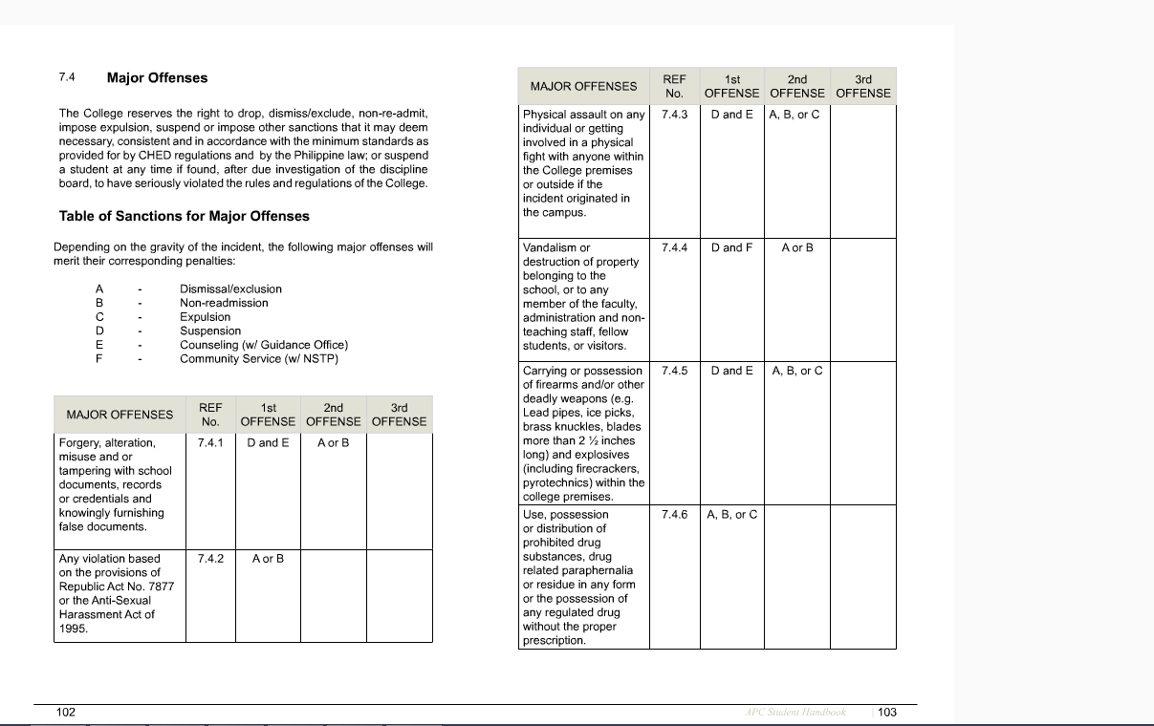**Appendix A – APC Student Handbook Major/Minor Offense Table of Sanctions**

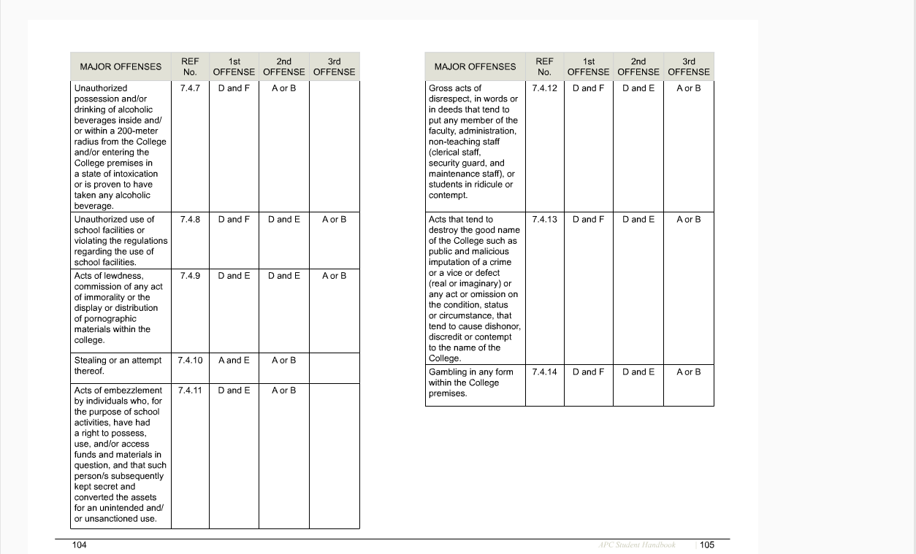

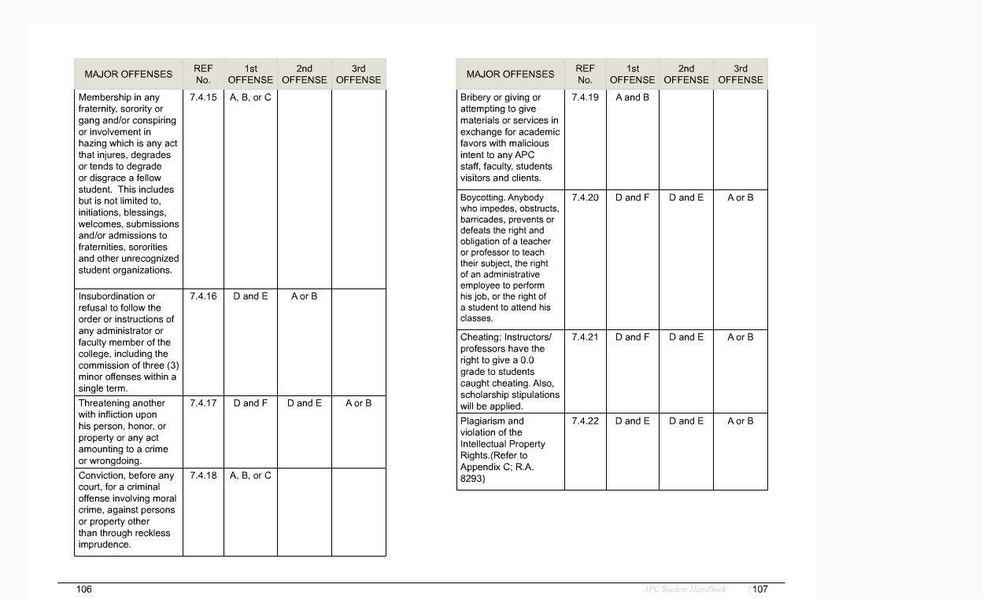

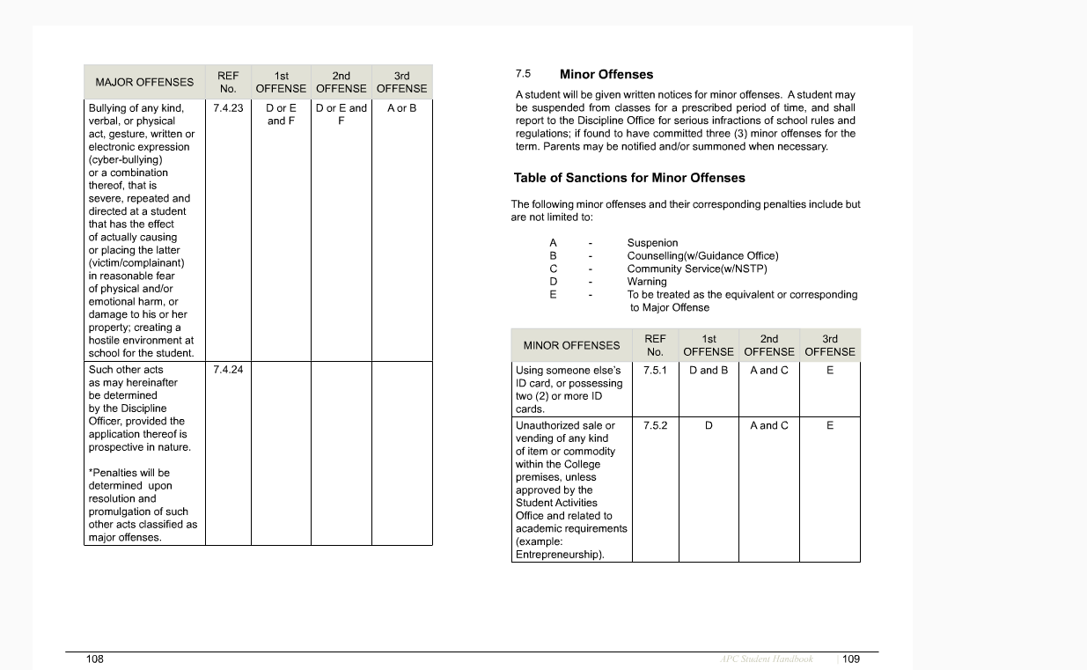

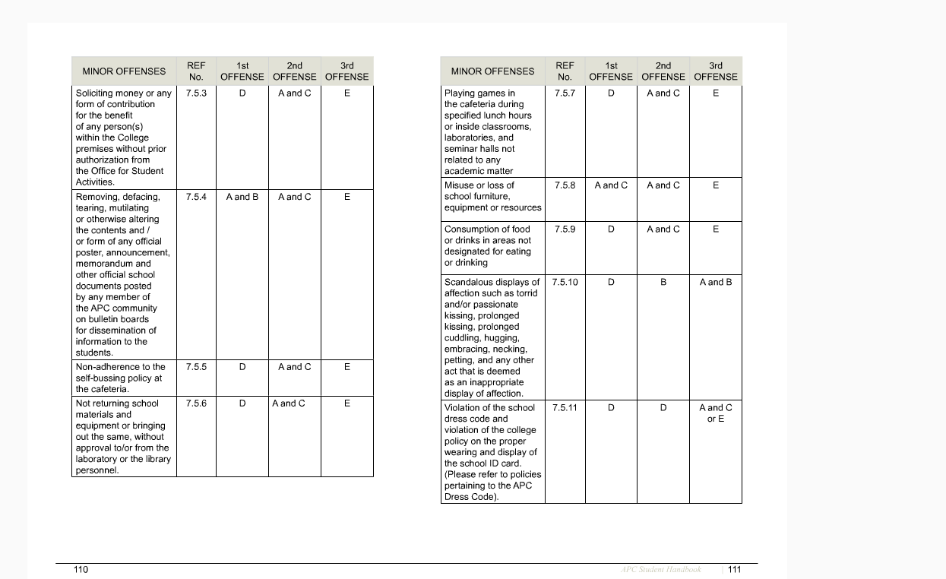

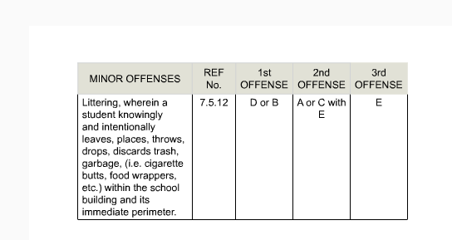

**Appendix B – Use Case Specifications**

|  |  |  |
| --- | --- | --- |
| **NUMBER** | DVS01 | |
| **USE CASE NAME:** | Violation Filing Process | |
| **REQUIREMENTS** | ·         Web Cam  ·         RFID Scanner  ·         RFID Card | |
| **DEFINITION** | Web Cam Feature Settings:  ·         Capture - clicking this button means it will capture an image.  ·         Upload - clicking this button will display the captured image.  ·         Reset - clicking this button will allow the user to capture a new image. | |
| **ACTOR(S):** | ·         Student  ·         Security Guard | |
| **DESCRIPTION** | ·         Entry Point Access of the School  ·         Purpose: File Dress Code Violation Ticket **ONLY** and no any other minor offenses to the offending student as per rules written in the student handbook. | |
| **BASIC FLOW:** | **Actor Action** | **System Response** |
|  | **Step 1:** Student will scan their ID in the RFID Scanner.  Screenshot: [**Violation Filling**](http://i.imgur.com/U22wdvO.png)  **See "Screenshot Use Case" for more details** |  |
|  | **Step 2:**System will display student information corresponding to the student and dress code violation ticket details. The following details are:  **Student Information:**     1.) Name:          - Last Name          - First Name          - Middle Name (If any)     2.) Course     3.) ID Picture  Screenshot: [**Student Information**](http://i.imgur.com/ZrjeSww.png)  **Dress Code Violation Ticket:**     1.) List of Dress Code                     Violation     2.) Reason for Violation     3.) Web Cam Feature Settings          - Capture          - Upload          - Reset     4.) Authorized Personnel                 Input Field     5.) Cancel Button  Screenshot: [**Dress Code Ticket**](http://i.imgur.com/dEIBXLr.jpg)  **See "Screenshot Use Case" for more details** |
| **Step 3:**Security Guard will fill-out the details of the violation committed.  Details:  1.) List of Dress Code Violation  2.) Reason for Violation  3.) Web Cam Feature Settings  Screenshot: [**Security Guard Details**](http://i.imgur.com/800JtEH.jpg)  **See "Screenshot Use Case" for more details** |  |
| **Step 4:**Upon confirmation, Security Guard will scan his or her ID in the "Authorized Personnel" input field in order to file the dress code violation. |  |
|  | **Step 5:** Ticket will be processed and added to database. |
|  | **Step 6:** Return to main page displaying or returning a success message that the ticket has been processed.  Success Message: - **Violation Ticket has been processed. For more information login to the APC Violation Website.**  Screenshot: [**Success Message**](http://i.imgur.com/yIdMoXx.jpg)  **See "Screenshot Use Case" for more details** |
| **ALTERNATE FLOW:** | **Actor Action** | **System Response** |
|  | 1.     At Step 1 (Alternate Flow)  Student will enter their ID Number. |  |
|  | System will display the student information and dress code violation ticket details:  **Student Information:**     1.) Name:          - Last Name          - First Name          - Middle Name (If any)     2.) Course     3.) ID Picture  **Dress Code Violation Ticket:**     1.) List of Dress Code                     Violation     2.) Reason for Violation     3.) Web Cam Feature Settings          - Capture          - Upload          - Reset     4.) Authorized Personnel                 Input Field     5.) Cancel Button |
| 2.     At Step 1 (Alternate Flow)  Student will enter their ID Number or Scan their ID in the RFID Scanner. |  |
|  | Error message will appear stating that the student must comply with the following requirements.  Error Message:  - **Please Register and Accomodate your Student Account in the IT Resource Office.**  Screenshot: [**Error Message**](https://imgur.com/tPXmJHp)  **See "Screenshot Use Case" for more details** |
| 3.     At Step 4 (Alternate Flow)  Student will submit the form by scanning their ID or Entering their ID Number |  |
|  | Error message will appear dictating only Security Guard can submit the form.  Error Message:  -**Authorized Personnel can only accomodate the Violation Ticket**  Screenshot: [**Error Message**](http://i.imgur.com/tPXmJHp.jpg)  **See "Screenshot Use Case" for more details** |
| **PRECONDITION:** | User can either have their ID scanned or input their Student ID number. | |
| **POSTCONDITION:** | Violation Filing was processed. | |

|  |  |  |
| --- | --- | --- |
| **NUMBER** | DVS02 | |
| **USE CASE NAME:** | Violation Ticket Status | |
| **DEFINITION** | * Ticket - refers to the processed Dress Code Violation ticket. * Dress Code Violation Ticket - it is the ticket where the Security Personnel or Security Guard will enter the dress code violation details. | |
| **ACTOR(S):** | * Student * Security Guard | |
| **DESCRIPTION** | * Protect Student from being given a dress code violation ticket twice. * Offers a hassle free for the Disciplinary Officer to flag up multiple violation ticket onto one student. | |
| **BASIC FLOW:** | **Actor Action** | **System Response** |
|  | **Step 1:** Student will scan their ID in the RFID Scanner |  |
|  | **Step 2:**System will display   * Prompt Message * View Ticket button * Cancel button   Prompt Message: "Violation Ticket has been processed. For more inforimation"  Screenshot: [**Ticket**](http://i.imgur.com/MdDqTN0.jpg)  **See "Screenshot Use Case" for more details.** |
| **Step 3:**Security Guard clicks on the "View Ticket" button |  |
|  | **Step 4:**System will display the Ticket details which comprises the following:  1.) Name - given name of student.  2.) Status - with a given metadata of: Pending, Excused and Violated.  3.) Issued Date  4.) Issued By - Security Guard given name  5.) Student and Security Guard ID Picture  6.) Close button  Screenshot: [**Ticket Details**](http://i.imgur.com/9PvXhUn.jpg)  **See "Screenshot Use Case" for more details.** |
| **Step 5:**After validating the results the Security Guard will click on the "Close" button. |  |
|  | **Step 6:**Return to the main page. |
| **ALTERNATE FLOW:** | **Actor Action** | **System Response** |
|  | 1. At Step 1 (Alternate Flow)  Student will enter their ID Number in the input field. |  |
|  | System will display   * Prompt Message * View Ticket button   Prompt Message: "Violation Ticket has been processed. For more inforimation" |
|  | 2. At Step 2 (Alternate Flow)  If Student does not have any dress code violation for the given day then it will display the dress code violation ticket instead. |
| 3. At Step 3 (Alternate Flow)  Security Guard clicks on the "Close" button |  |
|  | Redirect the user to the main page. |
| **PRECONDITION:** | User can either have their ID scanned or input their Student ID number. | |
| **POSTCONDITION:** | Violation Ticket status and to protect student from being issued a violation twice. | |

|  |  |  |
| --- | --- | --- |
| **NUMBER** | DVS03 | |
| **USE CASE NAME:** | Student Authentication | |
| **ACTOR(S):** | * Student | |
| **DESCRIPTION** | Frontend page for Student authentication functionality | |
| **BASIC FLOW:** | **Actor Action** | **System Response** |
|  | **Step 1:**Student will fill-out the username and password field.  Screenshot: [**Login Page**](http://i.imgur.com/ahwexuo.png)  **See "Screenshot Use Case" for more details.** |  |
|  | **Step 2:**Identify the Role Based Access Control of a particular User, for this instance it will be Student. |
|  | **Step 3:**Redirect the student to the main page of the web application. |
|  | **Step 4**: Display the Dashboard of the Student. Comprises of:  1.) Dress Code Violation:     - Pending     - Infringement     - Excused  2.) Notification Inbox  Screenshot: [**Dashboard**](http://i.imgur.com/ek5FMRC.png)  **See "Screenshot Use Case" for more details.** |
| **Step 5:** Student clicks on the upper right navigation bar:       <ID Picture> <Given Name>. |  |
|  | **Step 6:**Small Frame will appear displaying:  1.) Student ID Picture  2.) Student Name  3.) Student Course  4.) Home button  5.) Sign Out button  Screenshot: [**Nav-Profile**](http://i.imgur.com/uKX4CRw.png)  **See "Screenshot Use Case" for more details.** |
| **Step 7:**Student clicks on the "Sign Out" button |  |
|  | **Step 8:**Session will be destroyed thus returning the student to the login screen. |
| **ALTERNATE FLOW:** | **Actor Action** | **System Response** |
|  | 1. At Step 1 (Alternate Flow 1): Student enters the wrong credential |  |
|  | System will display an error message.  Prompt Message: Incorrect Username or Password  Screenshot: [**Error Message**](http://i.imgur.com/0DtevcN.png) |
|  | 2. At Step 4 (Alternate Flow 1): Display Notification Notices (If there are any notices to be displayed). Notification Notices comprises of:   * Notice - Disciplinary Officer * Violation:             - Dress Code: Pending            - Dress Code: Issued            - Dress Code: Excused  Screenshot: [**Dashboard-Notification**](http://i.imgur.com/uLLmUUw.jpg)   * Pop-up Notification             - Close button  Screenshot: [**Notification**](http://i.imgur.com/8F2gIJT.jpg)  **See "Screenshot Use Case" for more details.** |
| 3. At Step 1 (Alternate Flow 2): Student leaves the username or password field. |  |
|  | System will prompt the user to fill out the required field either username or password.  Prompt Message: Please Fill out this field.  Screenshot: [**Empty Field**](http://i.imgur.com/7XaDK7w.png) |
| 4. At Step 7 (Alternate Flow)  Student clicks on the Home button |  |
|  | System will return the student to the index page thus displaying the dashboard again. |
| **PRECONDITION:** | Student must log-in to the system. | |
| **POSTCONDITION:** | Student will be able to navigate the Dress Code Violation Module. | |

|  |  |  |
| --- | --- | --- |
| **NUMBER** | DVS04 | |
| **USE CASE NAME:** | Administrator Authentication | |
| **ACTOR(S):** | * Administrator | |
| **DESCRIPTION** | Backend page for Administrator authentication functionality. | |
| **BASIC FLOW:** | **Actor Action** | **System Response** |
|  | **Step 1:**Administrator will fill-out the username and password field.  Screenshot: [**Login Page**](http://i.imgur.com/ahwexuo.png)  **See "Screenshot Use Case" for more details.** |  |
|  | **Step 2:**Identify the Role Based Access Control of a particular User, for this instance it will be Administrator. |
|  | **Step 3:**Redirect the Administrator to the main page of the web application. |
|  | **Step 4**: Display the Dashboard of the Administrator. Comprises of:  1.) Dress Code Violation Report     - Pending     - Infringement  2.) Student Offenses  3.) Student Notification  4.) Summary  5.) Settings     - Dress Code Violation List         - Male         - Female     - Offense Details         - Major Offense         - Minor Offense     - Notification Details     - School Term     - Sanctions  Screenshot: [**Dashboard Admin**](http://i.imgur.com/XFb4cTp.png)  **See "Screenshot Use Case" for more details.** |
| **Step 5:** Administrator clicks on the upper right navigation bar:       <ID Picture> <Given Name>. |  |
|  | **Step 6:**Small Frame will appear displaying:  1.) Administrator ID Picture  2.) Administrator Name  3.) Administrator Course  4.) Home button  5.) Sign Out button  Screenshot: [**Nav-Profile**](http://i.imgur.com/3vnRAbZ.png)  **See "Screenshot Use Case" for more details.** |
| **Step 7:**Administrator clicks on the "Sign Out" button |  |
|  | **Step 8:**Session will be destroyed thus returning the Administrator to the login screen. |
| **ALTERNATE FLOW:** | **Actor Action** | **System Response** |
|  | 1. At Step 1 (Alternate Flow 1): Administrator enters the wrong credential |  |
|  | System will display an error message.  Prompt Message: Incorrect Username or Password  Screenshot: [**Error Message**](http://i.imgur.com/0DtevcN.png) |
| 3. At Step 1 (Alternate Flow 2): Administrator leaves the username or password field. |  |
|  | System will prompt the user to fill out the required field either username or password.  Prompt Message: Please Fill out this field.  Screenshot: [**Empty Field**](http://i.imgur.com/7XaDK7w.png) |
| 4. At Step 7 (Alternate Flow)  Administrator clicks on the Home button |  |
|  | System will return the Administrator to the index page thus displaying the dashboard again. |
| **PRECONDITION:** | Administrator must log-in to the system. | |
| **POSTCONDITION:** | Administrator will be able to navigate the Dress Code Violation Module. | |

|  |  |  |
| --- | --- | --- |
| **NUMBER** | DVS05 | |
| **USE CASE NAME:** | Student View Violation Ticket | |
| **ACTOR(S):** | Student | |
| **DESCRIPTION:** | Upon generating the violation ticket submitted by the security guard. Student will be able to view their ticket via web application. The duration of the ticket is 2 days. | |
| **BASIC FLOW:** | **Actor Action** | **System Response** |
|  | **Step 1:**Student clicks the “Dress Code Violation” tab.      **Step 3:** Student clicks on either of the three sections they want to view. | **Step 2:**Displays three sections (Pending, Infringement, Excused), which is a list of violation they committed.      **Step 4:** Displays the Violation Ticket and the corresponding Security Guard that processed the ticket, its status, date of incident, date of validity. |
| **ALTERNATE FLOW:** | If the ticket has reached its deadline (2 days) then the ticket will be put into the infringement section, which is flagged red.   |  |  | | --- | --- | | **Step 1:**Student type his ID number/scan ID  in the entry point access web page.      **Step 3:** Student clicks View ticket | **Step 2:**Displays the option to view ticket or close      **Step 4:**Displays the ticket and the security guard who issued the violation | | |
| **PRECONDITION:** | Student must be logged in | |
| **POSTCONDITION:** | Student will be able to view the Violation Ticket | |

|  |  |  |
| --- | --- | --- |
| **NUMBER** | DVS06 | |
| **USE CASE NAME:** | Create Appeal Ticket | |
| **ACTOR(S):** | Student | |
| **DESCRIPTION:** | Student will be able to create an appeal ticket corresponding to the violation that they made. | |
| **BASIC FLOW:** | **Actor Action** | **System Response** |
|  | **Step 1:**Student clicks the "Dress Code Violation" tab.      **Step 3:** Student clicks on either of the three sections.            **Step 5:** Student clicks on the “Appeal” button      **Step 7:** Student clicks submit. | **Step 2:**Displays a list of violation they committed. It has three sections: "Pending", "Infringement", "Excused"      **Step 4:** Displays the Violation Ticket and the corresponding Security Guard that processed the ticket, its status, date of incident, date of validity.      **Step 6:** Text field will be displayed where student can enter the appeal statement.    **Step 8:** Displays message: "Appeal Ticket Created" |
| **ALTERNATE FLOW:** | Student will be able to create an appeal ticket; however, it can only be updated once.  If the Disciplinary Officer already flagged it as “Violation Committed” then by all means the student cannot create an Appeal Ticket. | |
| **PRECONDITION:** | Student must be logged in in order to know or identify the corresponding status. | |
| **POSTCONDITION:** | Student will be able to create an appeal ticket prior only to the violation that they have committed. | |

|  |  |  |
| --- | --- | --- |
| **NUMBER** | DVS07 | |
| **USE CASE NAME:** | Administrative Managing of Appeal Ticket | |
| **ACTOR(S):** | Disciplinary Officer | |
| **DESCRIPTION:** | Disciplinary Officer will be able to comprehend the appeals of the student if and only if valid. | |
| **BASIC FLOW:** | **Actor Action** | **System Response** |
|  | **Step 1:**Disciplinary Officer clicks the “Dress Code Violation Report” tab.        **Step 3:** Disciplinary Officer clicks on either of the two sections.  **Step 5:** Disciplinary Officer clicks view on the violation ticket            **Step 7:** Disciplinary Officer clicks the couse of action according to his discretion: "Pending", "Issue Dress Code Violation", "Excused." | **Step 2:**Displays sections: "Pending", "Infringement."      **Step 4:** Displays the Violation Ticket and the corresponding Security Guard that processed the ticket, name of student, date of violation.      **Step 6:** Displays the violation ticket: list of violations, remarks, appeal statement, status, screenshot.          **Step 8:** Displays message that changes were applied to the violation ticket. |
| **ALTERNATE FLOW:** | If the Disciplinary Officer was not able to impose any sanctions against the student then the system will automatically update the ticket. (2 days prior to the generated ticket). | |
| **PRECONDITION:** | Violation Ticket must exist. | |
| **POSTCONDITION:** | The Disciplinary Officer can update the ticket any time he wants. | |

|  |  |  |
| --- | --- | --- |
| **NUMBER** | DVS08 | |
| **USE CASE NAME:** | Create new violation | |
| **ACTOR(S):** | Disciplinary Officer | |
| **DESCRIPTION:** | Within a point in time, the disciplinary officer can add new violation component in the List of Violation of students. | |
| **BASIC FLOW:** | **Actor Action** | **System Response** |
|  | **Step 1:**Disciplinary Officer clicks the “Settings” tab.      **Step 3:** Disciplinary Officer clicks either Male or Female          **Step 5:** Disciplinary Officer clicks “Add”.            **Step 7:**Disciplinary Officer fills out the field and selects the appropriate radio buttons.  **Step 8:**Clicks “Submit”. | **Step 2:**Displays options between Male or Female      **Step 4:** Display the Violation Field and to whom it should be addressed to – “Male, Female or Everyone”      **Step 6:** Display text field for violation name, and radio buttons: “Male, Female or Everyone”; and “Active or Inactive”.          **Step 9:**System accepts the violation and adds it to the database. |
| **ALTERNATE FLOW:** | Disciplinary Officer must specify whether it should be active or not, for the new violation to be saved in the database. | |
| **PRECONDITION:** | Disciplinary Officer must logged in in order to make necessary changes. | |
| **POSTCONDITION:** | The Disciplinary Officer has created but may not display the new violation created. | |

|  |  |  |
| --- | --- | --- |
| **NUMBER** | DVS09 | |
| **USE CASE NAME:** | Update Violation List | |
| **ACTOR(S):** | Disciplinary Officer | |
| **DESCRIPTION:** | Disciplinary Officer will be able to make necessary changes in the violation list. | |
| **BASIC FLOW:** | **Actor Action** | **System Response** |
|  | **Step 1:**Disciplinary Officer clicks the “Settings” tab.      **Step 3:** Disciplinary Officer clicks either Male or Female          **Step 5:** Disciplinary Officer clicks on the “Update” button            **Step 7:**Disciplinary Officer fills out the field and selects the appropriate radio buttons.  **Step 8:**Clicks “Submit”. | **Step 2:**Displays options between Male or Female      **Step 4:** Display the Violation Field and to whom it should be addressed to – “Male, Female or Everyone”      **Step 6:** Display text field for violation name, and radio buttons: “Male, Female or Everyone”; and “Active or Inactive”.          **Step 9:**System accepts the violation and updates the corresponding database entry. |
| **ALTERNATE FLOW:** | Disciplinary Officer must specify whether it should be active or not, for the new violation to be saved in the database. | |
| **PRECONDITION:** | Disciplinary Officer must logged in in order to make necessary changes. | |
| **POSTCONDITION:** | The Disciplinary Officer has updated the violation list but may not be displayed upon updated. | |

# Bibliography

<https://www.apc.edu.ph/student_handbook>

<https://almsaeedstudio.com/>

<http://startbootstrap.com/template-overviews/modern-business/>

<https://www.apachefriends.org/index.html>

<http://www.phpclasses.org/blog/post/228-How-to-Use-a-Webcam-to-take-Pictures-in-PHP-Application.html>

<http://stackoverflow.com/questions/219476/using-php-to-access-a-users-webcam>

<http://gnuhealth.ioss.com.ph/testlink/index.php>

<http://getbootstrap.com/>

https://fortawesome.github.io/Font-Awesome/